**SOFTWARE FUNCTION SPECIFICATION (SFS)**

**Doc: SRS.v1**

INFO STAFF (HR) PROJECT

**NOTICE OF CHANGES TABLE**

|  |  |  |  |  |
| --- | --- | --- | --- | --- |
| **Date** | **Version** | **\* A, M, D** | **Description** | **Author** |
| 07/09/2020 | Ver 1.001 | A, M | 1. Define ERRP functions in project. | Anhtn |
|  |  |  |  |  |
|  |  |  |  |  |
|  |  |  |  |  |
|  |  |  |  |  |
|  |  |  |  |  |
|  |  |  |  |  |
|  |  |  |  |  |
|  |  |  |  |  |
|  |  |  |  |  |
|  |  |  |  |  |
|  |  |  |  |  |

*A - Added M - Modified D – Deleted

Version: x.y:

* The first version start 1.0
* After reviewing and updating, version increase to 1
* After golive, if document have any changes, version increase to

|  |  |
| --- | --- |
| **Maker** | *Name: Date: <dd/MM/yyyy>*  *Role:* |
| **Auditor** | *Name: Date: <dd/MM/yyyy>*  *Role:* |
|  | *Name: Date: <dd/MM/yyyy>*  *Role:* |
| **Approver** | *Name: Date: <dd/MM/yyyy>*  *Role:* |

**MỤC LỤC**

**NOTICE OF CHANGES TABLE 2**

1 Introduction 5

1.1 Purpose of document 5

1.2 Scope 5

1.3 Term and acronyms 5

1.4 Refferences 5

2 Overview 5

2.1 General description 5

2.2 Flow 5

2.3 Models of overall use cases 5

2.3.1 Usecase diagram 5

2.3.2 Actors 6

2.3.3 Usecase 6

2.3.4 Diagram 7

2.3.5 Use case detail 7

2.4 Integrations 9

2.5 Switching 9

3 Function requirements 9

3.1 Login function 9

3.1.1 Flow 10

3.1.2 UI 11

3.1.3 Rule 11

3.2 Registration 11

3.2.1 Flow 13

3.2.2 UI 14

3.3 Reset password 14

3.3.1 Flow 16

3.3.2 UI 17

3.4 Account management 17

3.4.1 Flow 19

3.4.2 UI 20

4 Appendix 20

# Introduction

## Purpose of document

## Scope

## Term and acronyms

|  |  |  |
| --- | --- | --- |
| **Term/Acronyms** | **Full name** | **Meaning** |
| HR | Human resource | Infoplus staff management |
|  |  |  |
|  |  |  |
|  |  |  |
|  |  |  |
|  |  |  |

## References

|  |  |  |
| --- | --- | --- |
| **No.** | **Name** | **Note** |
| 1 |  |  |
| 2 |  |  |
| 3 |  |  |

# Overview

## General description

## Flow

N/A

## Models of overall use cases

### Use-case diagram



### Actors

|  |  |  |
| --- | --- | --- |
| **Idx** | **Actor** | **Definition** |
|  | Admin | Administrator |
|  | Manager | Manager group. |
|  | Staff | Staff group |
|  |  |  |
|  |  |  |

### Usecase

|  |  |  |
| --- | --- | --- |
| **Idx** | **Usecase** | **Note** |
|  | Login | Apply for all user |
|  | Configuration |  |
|  | Check-in/check-out |  |
|  | Request holiday |  |
|  | Request overtime |  |
|  | Approve holiday |  |
|  | Approve overtime |  |
|  | History | Inclulde holiday history and timecard history |
|  | Report |  |

## Integrations

N/A

## Switching

N/A

# Function requirements

## Check-in function

### Flow



|  |  |  |  |  |  |  |
| --- | --- | --- | --- | --- | --- | --- |
| **Index** | **Name** | **Type** | **Input** | **Output** | **Action** | **Note** |
| 1 | api/v1.0/infostaff/check-in | url | {  staffCode: <value>(*),  checkIn: <value>(*),  checkOut: <value>,  workingDate: <value>(*)  } | {  code: <value>  Reason: <value>  } | Call Check-in controller |  |
| 2 | checkIn | Func | User loginUser,  TimeCardModel model | ResponseModel | Call check-in service.  If validation error, return RepsoneModel{ code = 14, content = “Validation error”}.  If mapping error, return ResponseModel{code = 15, content = “Mapping error”}.  If execute error, reuturn ResponseModel{code = 10,  Content= “Execution error”}  If success, return ResponseModel{code = 00,  Content = “Success”} | User is springsecurity model |
| 3 | Validation | Func | TimeCardModel model | Boolean | Validation key and not null data |  |
| 4 | modelToEntity | Func | TimeCardModel model | TblTimeCardEntity |  |  |
| 5 | insertTimeCard | Func | TblTimeCardEntity entity | Long | Insert into db |  |

## Check-out function

### Flow



|  |  |  |  |  |  |  |
| --- | --- | --- | --- | --- | --- | --- |
| **Index** | **Name** | **Type** | **Input** | **Output** | **Action** | **Note** |
| 1 | api/v1.0/infostaff/check-out | url | {  staffCode: <value>(*),  checkIn: <value>,  checkOut: <value>(*),  workingDate: <value>(*)  } | {  code: <value>  Reason: <value>  } | Call Check-out controller |  |
| 2 | checkOut | Func | User loginUser,  TimeCardModel model | ResponseModel | Call check-out service.  If validation error, return RepsoneModel{ code = 14, content = “Validation error”}.  If mapping error, return ResponseModel{code = 15, content = “Mapping error”}.  If execute error, reuturn ResponseModel{code = 10,  Content= “Execution error”}.  If no data found, reuturn ResponseModel{code = 11,  Content= “No data found”}.  If success, return ResponseModel{code = 00,  Content = “Success”} | User is springsecurity model |
| 3 | validation | Func | TimeCardModel model | Boolean | Validation key and not null data |  |
| 4 | modelToEntity | Func | TimeCardModel model | TblTimeCardEntity |  |  |
| 5 | findById | Func | Long id | TblTimeCardEntity | Get timecard record by ID |  |
| 6 | updateTimeCard | Func | TlimeCardEntity entity | Void | Update fileds:  Checkout  In database |  |

## Change timecard information function

### Flow



|  |  |  |  |  |  |  |
| --- | --- | --- | --- | --- | --- | --- |
| **Index** | **Name** | **Type** | **Input** | **Output** | **Action** | **Note** |
| 1 | api/v1.0/infostaff/change-timecard | url | {  staffCode: <value>(*),  checkIn: <value>,  checkOut: <value>(*),  note: <value>(*)  workingDate: <value>(*)  } | {  code: <value>  Reason: <value>  } | Call change timecard controller |  |
| 2 | changeTimeCard | Func | User loginUser,  TimeCardModel model | ResponseModel | Call changTimeCard service.  If validation error, return RepsoneModel{ code = 14, content = “Validation error”}.  If mapping error, return ResponseModel{code = 15, content = “Mapping error”}.  If execute error, reuturn ResponseModel{code = 10,  Content= “Execution error”}.  If no data found, reuturn ResponseModel{code = 11,  Content= “No data found”}.  If success, return ResponseModel{code = 00,  Content = “Success”} | User is springsecurity model |
| 3 | validation | Func | TimeCardModel model | Boolean | Validation key and not null data |  |
| 4 | modelToEntity | Func | TimeCardModel model | TblTimeCardEntity |  |  |
| 5 | findById | Func | Long id | TblTimeCardEntity | Get timecard record by ID |  |
| 6 | updateTimeCard | Func | TlimeCardEntity entity | Void | Update fileds:  Check-in,  Check-out,  Note,  Changed-user,  Changed-date  In database |  |

## Get Time Card Information

### Flow



|  |  |  |  |  |  |  |
| --- | --- | --- | --- | --- | --- | --- |
| **Index** | **Name** | **Type** | **Input** | **Output** | **Action** | **Note** |
| 1 | api/v1.0/infostaff/get-timecard | url | {  staffCode: <value>,  groupCode: <value>,  workingDate: <value>  previousMonth: <value>,  previousQuarter: <value>,  fromDate: <value>,  toDate: <toDate>  } | {  {TimeCardModel model 01},  { TimeCardModel model 02},  { TimeCardModel model 03},  ….  { TimeCardModel model n}  } | Call get timeCard controller |  |
| 2 | getTimeCard | Func | SearchTimeCardModel model | List<TimeCardModel> |  |  |
| 3 | entityToModel | Func | List<TblTimeCardEntity> entities | List<TimeCardModel> |  |  |

## Import TimeCard information

### Flow



|  |  |  |  |  |  |  |
| --- | --- | --- | --- | --- | --- | --- |
| **Index** | **Name** | **Type** | **Input** | **Output** | **Action** | **Note** |
| 1 | api/v1.0/infostaff/import-timecard | url | ExcelFile dataFile | {  Code: <value>,  Reason: <value>,  total: <value>,  success: <value>  fail: <value>  } | Call import timeCard controller |  |
| 2 | importTimeCard | Func | User user, File dataFile | ResponseModel |  |  |
| 3 | ValidationFile | Func | File dataFile | Boolean |  |  |
| 4 | readData | Func | File dataFile | List<TimeCardModel> models | Convert data from file to model |  |
| 5 | fileToEntity | Func | File dataFile | TblFile |  |  |
| 6 | modelToEntity | Func | TimecardModel model | TblTimeCardEntity |  |  |
| 7 | insertTimeCard | Func | TblTimeCardEntity entity | Long |  |  |
| 8 | countExecuteData | Func | Long timeCardId | List<int> | If row execute, total += 1.  If execute success, success +=1.  If execute failed, fail +=1. |  |
| 9 | insertFile | Func | TblFile entity | Long |  |  |
| 10 | createResponseModel | Func | List<int> countExecuteDt | ResponseModel |  |  |

# Database

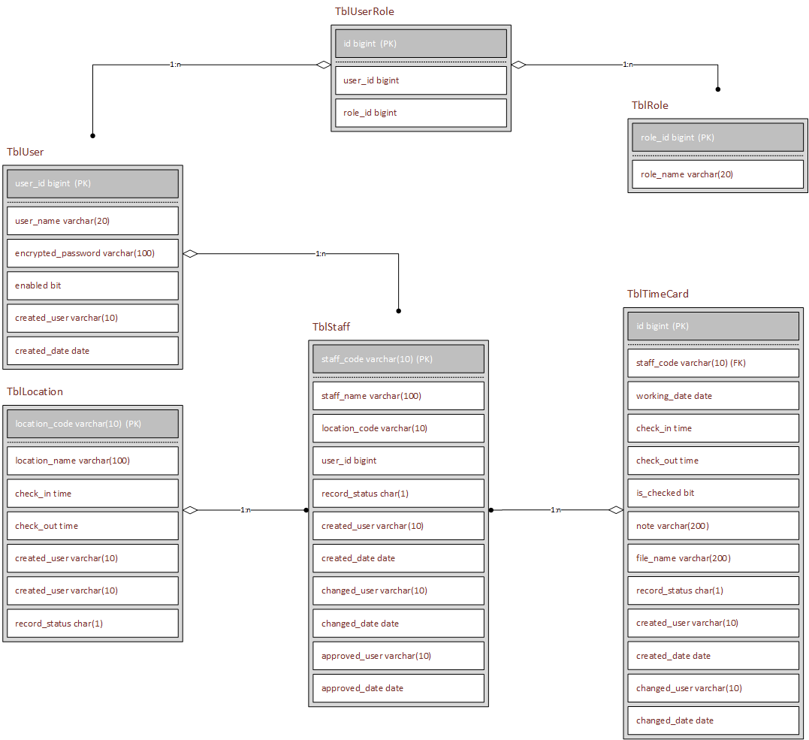

|  |  |  |  |  |  |
| --- | --- | --- | --- | --- | --- |
| Name | **tblLocation** | | | | |
| **Name** | **Type** | **Is KEY** | **Is NULL** | **Is AU** | **Default value** |
| Location_code | Varchar(10) | Y | N | N |  |
| Location_name | Varchar(100) | N | N | N |  |
| Check_in | Time | N | N | N |  |
| Check_out | Time | N | N | N |  |
| Created_user | Varchar(10) | N | Y | N |  |
| Created_date | Date | N | Y | N |  |
| Record_status | Char(1) | N | N | N | O: open |

|  |  |  |  |  |  |
| --- | --- | --- | --- | --- | --- |
| Name | **tblUser** | | | | |
| **Name** | **Type** | **Is KEY** | **Is NULL** | **Is AU** | **Default value** |
| User_id | Bigint | Y | N | Y |  |
| User_name | Varchar(20) | N | N | N |  |
| Enabled | Bit | N | N | N |  |
| Created_user | Varchar(10) | N | Y | N |  |
| Created_date | Date | N | Y | N |  |

|  |  |  |  |  |  |
| --- | --- | --- | --- | --- | --- |
| Name | **tblRole** | | | | |
| **Name** | **Type** | **Is KEY** | **Is NULL** | **Is AU** | **Default value** |
| Role_id | Bigint | Y | N | Y |  |
| Role_name | Varchar(20) | N | N | N |  |
| Created_user | Varchar(10) | N | Y | N |  |
| Created_date | Date | N | Y | N |  |

|  |  |  |  |  |  |
| --- | --- | --- | --- | --- | --- |
| Name | **tblUserRole** | | | | |
| **Name** | **Type** | **Is KEY** | **Is NULL** | **Is AU** | **Default value** |
| id | Bigint | Y | N | Y |  |
| User_id | Bigint | N | N | N |  |
| Role_id | Bigint | N | N | N |  |
| Created_user | Varchar(10) | N | Y | N |  |
| Created_date | Date | N | Y | N |  |

|  |  |  |  |  |  |
| --- | --- | --- | --- | --- | --- |
| Name | **tblStaff** | | | | |
| **Name** | **Type** | **Is KEY** | **Is NULL** | **Is AU** | **Default value** |
| Staff_code | Varchar(10) | Y | N | N |  |
| Staff_name | Varchar(100) | N | N | N |  |
| Join_date | Date | N | N | N |  |
| Dob | Date | N | N | N |  |
| Gender | Char(1) | N | N | N | 1: male, 0: woman |
| Location_code | Varchar(10) | N | N | N |  |
| File_name | varchar(100) | N | Y | N |  |
| Created_user | Varchar(10) | N | Y | N |  |
| Created_date | Date | N | Y | N |  |
| Changed_user | Varchar(10) | N | Y | N |  |
| Changed_date | Date | N | Y | N |  |
| Record_status | Char(1) | N | N | N | O: open, C: close |

|  |  |  |  |  |  |
| --- | --- | --- | --- | --- | --- |
| Name | **tblTimeCard** | | | | |
| **Name** | **Type** | **Is KEY** | **Is NULL** | **Is AU** | **Default value** |
| Id | Bigint | Y | N | Y |  |
| Staff_code | Varchar(10) | N | N | N |  |
| Working_date | Date | N | N | N |  |
| Check_in | Time | N | Y | N |  |
| Check_out | Time | N | Y | N |  |
| Is_checked | Bit | N | N | N |  |
| Note | Varchar(200) | N | Y | N |  |
| File_name | Varchar(200) | N | Y | N |  |
| Created_user | Varchar(10) | N | N | N |  |
| Created_date | Date | N | N | N |  |
| Changed_user | Varchar(10) | N | N | N |  |
| Changed_date | Date | N | N | N |  |
| Record_status | Char(1) | N | N | N | O: open, C: close |

# Appendix