This report is Ngoc Anh (Rachel) Phung’s work as part of MIS373 – Artificial Intelligence for Business.

Task 1 - House Price Prediction
Executive Summary
Buyers rely on appraisals’ valuation when deciding to invest in residential properties, and when appraisals are incorrect, buyers fail to assess the risk of real estate assets (Kok et al, 2017). For Housely, this is a critical issue if its clients (buyers and sellers of properties) cannot trust Housely’s valuation, and eventually turn to other real estate analytics platform with more accurate pricing data. To solve this, and also to reduce the manual valuation workload for Housely employees, I present a machine-learning (ML) approach to predict house prices, giving Housely a credible tool to assist in property valuation.
Two ML techniques were used on a dataset of 20,000 property sales – Linear Regression and Artificial Neural Networks (ANN). To test whether ANN outperform regression in predictions, I compared a Linear Regression (LR) model and 9 Multi-layer Perceptrons (MLPs), each varied by one dimension, and arrived at the ultimate MLP model – M7 with an outstanding ability to explain 88.7% of variation in prices. Upon experiment, I found that training stability is what drives performance in this dataset. M7’s predictions are off by $70,000 on average, which leads to my recommendation for Housely – deploying M7 as a tool for decision support, rather than relying on it for exact valuation. The model works best for standard houses, predictions for high-value assets (those above $1.5M) require human intervention. Finally, for up-to-date, precise valuation, the model should be fed with more recent property sales to account for changes in market and economic conditions.
Data Exploration and Pre-processing
The dataset from Housely contains 20,000 residential properties with 21 features including sales price, physical characteristics (number of floors, bedrooms and bathrooms, size of living area, lot and basement), quality (condition, grade, waterfront, view), location (latitude, longitude and zip code), year built and year renovated. Several pre-processing steps were taken.
(i) Outlier removal. One property with 33 bedrooms was flagged as an anomaly given its limited living area of 1,620 square feet (sqft) and removed.
(ii) Feature engineering. 2 binary features were added – is_renovated (1 if year_renovated > 0) and has_basement (1 if sqft_basement > 0). These features turn continuous variables into meaningful binary to show a property’s renovation status and presence of basement.
(iii) Multi-collinearity. Correlation matrix revealed high correlation between sqft_living, sqft_above and sqft_basement since sqft_living = sqft_above + sqft_basement. Keeping all 3 features adds reduntant noise, so sqft_above and sqft_basement (now represented by has_basement) were dropped. Variance Inflation Factor (VIF) confirmed multi-collinearity was resolved, as no feature has VIF exceeding 5.1.
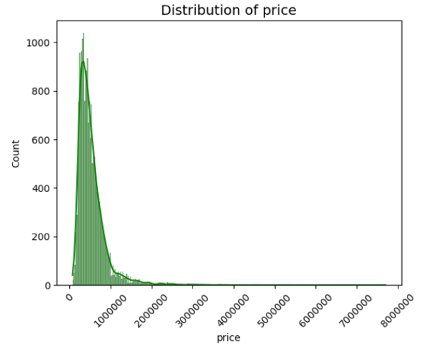
(iv) Feature selection. Price was set as the target variable. 6 features were dropped including ID, date, sqft_above, sqft_basement, yr_renovated (now represented by is_renovated), and price (to avoid data leakage). The rest were kept as predictors.
Figure 1. Distribution of Price.
(v) Log transformation of Price. Initial EDA revealed that house prices are right-skewed with a long tail of high-value properties (Figure 1). Log transform price compress the this range to make gradient descent more stable. For interpretability, when evaluating model performance, price will be converted back to dollars.
(vi) Train-test split. 70% of data was used for training and 30% for testing to prevent data leakage.
(vii) Target encoding Zipcode. Zipcode has 70 unique values, which makes one-hot encoding (creating 70 binary columns) inappropriate. Instead, target encoding was used for the training dataset to capture how prices varies by location without increasing dimensionality to the dataset.
(viii) Feature scaling. After splitting, StandardScaler was used to scale all features. This is critical for neural networks because without scaling, sqft_living (e.g 1000 sqft) will dominate bedrooms (e.g. 1 bedroom). Scaling also improve linear regression’s performance.
After pre-processing, 19,999 rows were retained. For model development, price will be predicted by 17 features – bedrooms, bathrooms, sqft_living and sqft_lot of the property and of 15 properties surrounding it, floors, waterfront, view, condition, grade, year_built, zipcode, latitude, longitude, is_renovated and has_basement.
The average house price is $535,563. While prices mostly fall below $1M, a small proportion of premium houses exist, with prices exceeding $2M. The highest price recorded was a $7.7M house with 12K sqft of interior area and 27.6K sqft of lot. Expensive properties are often seen with large living space and lot size, in good condition, has good view or has been renovated.
AI Model Development
10 models were developed, including 1 Linear Regression (LR) and 9 Multi-layer Perceptrons (MLPs). The goal is to test whether neural networks outperform LR in predicting house price using the same predictors. Each new MLP model differ from the previous by one dimension (Table 1).
Model | No. of layers | Neurons per layer | Activa-tion | Regularisa-tion | Opti-mizer | Learning rate | Loss | Change from previous model
M1 – LR |  |  |  |  |  |  | MSE | Linear Regression
M2 – MLP | 1 | 32 | ReLU | None | Adam | 1e-3 | MSE | MLP Baseline
M3 – MLP | 2 | 32 | ReLU | None | Adam | 1e-3 | MSE | + 1 hidden layer
M4 – MLP | 3 | 32 | ReLU | None | Adam | 1e-3 | MSE | + 1 hidden layer
M5 – MLP | 3 | 64 | ReLU | None | Adam | 1e-3 | MSE | 2x neurons per layer
M6 – MLP | 3 | 32 | ReLU | Dropout (0.2) | Adam | 1e-3 | MSE | Dropout
M7 – MLP | 3 | 32 | ReLU | BatchNorm | Adam | 1e-3 | MSE | Batch Normalization
M8 – MLP | 3 | 32 | ReLU | BatchNorm | Adam | 1e-4 + Reduce  On Plateau | MSE | Lower learning Rate
M9 – MLP | 3 | 32 | LeakyReLU | BatchNorm | Adam | 1e-3 | MSE | Activation function
M10 - MLP | 3 | 32 | ReLU | BatchNorm | Adam | 1e-3 | Huber | Loss function
Table 1. AI model development (Housely price prediction task).
Experiment Report and Evaluation
Model | Architecture | Test R² | Test RMSE ($) | Test MAE ($) | Decision
M1 – LR |  | 0.8602 | $149,833 | $81,556 | Experiment with MLP to test neural networks’ performance
M2 – MLP | 1x32 | 0.8675 | $132,105 | $74,958 | Experiment with 1 more layer (2 layers total)
M3 – MLP | 2x32 | 0.8691 | $138,228 | $78,231 | R² increases, add 1 more layer (3 layers total)
M4 – MLP | 3x32 | 0.8762 | $134,948 | $74,431 | R² increases, keep 3 layers, double width to 64 neurons
M5 – MLP | 3x64 | 0.8575 | $149,641 | $80,842 | R² reduces, return to 3x32 (M4) and add Dropout regularization
M6 – MLP | 3x32, Dropout | 0.8685 | $140,512 | $75,610 | R² lower than M4’s, swap Dropout with BatchNorm
M7 – MLP (Best model) | 3x32, BatchNorm | 0.8870 | $122,689 | $69,873 | Higher R² than M6 Dropout’s, keep BatchNorm, experiment with lower learning rate
M8 – MLP | 3x32, BatchNorm, Learning rate  1e-4 | 0.8711 | $142,281 | $76,832 | R² reduces, return to learning rate 1e-3 (M7), experiment with activation function (LeakyReLU)
M9 – MLP | 3x32, BatchNorm, LeakyReLU | 0.8807 | $130,696 | $72,670 | R² lower than M7, return to ReLU, experiment with loss function (Huber)
M10 - MLP | 3x32, BatchNorm, Huber loss | 0.8618 | $151,511 | $83,211 | R² lower than M7, conclude M7 as best model
Table 2. AI model performance report (Housely price prediction task).
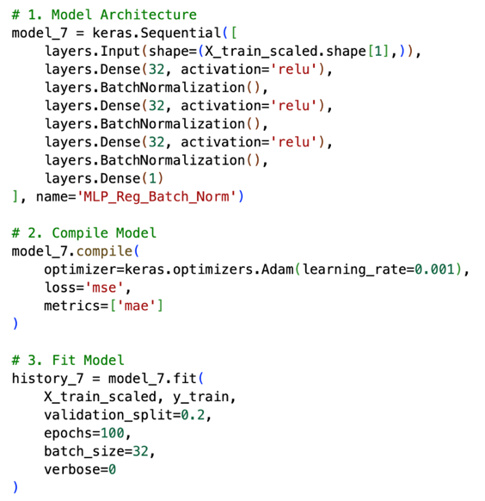
Model 7 (see architecture in Figure 2) is selected as the final model. It achieves the highest performance and is able to explain 88.7% of variations in house price (Table 2). Batch Normalization improved training stability, while still allowing for fast training time. On average, predictions are off by $70K (approximately by 15%), which is acceptable but the model would better serve as a tool for supporting decision-making rather than for exact valuation.
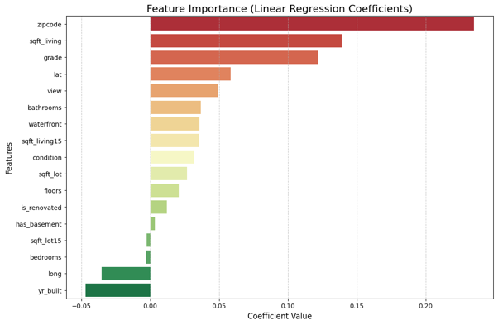
M7’s limitation is its weakness in valuating high-value properties, particularly those priced above $1.5M. This is because training data for such premium properties are limited, making the model is unable to fully capture what drives luxury pricing. If Housely deploys this model to valuate house prices, buyers and sellers relying on M7’s valuation face certain risks. For example, a house worth $1M but M7 underestimates it to worth only $930K means sellers listing the house for sale at $430K risk a 7% loss. Conversely, if M7 overestimates and buyers pay $1M for a house worth $930K, they overpay by 7%. Either way, clients (i.e. buyers, sellers, real estate agents, brokers) of Housely who uses M7’s wrong valuation will lose trust in the company’s consultancy. Additionally, the training data includes sales from 2014-2015. Over 11 years, market condition, interest rates and buyer preference have changed, meaning using M7 to valuate 2026 house prices can be misleading. However, given M7’s outstanding performance, fast training time and simplicity, it should still be deployed as Housely’s automatic valuation tool. It is recommended that Housely deploy M7 (i) mainly for standard properties, and manually review properties predicted above $1.5M; (ii) present predictions as a range (e.g. $930-950K); and (iii) retrain the model with updated data. Combined, M7 is a business asset that helps the Housely with more accurate valuation, allow for more frequent update with clients, more properties valued and ultimately more revenue.
Figure 2. Model 7 (M7) architecture.

Additionally, Linear Regression revealed that house prices are most driven by zip code, sqft_living and grade, suggesting that the most important factors driving house price are location, interior area, and condition of the house.

Reflection on GenAI Use
Claude was used throughout the process of experimenting with model hyperparameters. However, as it does not have access to the dataset, Claude constantly suggested overly complex architecture, for example, a MLP with 4 layers, hourglass design for width (128, 64, 128), a mix of tanh and ReLU for activation function, which broke the model and returned negative training R² = -0.8426 but postive test R² = 0.6338. Its RMSE ($493K) is 6 times larger than its MAE ($79K), meaning the broken model is actually accurate for standard houses, but it completely failed with luxury outliers in the training data. Claude also suggested new models that completely deviate from previous ones, which left me confused changing which hyperparameter actually helped improve model performance. Instead, I followed a structural, staircase approach, starting with a baseline model and gradually change one hyper-parameter at a time to arrive at the most reasonable experiment. Though M7 does not achieve high performance as one model Gemini randomly suggested, the experiment tells a logical, data-driven narrative for Housely.
Figure 3. Linear Regression feature importance.

Task 2 - Waste classification with image data
Executive Summary
Waste classification has gone from manual separation to smart bins and kiosks, and recent rise of image classification tasks has been a new direction to solve the waste classification problem (Yong et al, 2023). For EcoSort, automating this process will help reduce labor costs, but the question is how to achieve this with highest accuracy. Therefore, I propose a machine-learning approach to solve this issue, developing 10 neural networks (ANNs and CNNs) on a dataset of 2,862 real waste image with an aim to classify images into six waste categories — Cardboard, Glass, Metal, Paper, Plastic, and Vegetation. It is recommended that EcoSort deploy M10 – Fine-tuned MobileNetV2. Instead of building CNNs from scratch, M10 is a transfer learning model, leveraging ImageNet-pretrained visual features. M10 shows highest performance of all experimented models (82% accuracy), and was chosen because of its generalization ability and cheap computational costs. Its notable weakness is classifying Plastic, and M10 frequently mistakes Glass with Plastic, which leads to my recommendation for EcoSort – deploying M10 after training it with more Plastic images, and operate with human intervention when predictions’ confidence is below 0.75.
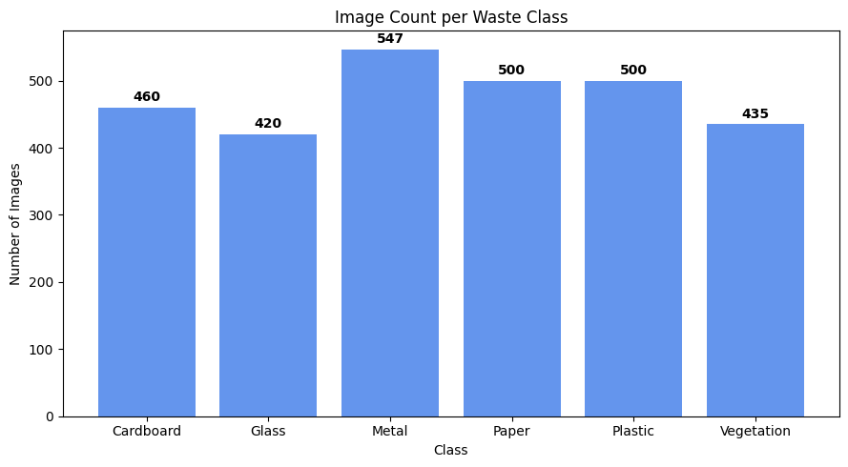
Data Exploration and Pre-processing
The dataset contained 2,862 images of 6 waste categories (Figure 4). Metal is the largest class (547 images) and Glass is the smallest (420 images) – a moderate imbalance that can cause the model to underperform. Manual inspection of images revealed several issues. For example, Metal cans and Plastic containers are easily mistaken due to their similar cylinder shapes, or Paper and Cardboard have similar texture (Figure 5). Additionally, background and lighting conditions differ across images. Combined, the dataset needs to undergo several pre-processing steps as follow.
Figure 4. Image count per waste class.
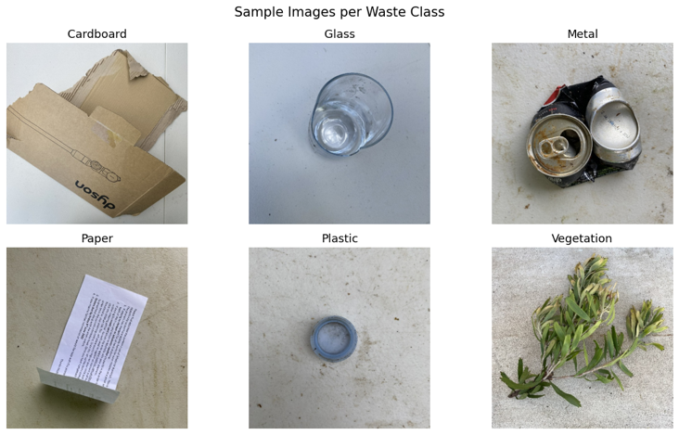
(i) Resizing images to 96x96 pixels. This balance between preserving enough spatial details for the model to recognize shapes and texture, while still ensure compatibility with Colab’s GPU. Experiment with 64x64 pixels were conducted but smaller image size over-smoothed the images and resulted in lower model performance.
(ii) Normalization. To scale input values into a stable range from 0 to 1, pixels were divided by 255. This prevents large magnitude causing gradient instability or slowing down convergence.
(iii) Train-test split. Images were split into 70% for training (2003 images) and 30% for testing (859 images) using stratified split, with a random seed of 42. This ensure reproducibility and prevent any waste class from being disproportionate between training and testing set.
Figure 5. Sample images per waste class.
(iv) Data augmentation. 2 ImageDataGenerator were designed – light augmentation for M1 – M6 and M8, and strong augmentation for M7. Light augmentation flipped the images horizontally and added a 15° rotation, adding diversity to the training dataset without distorting the images. Strong augmentation goes beyond this and add 20% zoom, ±20% brightness jitter, and small translation. Data augmentation aims to improve models’ ability to generalize to unseen data and prevent them from memorizing the training set.
(v) Scaling specific for M9 & M10. For M9 and M10, I used transfer learning – MobileNetV2, a light-weight convolutional neural network (CNN) designed by Google which has been pre-trained on 1.2M images from ImageNet and therefore, is capable of capturing edges and textures in waste images. These two transfer learning models require re-scaling the pixels from -1 to 1 range to match MobileNetV2 backbone. If [0,1] normalization mentioned above is applied, there will be a mismatch between training data and MobileNetV2’s frozen weights.

AI Model Development
10 models were developed, including 1 Multi-layer Perceptron (MLP) and 9 Convolutional Neural Networks (CNNs). The goal is to test whether CNN outperform ANN in classifying waste images. Each new CNN model differ from the previous by one dimension, creating an evidence-based chain from baseline to final solution (Table 3).
Model | Blocks | Filters per block | Kernel size | Layers per block | Pooling | Normalization | Dense layer | Opt + LRate | Augment-ation
M1 - ANN | 0 | — | — | — | — | — | Dense(128) → Dense(6) | Adam 1e-3 | Light
M2 - CNN | 1 | 32 | 3×3 | 1 | MaxPool 2×2 ×1 | — | Flatten → Dense(128) → Dense(6) | Adam 1e-3 | Light
M3 - CNN | 3 | 32 / 64 / 128 | 3×3 | 1 | MaxPool 2×2 ×3 | — | Flatten → Dense(256) → Dense(6) | Adam 1e-3 | Light
M4 - CNN | 3 | 32 / 64 / 128 | 3×3 | 1 | MaxPool 2×2 ×3 | Spatial Dropout (0.25) | Flatten → Dense(256) → Dense(6) | Adam 1e-3 | Light
M5 - CNN | 3 | 32 / 64 / 128 | 3×3 | 1 | MaxPool 2×2 ×3 | BatchNorm | Flatten → Dense(256) → Dense(6) | Adam 1e-3 | Light
M6 - CNN | 3 | 32 / 64 / 128 | 3×3 | 1 | MaxPool 2×2 ×3 | BatchNorm | GAP → Dense(128) → Dense(6) | Adam 1e-3 | Light
M7 - CNN | 3 | 32 / 64 / 128 | 3×3 | 1 | MaxPool 2×2 ×3 | BatchNorm | Flatten → Dense(256) → Dense(6) | Adam 1e-3 | Strong
M8 - CNN | 3 | 32 / 64 / 128 | 3×3 | 2 | MaxPool 2×2 ×3 | BatchNorm | Flatten → Dense(256) → Dense(6) | Adam 1e-3 | Light
M9 – MobileNetV2 | Freeze all weight of backbone |  |  |  | GAP (backbone) | Dropout (0.4 & 0.3) | GAP →  Dense(256) → Dense(128) → Dense(6) | Adam 1e-3 | Light
M10 - MobileNetV2 | Unfreeze last 30 layers of backbone |  |  |  | GAP (backbone) | Dropout (0.4 & 0.3) | GAP →  Dense(256) → Dense(128) → Dense(6) | Adam 1e-5 | Light
Table 3. AI model development (EcoSort waste classification task).
Experiment Report and Evaluation
Model | Architecture | Test Acc | Test Loss | Macro Precision | Macro Recall | Macro F1 | Decision
M1 — ANN |  | 0.4435 | 1.3772 | 0.4301 | 0.441 | 0.4165
M2 — CNN | 1 block (32) | 0.7113 | 0.8346 | 0.7199 | 0.7186 | 0.7141 | F1 increases, add more depth (3 blocks, x2 filters)
M3 — CNN | 3 blocks  (32, 64, 128) | 0.7637 | 0.6882 | 0.7726 | 0.7689 | 0.769 | F1 increases, experiment with Dropout
M4 — CNN | 3 blocks  (32, 64, 128)  Spatial Dropout | 0.759 | 0.6569 | 0.771 | 0.7645 | 0.7645 | F1 lower than M3, experiment with Batch Normalization
M5 — CNN | 3 blocks  (32, 64, 128) BatchNorm | 0.7858 | 0.6175 | 0.8036 | 0.7922 | 0.7889 | F1 higher than M3, keep BatchNorm, replace Flatten with GAP
M6 — CNN | 3 blocks  (32, 64, 128) BatchNorm + GAP | 0.7776 | 0.5819 | 0.7842 | 0.7834 | 0.7735 | F1 lower than M5, return to Flatten, add augmentation
M7 — CNN | 3 blocks  (32, 64, 128) BatchNorm +Augmentation | 0.2189 | 1.8066 | 0.1471 | 0.2008 | 0.1468 | Lowest F1, strong augmentation destroy the images, return to light augmentation, x2 layers per block
M8 — CNN | 3 blocks  (32, 64, 128)  2 layers/block BatchNorm | 0.8056 | 0.5359 | 0.8395 | 0.8086 | 0.816 | F1 increases, keep this architecture, experiment with transfer learning
M9 — Mobile  NetV2 | MobileNetV2  All weights frozen | 0.8126 | 0.5168 | 0.8338 | 0.8139 | 0.817 | Experiment unfreezing last 30 layers of MobileNetV2 to let model recognize specific waste visuals
M10 — Mobile  NetV2 | MobileNetV2 Fine-tuned, Unfreeze last 30 layers | 0.8161 | 0.4973 | 0.8262 | 0.8154 | 0.8182 | Best model
Table 4. AI model performance (EcoSort waste classification task).
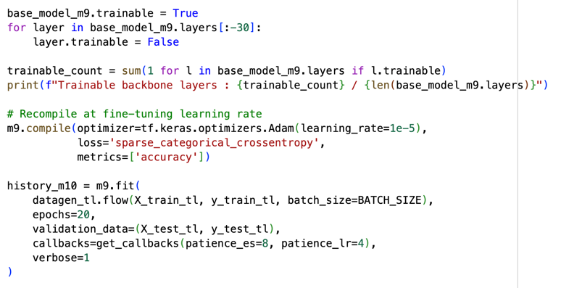
M10 – Fine-turned MobileNetV2 is selected as the best model with highest performance overall – Macro F1 (0.82) and test accuracy (81.6%). By first training the classification head in M9, and then fine-tuning the last 30 layers of MobileNetV2 in M10, M10 was able to adapt the pretrained visuals from ImageNet data to EcoSort’s waste image data. Compared to the best from-scratch CNN – M8 (Macro F1 = 0.81), M10 is chosen because of its better generalization from a pre-trained backbone, and lower computational costs (more lightweight than M8’s 5 million parameters).
Figure 6. Model 10 (M10) architecture.
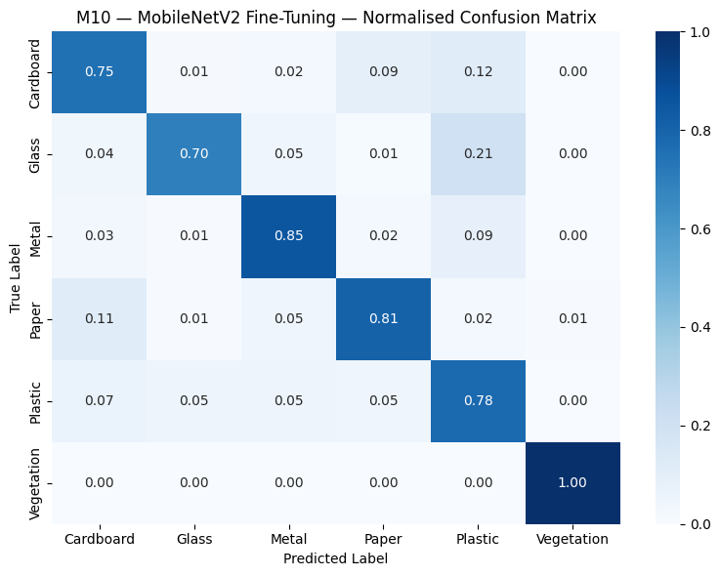
 | Precision | Recall | F1-score
Cardboard | 0.7376 | 0.7536 | 0.7455
Glass | 0.8800 | 0.6984 | 0.7788
Metal | 0.8537 | 0.8537 | 0.8537
Paper | 0.8288 | 0.8067 | 0.8176
Plastic | 0.6648 | 0.7800 | 0.7178
Vegetation | 0.9924 | 1.0000 | 0.9962
Table 5. M10 performance by class
M10 performs worst when recognizing Plastic images (lowest F1 0.72 (Table 5). Confusion matrix revealed that M10 mainly mistakes Plastic with Cardboard, which is an actual visual ambiguity (Figure 6). For example, under lighting condition, a glare on cardboard can make it look like plastic. Additionally, M10’s largest error is its incorrect identification of Glass as Plastic. Combined, plastic remain the most difficult waste to recognize as it can either be transparent film, opaque containers, or dark-coloured bottle. Another limitation of M10 is that it is trained on cleaned data, where input is a single waste item against simple background. When EcoSort deploys the model in sorting waste in real life, items can be wet, torn, crumbled or contaminated – conditions that M10 has not been exposed to. If M10 misclassify Plastic as Metal, metal recycling streams will be contaminated. Similarly, if it misclassify Glass as Cardboard, downstream pulping equipment will be damaged. However, the model should still be deployed for EcoSort’s automatic waste sorting system, given its 82% accuracy, fast training time and good generalization ability from MobileNetV2 backbone. To fully leverage M10 as a business asset, EcoSort should: (i) Increase training samples of Plastic images, including opaque, dark-coloured, and film-type plastics for diversity. (ii) Roll out M10 with human operator first, and immediately require human intervention if Maximum Softmax Probability (confidence of prediction) falls below 0.75.
Figure 7. M10 confusion matrix.
Reflection on GenAI Use
Claude was used to assist with model architecture experiment. However, as it does not have access to Colab live runtime, its staircase architecture suggestions were not based on actual experiment results. For example, Dropout returns lower F1 than BatchNormalization, but Claude’s suggestions for M6 onwards all included Dropout. To make sure architecture changes are logical, I documented results and decided which hyper-parameters to change before asking Claude to write the codes.

References
Kok, N., Koponen, E.-L., & Martínez-Barbosa, C. A. (2017). Big Data in Real Estate? From Manual Appraisal to Automated Valuation. The Journal of Portfolio Management, 43(6), 202–211. https://doi.org/10.3905/jpm.2017.43.6.202
Yong, L., Ma, L., Sun, D., & Du, L. (2023). Application of MobileNetV2 to waste classification. 18(3), e0282336–e0282336. https://doi.org/10.1371/journal.pone.0282336

