This report is Ngoc Anh (Rachel) Phung’s work as part of MIS373 – Aritificial Intelligence for Business.

Executive Summary

Airbnb is an online peer-to-peer (P2P) marketplace that connect property owners with travellers, allowing hosts to rent out their properties to guests. It has been considered as the most successful sharing economy business model in the lodging sector (Ding et al, 2020). Australia is among the top countries with the highest number of active Airbnb listing – in 2016, Airbnb is the most common website for booking private accommodation in Australia with 426,000 users (Volgger et al, 2019). For Airbnb business model, guest satisfaction is the core, as it directly increase booking and drive sales for hosts and platform managers. However, a rich source of business intelligence from guest reviews is underutilized; and if used to full capacity, guest reviews can identify dissatisfaction risks and inform hosts and platform managers of strategy. This report analyzes 100,000 guest reviews of Airbnb in Victoria and aim to answer three questions:
1. In the most popular neighborhoods, which area deliver the highest and lowest guest satisfaction?
2. What aspects of guest experience most strongly influence guest dissatisfaction?
3. What are the most discussed topics across different accommodation types?

This report analyzes 2 datasets – Listings (information about the properties) and Reviews (reviews of guest experience at the properties), and three different approaches were used to address the questions. In Section 1, Lexicon-based Sentiment Analysis using VADER was used to quantify overall guest satisfaction at neighbourhood level. VADER was used because of its suitability to informal, social media-generated texts. Among the 10 most popular neighbourhoods in Victoria, Yarra Ranges delivers the highest overall guest satisfaction; while Monash recorded the lowest (Figure 1). In Section 2, Aspect-based Sentiment Analysis (ABSA) was used to identify which aspects of the guest experience are most represented in negative reviews. It reveals listing accuracy, security, facilities, value for money and cleanliness as the five aspects appearing most frequently in negative reviews relative to all reviews (Figure 3). In Section 3, topic modelling was applied to all 100,000 reviews to extract the most common topics dicussed by guests. Our Latent Dirichlet Allocation (LDA) model revealed three main themes – Overall Postive Experience, Host & Check-in, and Location & Transit (Figure 5). Comparison reveals that private room guests are more concerned with Host & Check-in than guests who rent the entire property, a difference that could be explained by the nature of accommodation types (Figure 7).

Based on these findings, three recommendations are made for Airbnb hosts. First, hosts in the city of Monash where overall satisfaction is lowest should utilize Monash University’s location and target short-term accommodation for university students. Second, hosts should improve all aspects driving dissatisfaction, i.e. provide accurate description and photos of properties, strengthen door locks, renew facilities and regularly clean properties. To maximize profit, guests can put their property at lower price when first listing it on Airbnb before charging higher prices over time. Third, since host relationship, arrival support and transportation are key topics discussed in guest reviews, I recommend giving guests discount or free airport pickup service, and pre-loaded Myki cards to help guests with getting around the city. Collectively, these recommendations aims to address the pain points causing dissatisfaction, while also improving the general, already-satisfied aspect of guest experience. Anticipated benefits from implementing three recommendations include identifying and solving the core problems in not only in Monash but in all Victoria neighborhoods, therefore improving guest satisfaction, increase number of booking and drive sales for hosts and Airbnb platform managers.

Among the 10 most popular Airbnb neighbourhoods in Victoria, which neighbourhoods show the highest and lowest levels of overall guest satisfaction based on review sentiment?

The “popularity of a neighborhood” is measured by how many reviews all properties within that specific neighborhood gets. Rather than counting number of listings which only capture the booking volume, total number of reviews is more inclusive, capturing both booking volume and guest engagement – before a property gets reviewed, it needs to be booked by customers in the first place. Building upon this definition, 10 most popular neighborhoods are identified by aggregating count of reviews across neighborhoods from the Listings dataset. Afterwards, listing ID is used to merge Listings with Reviews, which returns a new data frame where each review is mapped to its corresponding property and neighborhood. In 10 most popular neighborhoods, I examine a total of 52667 reviews for 18100 properties. 3 columns in Listings with no values, i.e. Neighborhood group, Price and License, were removed to reduce dimensionality of the dataset.

To evaluate “overall guest satisfaction” of a property, I present a Lexicon-Based approach of extracting sentiment from each review, determining the polarity (i.e. positive, negative or neutral) of each review by the semantic orientation of words and phrases (Taboada et al, 2011). Compared to a Text Classification approach (essentially used for supervised classification tasks), Lexicon-based approach is more suitable in this case, since the reviews in the dataset are unlabeled (eg. positive or negative). VADER (Valence Aware Dictionary and sEntiment Reasoner)’s proven sensitivity to sentiment expressions in social media texts (Hutto & Gilbert, 2015) justifies itself as the optimal tool for this task, where Airbnb review texts are user-generated and informal. Due to VADER’s ability to capture nuances (e.g. capitalization, emojis) in text data, no preprocessing has been applied to Reviews apart from removing rows with missing comment. VADER returns the compound score for each review, and in this case, “overall guest satisfaction” of a neighborhood is the average compound score of all reviews given to all properties in that neighborhood (Figure 1).

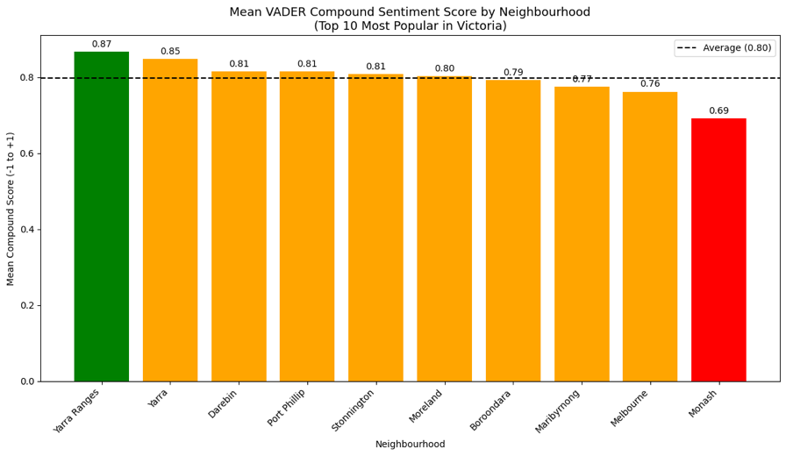
Yarra Ranges has the highest overall satisfaction, while Monash has the lowest. Generally speaking, Melbourne CBD and Monash have lower guest satisfaction than outer suburbs, despite their ideal location. Counter-intuitive as it may seems, this paradox is explained by the Expectancy-Disconfirmation Theory (EDT), which establishes that satisfaction is determined by how much the actual experience matches expectations (Oliver, 1980), rather than by absolute quality. City guests arrive with high expectations, but can be upset with noise or prices which worsen the experience. Statistically, the total number of reviews for Melbourne was 23,300, compared to other suburbs with only 1000 – 7000 reviews. This imbalance also dilutes the sentiment score for Melbourne.
Figure 1. Average VADER compound score of 10 most popular neighbourhoods.
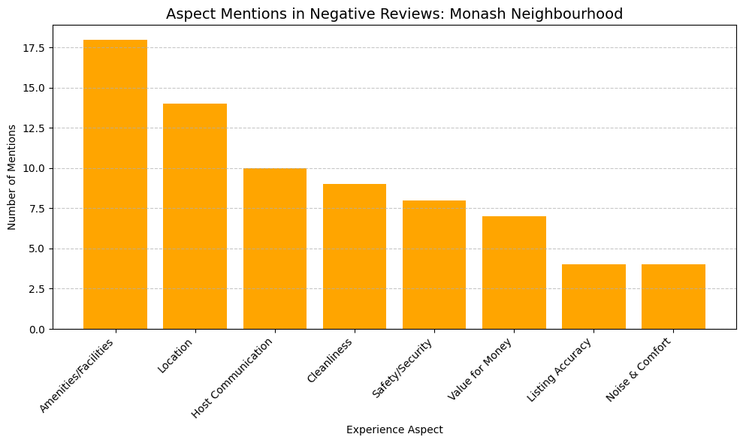

Aspect-level Sentiment Analysis (see Question B) were conducted to examine the key factors driving Monash’s lowest guest satisfaction. In all negative reviews for Monash, guests were particularly concerned about the properties’ amenities and facilities (Figure 2). In reality, Monash is not a tourist hub, compared to Yarra Ranges’ nature or Port Phillip’s St Kilda beach. The area is commonly known for Monash University infrastructure and medical centers; its lack of leisure identity further explains its lowest compound score.

This lead to a recommendation for hosts of properties in Monash – exploiting the neighborhood’s utility identity and target short-term accommodation for university students. Facilities need to be tackled, e.g by upgrading to high-speed Wi-Fi for Internet browsing, purchasing new study desks, etc. Listing on Airbnb should also be modified to reach the target customer, e.g. “Quiet, fully-furnished room, 5-minute walk from Monash University”.
Figure 2. Aspects in Monash properties' negative reviews.

What aspects of the Airbnb guest experience are most strongly associated with guest dissatisfaction in Victoria, and why are these aspects likely to generate negative experiences?

To evaluate guest satisfaction in entire Victoria, a similar VADER Sentiment Analysis approach has been used on the entire Reviews dataset, determining the polarity (positive, negative or neutral) for each comment. In particular, “guest dissatisfaction” is measured by negative, dissatisfied comments, i.e. comments with VADER compound score less than or equal to -0.05, a standard threshold. Out of all 99,985 reviews, 1,691 reviews (1.7%) were classified as negative and used for further analysis.

I aim to understand “aspects of guest experience” most associated with guest dissatisfaction, i.e. most common problems mentioned in negative comments, using Aspect-Based Sentiment Analysis (ABSA) – a subset of Sentiment Analysis that extracts aspect terms and assign sentiment to each of these aspects (Vassilikopoulou et al, 2024). The first stage of ABSA requires Aspect Terms Extraction (ATE) – in this case, determining several problems concerned by Airbnb guests. Common methods for ATE include supervised learning, unsupervised/rule-based and hybrid approach; though for the simplicity of this task, 8 key aspects were identified – location; cleanliness; amenities/facilities; value for money; host communication; noise and comfort; listing accuracy; and safety and security. Aspects were chosen considering domain knowledge and the P2PSERVQUAL model, a model to evaluate experience of peer-to-peer accommodation like AirBnb (Wong & Chan, 2023). After 8 aspects have been determined, each was defined by a set of keywords, e.g. keywords for “cleanliness” include “clean”, “dirty”, “dust”, etc. Keywords are common Airbnb review language, supported by results from Sutherland & Kiatkawsin’s research (2020). Once negative reviews have been filtered out using VADER, keyword matching identifies which aspect is mentioned in each complaining review. Here, instead of using raw counts of mentions alone, I calculated dissatisfaction ratio, i,e frequency of aspect mentioned in negative reviews out of all reviews; results are in Figure 3.

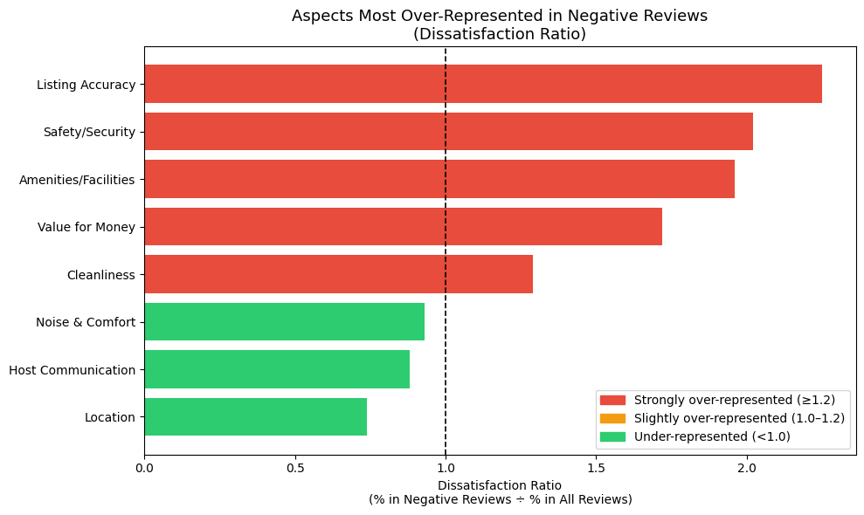
Figure 3. Dissatisfaction ratio of 8 aspects of guest experience.
5 most prevalent aspects in negative reviews include listing accuracy; safety and security; amenities and facilities; value for money; and cleanliness. Listing accuracy and Amenities & Facilities can again be explained by Oliver’s Expectancy-Disconfirmation Theory (EDT) (1980) – dissatisfaction is caused when reality does not match guests’ expectations, i.e. actual Airbnb properties appear different from online edited photos, or one sample complaint “Not a big fan of the small boiler for hot water shower, future stays with more than 1 guest should take note of that.” Safety & Security and Cleanliness are basic human needs according to Maslow’s five-tier pyramid, thus when a property appears unsafe with light door locks or smells unpleasant, guests will undeniably feel disappointed. In terms of economic value, Carnehl et al (2025) found that higher prices are associated with lower ratings (lower satisfaction) due to lower value for money – same property quality but higher prices.

To enhance guests’ satisfaction, recommendations for Airbnb hosts include (i) frequently updating property description with actual, lightly edited photos; (ii) upgrade and regularly monitor high-use amenities like kitchen, toilet, mattress, door look, etc to ensure quality, cleanliness and safety for guests. In terms of profit maximization, hosts are advised to list their property at lower prices when first entering the Airbnb market, which helps receive better ratings and more booking, before gradually charging higher prices in later periods (Carnehl et al, 2025).

It is also critical to acknowledge a drawback of keyword-based ABSA – the predefined keyword list might not be exhaustive and is unable to capture all negation, e.g. “not dirty”. However, the approach still proves itself as reliable, considering the straight-forward, interpretable results, and no complex training data required.

What are the main topics discussed in Airbnb guest reviews in Victoria? How does the prevalence of these topics vary between the two most popular room types in the dataset, and what do these differences suggest about guest expectations and experiences?

To discover the most common topics in Airbnb guest reviews in Victoria, I present a Topic Modelling approach that uncovers themes from text documents. Techniques for Topic Modelling include Latent Dirichlet Allocation (LDA) proposed by Blei, Ng & Jordan (2003); structural topic model (STM) by Roberts et al (2014); and dynamic topic model (DTM) by Blei and Lafferty (2006). LDA has been chosen for this task due to its interpretability of topics and proven effectiveness in consumer research, particularly for Airbnb reviews. Unlike VADER which is a lexicon-based tool, LDA relies on word count to discover topics. Therefore, several preprocessing steps were made to the entire Reviews dataset, including removing punctuation, numbers, short words, stop words, and words that appear very frequently (in over 20% of reviews) and very rarely (less than 0.5%) which carry little semantic value for topic modelling. After cleaning, 486 terms were identified in 99,985 reviews and used to train the LDA model.
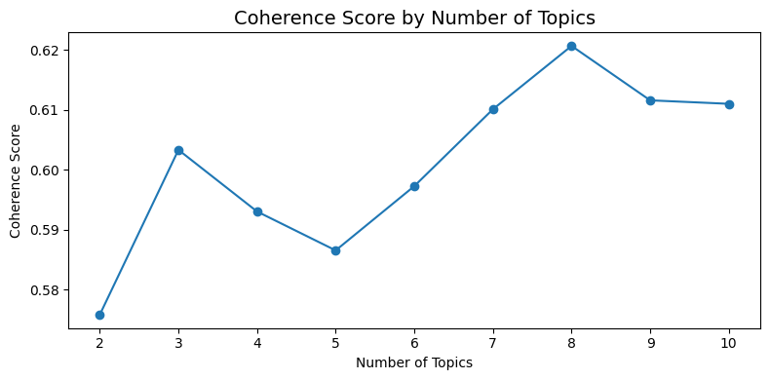
Figure 4. LDA's coherence score by number of topics.
To identify the optimal number of topics (k), different LDA models were trained with topic number ranging from 2 to 10, each evaluated by a coherence score, which shows how related top words in a topic are (Figure 4). Though k=8 gives the highest coherence score (0.62), the output is 8 topics with some overlaps in content. Therefore, to ensure interpretability while saving computational resources, k=3 (coherence = 0.60) was chosen as the final number of topics. LDA returns three major topics in Victoria Airbnb reviews (Figure 5).

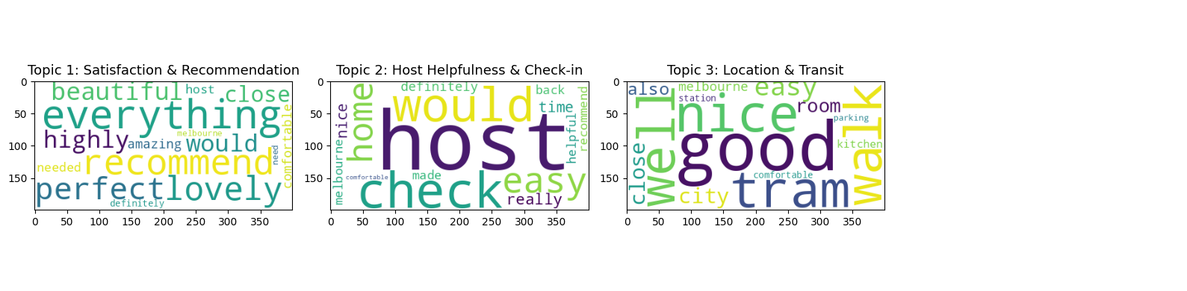
Figure 5. Main topics in all reviews.

(i) Overall Satisfaction and Recommendation – dominated by positive adjectives suggesting recommendation.
(ii) Host Helpfulness & Check-in Process – communication with host and arrivals.
(iii) Location and Transit – surroundings and travelling around (e.g. to city via tram).

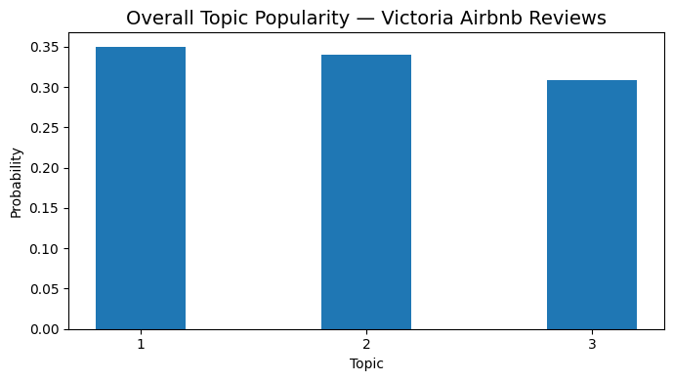
Though topic 1 (Overall Satisfaction and Recommendation) is not about a specific feature but rather about the general rating of the stay, topics 2 (Host Helpfulness & Check-in Process) and 3 (Location and Transit) are actual aspects of guest experience that could provide valuable insights for hosts. In Question B, a P2PSERVQUAL model (Wong & Chan, 2023) was used to pre-determine some aspects to evaluate Airbnb experience. This model is developed based on the original SERVQUAL model and modified to suit P2P (peer-to-peer) accommodation like Airbnb. P2PSERVQUAL defines 7 dimensions of P2P service quality - tangibles (home facilities), personal advice, helpfulness, feeling welcome, responsiveness, reliability, and caring. My findings map directly to P2PSERVQUAL’s responsiveness and helpfulness (topic 2 - Host Helpfulness & Check-in Process) and tangibles (topic 3 - Location and Transit). These two topics are also the two aspects with lowest dissatisfaction ratios (Figure 3). A fairly equal distribution of topics suggests that guests are equally concerned with all three topics, meaning that relying solely on one factor is insufficient (Figure 6). To ensure satisfaction, hosts should balance between being communication with guests and spatial convenience.
Figure 6. Distribution of topics.
For further analysis, I aim to explore how the distribution of these three topics varies by room types. The “most popular room types” are room types with the highest total number of reviews from the Listings dataset; this aligns with the definition of “most popular neighborhoods” in Question A. Afterwards, Reviews were merged with Listings using listing ID, and reviews for properties being either Entire home/apartment or Private room (2 most popular room types) were filtered out. I analyzed 63249 reviews in total, 54463 (86%) of which were Entire home/apartments and 8786 (14%) were Private rooms.

Using the same LDA model previously developed, I mapped both Entire home/apartments and Private rooms onto the already-trained model and represent both groups using the same three topic definitions – Overall Satisfaction and Recommendation; Host Helpfulness & Check-in Process; and Location and Transit (Figure 7).

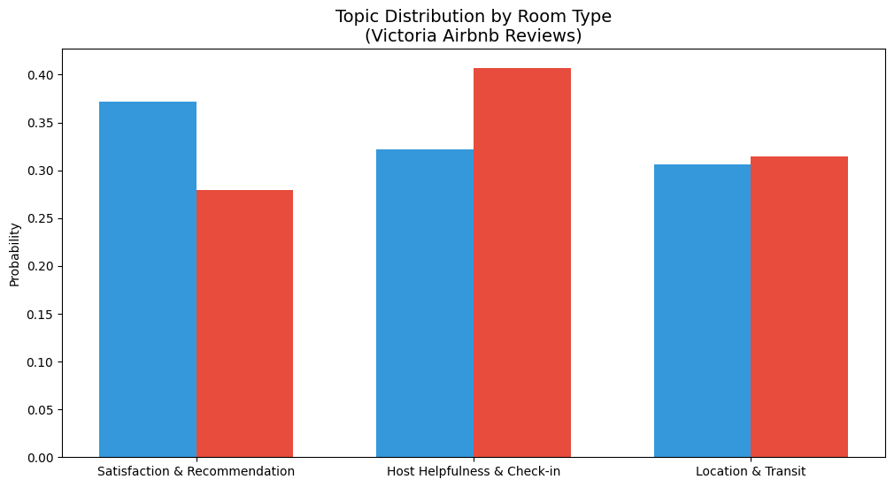
Figure 7. Topic distribution by room type.
The largest differences between 2 room types lie in topic 2 – Host Communication and Check-in Process. This can be explained by the nature of Airbnb arrangement. Guests renting an entire home or apartment uses the property independently with little to no communication with hosts. Therefore, host responsiveness and arrival help appear less frequently in reviews given to this type of property. On the other hand, guests occupying a private room concerns more about this topic, as they directly share the property with their host, making host communication a key element of the stay. Therefore, guests choosing a private room expect helpfulness from the hosts and smooth check-in, while guests choosing entire property generally seeks independence. Topic 3 – Location and Transit generally does not differ between two room types, suggesting that convenience of transport and surrounding amenities are important in guest experience regardless of room types. For topic 1 - Overall Satisfaction and Recommendation, no meaningful inference can be made since the topic is not a specific feature; and the difference in topic distribution is mainly caused by the imbalance between number of properties (86% are Entire home/apartments and 14% are Private rooms).

This lead to a final recommendation for Airbnb host. Since guests are primarily concerned with location and transit (topic 3), particularly convenience to public transport (trams to Melboune CBD) and closeby amenities, hosts in faraway locations are at a disadvantage. I recommend creating a welcome basket with pre-loaded Myki cards or free airport pickup, which will help guests feel more welcomed upon arrival and less worried when first getting around using public transport. This will also increase host professionalism and interactions with guests, the second most common topic mentioned in all reviews.

References

Blei, D. M., Ng, A. Y., & Jordan, M. I. (2003). Latent Dirichlet Allocation. Journal of Machine Learning Research, 3(Jan), 993–1022. https://www.jmlr.org/papers/volume3/blei03a/blei03a.pdf

Carnehl, C., Schaefer, M., Stenzel, A., & Tran, K. D. (2022). Value for money and selection: How pricing affects Airbnb ratings (Working Paper). SSRN. https://doi.org/10.2139/ssrn.4207034

Ding, K., Choo, W. C., Ng, K. Y., Ng, S. I., & Song, P. (2021). Exploring sources of satisfaction and dissatisfaction in Airbnb accommodation using unsupervised and supervised topic modeling. Frontiers in Psychology, 12, 659481. https://doi.org/10.3389/fpsyg.2021.659481

Ding, K., Niu, Y., & Choo, W. C. (2023). The evolution of Airbnb research: A systematic literature review using structural topic modeling. Heliyon, 9(7), e17090. https://doi.org/10.1016/j.heliyon.2023.e17090

Hutto, C. J., & Gilbert, E. (2014). VADER: A parsimonious rule-based model for sentiment analysis of social media text. In Proceedings of the Eighth International AAAI Conference on Weblogs and Social Media (pp. 216–225). AAAI Press.

Oliver, R. L. (1980). A cognitive model of the antecedents and consequences of satisfaction decisions. Journal of Marketing Research, 17(4), 460–469. https://doi.org/10.1177/002224378001700405

Sutherland, I., & Kiatkawsin, K. (2020). Determinants of guest experience in Airbnb: A topic modeling approach using LDA. Sustainability, 12(8), 3402. https://doi.org/10.3390/su12083402

Taboada, M., Brooke, J., Tofiloski, M., Voll, K., & Stede, M. (2011). Lexicon-based methods for sentiment analysis. Computational Linguistics, 37(1), 267–307. https://doi.org/10.1162/COLI_a_00049

Vassilikopoulou, A., Kamenidou, I., & Priporas, C. V. (2022). Negative Airbnb reviews: An aspect-based sentiment analysis approach. EuroMed Journal of Business, 19(2), 191–207. https://doi.org/10.1108/EMJB-03-2022-0052

Volgger, M., Taplin, R., & Pforr, C. (2019). The evolution of “Airbnb-tourism”: Demand-side dynamics around international use of peer-to-peer accommodation in Australia. Annals of Tourism Research, 75, 322–337. https://doi.org/10.1016/j.annals.2019.02.007

