UNIVERSITY OF INFORMATION TECHNOLOGY

FACULTY OF COMPUTER NETWORK AND COMMUNICATION

**REPORT**

Subject: Cryptography

Semester II (2023 – 2024)

**Report Lab 3**

Student: Võ Ngọc Bảo

Student ID Number: 22520127

Class: NT219.O22.ANTT

University of Information Technology

Lecturer: Nguyễn Ngọc Tự

**Hồ Chí Minh City, June 2024**

Report Lab 3

**Student Information**

Full Name: Võ Ngọc Bảo

Student ID Number: 22520127

Class: ATTT2022.1

**Device Information**

CPU: AMD Ryzen 5 5600H 3.30 GHz

Ram: 8 GB DDR4 3200MHz

SSD PCle: 512GB

**AES Encrypt (Window):**

**AES Decrypt (Window):**

**AES Encrypt (Linux):**

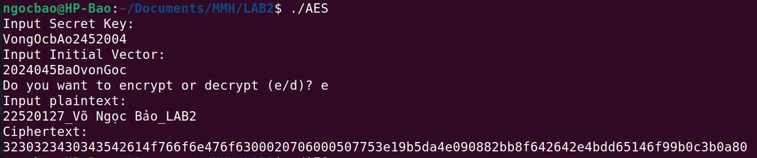

**AES Decrypt (Linux):**

