1. WITHDRAW_MONEY Use Case Description: Main Flow

|  |  |
| --- | --- |
| User Action | System Response |
| 1. User types in PIN into main screen | 1. System checks validity of PIN and presents options to user on another screen |
| 1. User selects “Withdraw Money” option | 1. System displays account options such as Checking, Saving. |
| 1. User selects the type to withdraw money | 3 System shows an alert with textbox for user input the amount |
| 1. User inputs the amount to withdrawal | 4 System checks account balance to ensure sufficient funds |
| 1. User confirms the transaction | 5 System processes the transaction and give money to user with correct amount |
| 1. User takes money to machine | 1. System updates the account balance and print a receipt |
| 1. User takes the receipt and card | 1. System returns to the main screen |

1. 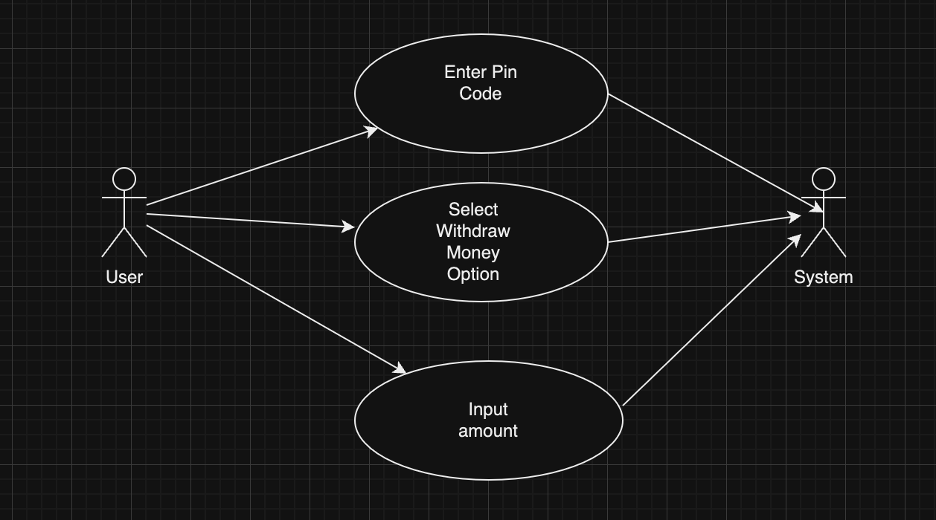
2. 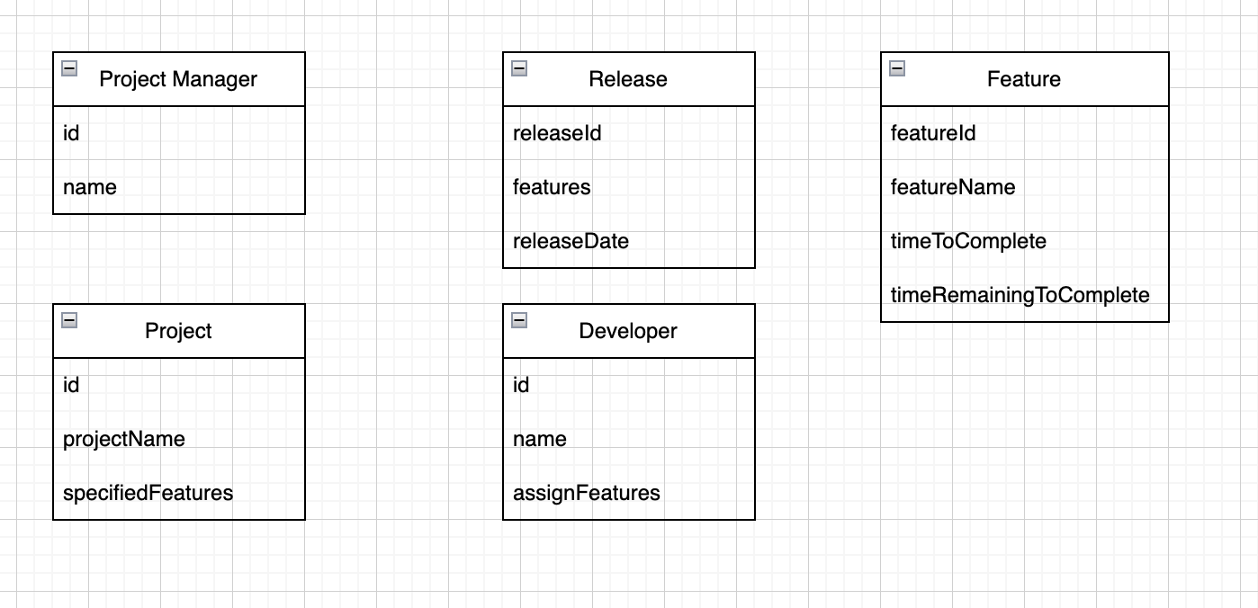
3. 