Pizza Website

Team 4

*Dang, Thanh Ngoc, t_dang88498*

*Kim, Michung, m_kim86292 -*

*Peres Dos Santos, Francisco Diego, f_peresdossantos*

*Quirino Dos Santos, Tiago, t_quirinodossantos*

*Siefert, Arin, a_siefert*

*Valiente, Andrew C, a_valiente*

# Purpose

This design will shortly explain the implementation of the requirements as group project in LAMP course. And this project is divided into two parts, being the first one built for database and the second one for the application.

# Overview

This project, pizza website has been developed on PHP and MySQL. The main objective for this project is to allow the customers to order pizza online. This project foresees the use of forms to allow the customer to select pizza toppings when placing their order online. Also, the customers can place an order online and pay on delivery.

This application will provide some features to manage customers’ orders. For example, when the customer chooses a type of pizza and toppings for the first time, the system will store that data and those data can be used in the next order, making the next order easier and convenient for that customer.

Throughout the order processing the order status will be updated and the customer will be notified. New orders will show up in a list for the employees in the kitchen, so the goal is to make the application easily operating for the kitchen.

# Project Team

|  |  |
| --- | --- |
| **Member** | **ID** |
| Dang, **Thanh Ngoc** | t_dang88498 |
| Kim, **Michung** | m_kim86292 |
| Peres Dos Santos, **Francisco Diego** | f_peresdossantos |
| Quirino Dos Santos, **Tiago** | t_quirinodossantos |
| Siefert, **Arin** | a_siefert |
| Valiente, **Andrew C** | a_valiente |

# Phases

This project was divided into 6 phases to be able to execute the 9 tasks (questions) that are brought with the requirements. At the end of these 6 phases, our team will be responsible for delivering the two parts that contemplate the project.

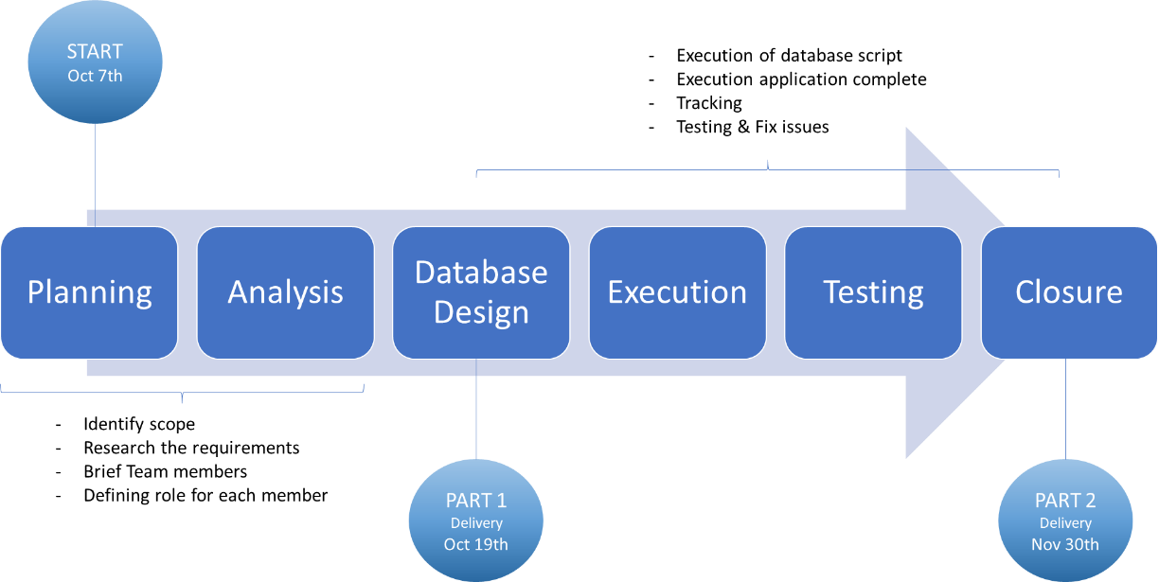

# System Environment

1. List

|  |  |  |
| --- | --- | --- |
| Software | VMware Workstation Pro, Ubuntu VM | |
| OS | **Linux (Ubuntu 18.04)** |
| Web Server | **Apache2** |
| Database | **MySQL** |
| Language | **PHP, HTML, CSS** |

1. Design

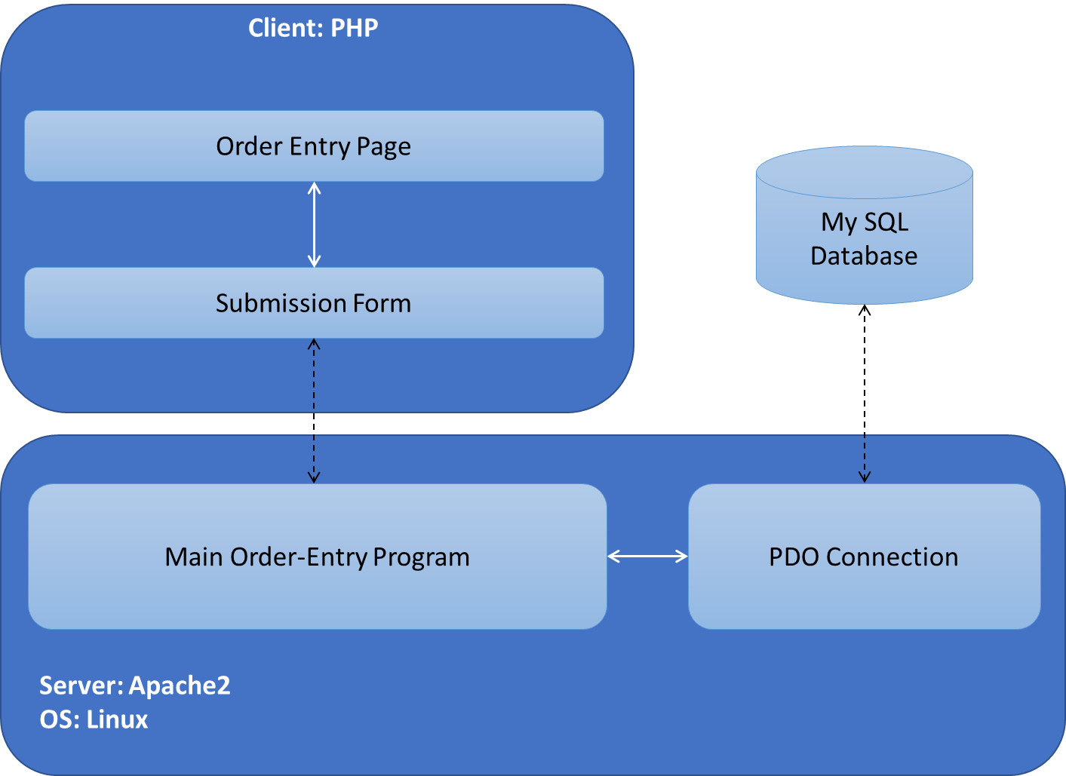

# Functionality

1. This application is built in PHP in order to order pizza online.
2. Information related to the order and customers will be stored in MySQL database.
3. Then create a welcome page on index.php, and receive new email information from new customers, or use stored information previously, the order is started to the start button.
4. There will be a file (common.php) linked to the database.
5. There will be a navigation menu, user friendly, also a php file that will be responsible to manage the order placing data and customer data.
6. Form is created to allow customers to order one pizza or several pizzas. And make options for each pizza with a radio button or a select box, and then makes delivery available when completed.
7. The email database which is previously made is used. And until submission is properly advanced, this process continues.
8. The summary content of the pizza order is made so that users can see.
9. Create a web page that shows user details previously ordered. And the saved email database is used.

# Database

