Bài tập nhóm 8:

**TẠO ẢNH PANORAMA**

Sinh viên:

NGUYỄN NGỌC ĐĂNG KHOA 1611625

VŨ KIẾN THIẾT 1637031

**Code**

|  |
| --- |
| # import the necessary packages  import numpy as np  import imutils  import cv2    class Stitcher:  def __init__(self):  # determine if we are using OpenCV v3.X  self.isv3 = imutils.is_cv3(or_better=True)  def stitch(self, images, ratio=0.75, reprojThresh=4.0,  showMatches=False):  # unpack the images, then detect keypoints and extract  # local invariant descriptors from them  (imageB, imageA) = images  (kpsA, featuresA) = self.detectAndDescribe(imageA)  (kpsB, featuresB) = self.detectAndDescribe(imageB)  # match features between the two images  M = self.matchKeypoints(kpsA, kpsB,  featuresA, featuresB, ratio, reprojThresh)  # if the match is None, then there aren't enough matched  # keypoints to create a panorama  if M is None:  return None  # otherwise, apply a perspective warp to stitch the images  # together  (matches, H, status) = M  result = cv2.warpPerspective(imageA, H,  (imageA.shape[1] + imageB.shape[1], imageA.shape[0]))  result[0:imageB.shape[0], 0:imageB.shape[1]] = imageB    # check to see if the keypoint matches should be visualized  if showMatches:  vis = self.drawMatches(imageA, imageB, kpsA, kpsB, matches,  status)    # return a tuple of the stitched image and the  # visualization  return (result, vis)    # return the stitched image  return result  def detectAndDescribe(self, image):  # convert the image to grayscale  gray = cv2.cvtColor(image, cv2.COLOR_BGR2GRAY)  # check to see if we are using OpenCV 3.X  if self.isv3:  # detect and extract features from the image  descriptor = cv2.xfeatures2d.SIFT_create()  (kps, features) = descriptor.detectAndCompute(image, None)  # otherwise, we are using OpenCV 2.4.X  else:  # detect keypoints in the image  detector = cv2.FeatureDetector_create("SIFT")  kps = detector.detect(gray)  # extract features from the image  extractor = cv2.DescriptorExtractor_create("SIFT")  (kps, features) = extractor.compute(gray, kps)  # convert the keypoints from KeyPoint objects to NumPy  # arrays  kps = np.float32([kp.pt for kp in kps])  # return a tuple of keypoints and features  return (kps, features)  def detectAndDescribe(self, image):  # convert the image to grayscale  gray = cv2.cvtColor(image, cv2.COLOR_BGR2GRAY)  # check to see if we are using OpenCV 3.X  if self.isv3:  # detect and extract features from the image  descriptor = cv2.xfeatures2d.SIFT_create()  (kps, features) = descriptor.detectAndCompute(image, None)  # otherwise, we are using OpenCV 2.4.X  else:  # detect keypoints in the image  detector = cv2.FeatureDetector_create("SIFT")  kps = detector.detect(gray)  # extract features from the image  extractor = cv2.DescriptorExtractor_create("SIFT")  (kps, features) = extractor.compute(gray, kps)  # convert the keypoints from KeyPoint objects to NumPy  # arrays  kps = np.float32([kp.pt for kp in kps])  # return a tuple of keypoints and features  return (kps, features)  def matchKeypoints(self, kpsA, kpsB, featuresA, featuresB,  ratio, reprojThresh):  # compute the raw matches and initialize the list of actual  # matches  matcher = cv2.DescriptorMatcher_create("BruteForce")  rawMatches = matcher.knnMatch(featuresA, featuresB, 2)  matches = []  # loop over the raw matches  for m in rawMatches:  # ensure the distance is within a certain ratio of each  # other (i.e. Lowe's ratio test)  if len(m) == 2 and m[0].distance < m[1].distance * ratio:  matches.append((m[0].trainIdx, m[0].queryIdx))  # computing a homography requires at least 4 matches  if len(matches) > 4:  # construct the two sets of points  ptsA = np.float32([kpsA[i] for (_, i) in matches])  ptsB = np.float32([kpsB[i] for (i, _) in matches])    # compute the homography between the two sets of points  (H, status) = cv2.findHomography(ptsA, ptsB, cv2.RANSAC,  reprojThresh)    # return the matches along with the homograpy matrix  # and status of each matched point  return (matches, H, status)    # otherwise, no homograpy could be computed  return None  def drawMatches(self, imageA, imageB, kpsA, kpsB, matches, status):  # initialize the output visualization image  (hA, wA) = imageA.shape[:2]  (hB, wB) = imageB.shape[:2]  vis = np.zeros((max(hA, hB), wA + wB, 3), dtype="uint8")  vis[0:hA, 0:wA] = imageA  vis[0:hB, wA:] = imageB    # loop over the matches  for ((trainIdx, queryIdx), s) in zip(matches, status):  # only process the match if the keypoint was successfully  # matched  if s == 1:  # draw the match  ptA = (int(kpsA[queryIdx][0]), int(kpsA[queryIdx][1]))  ptB = (int(kpsB[trainIdx][0]) + wA, int(kpsB[trainIdx][1]))  cv2.line(vis, ptA, ptB, (0, 255, 0), 1)    # return the visualization  return vis    # load the two images and resize them to have a width of 400 pixels  # (for faster processing)  imageA = cv2.imread("im1.jpg")  imageB = cv2.imread("im2.jpg")  imageC = cv2.imread("im3.jpg")  # stitch the images together to create a panorama  stitcher = Stitcher()  (result, visAB) = stitcher.stitch([imageA, imageB], showMatches=True)  (x,y,w,h) = (0,0,375,228)  result = result[y:y+h,x:x+w]  (result, visABC) = stitcher.stitch([result, imageC], showMatches=True)  (x,y,w,h) = (0,10,555,210)  cropped_im = result[y:y+h,x:x+w]  # show the images  cv2.imshow("Image A", imageA)  cv2.imshow("Image B", imageB)  cv2.imshow("Image C", imageC)  cv2.imshow("Keypoint Matches 12", visAB)  cv2.imshow("Keypoint Matches 123", visABC)  cv2.imshow("Result",result)  cv2.imshow("Cropping",cropped_im)  cv2.waitKey(0)  cv2.imwrite('output.jpg',cropped_im) |

**Kết quả:**

Các ảnh đầu vào:

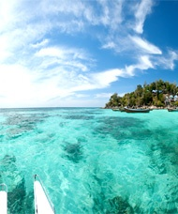

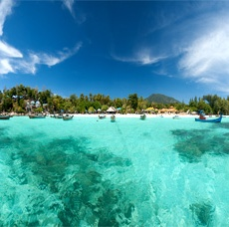

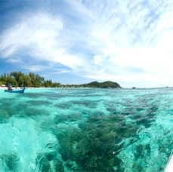

**Sau khi ghép:**

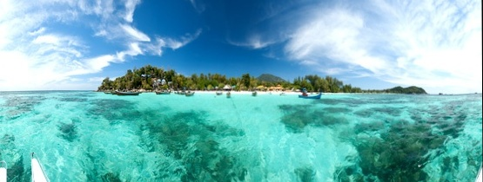

**Kết quả chạy chương trình:**

