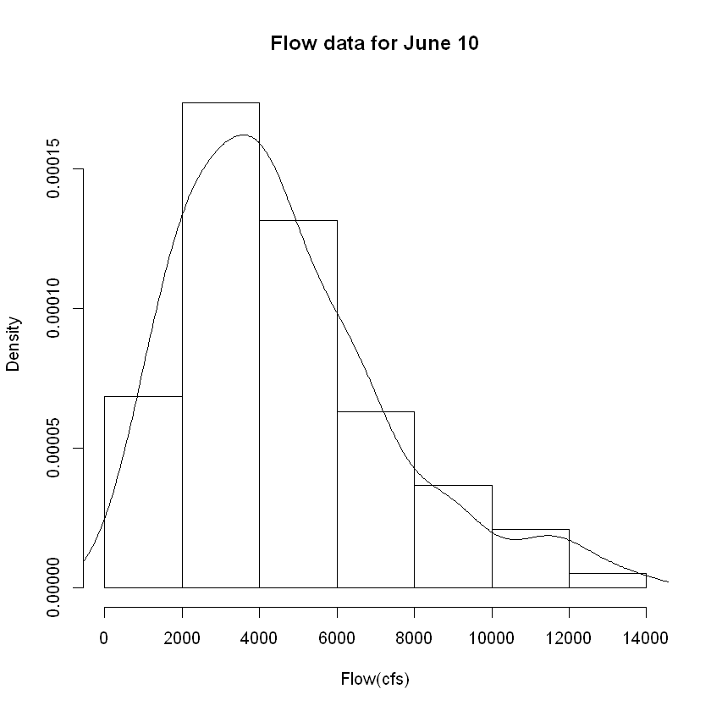

* The histogram seems to be from a Gamma model, with a long tail on the right.
* Min value is 550; max value = 13400,