Lab 5: Titanic

STAT 453

Ha, Ngoc

2018

Titanic dataset

Analyze the basic statistics for Titanic dataset.

# Females

|  |  |  |  |  |  |  |  |  |
| --- | --- | --- | --- | --- | --- | --- | --- | --- |
| n | s | se(x̅) | Min | 1st quartile | x̅ | x̃ | 3rd quartile | Max |
| 344 | 19.58 | 0.84 | 2.00 | 32.75 | 46.31 | 48.00 | 62.00 | 80.00 |

1. Summary of the data on the age of survival of females:
2. Density histogram of the age of survival for females with density line:

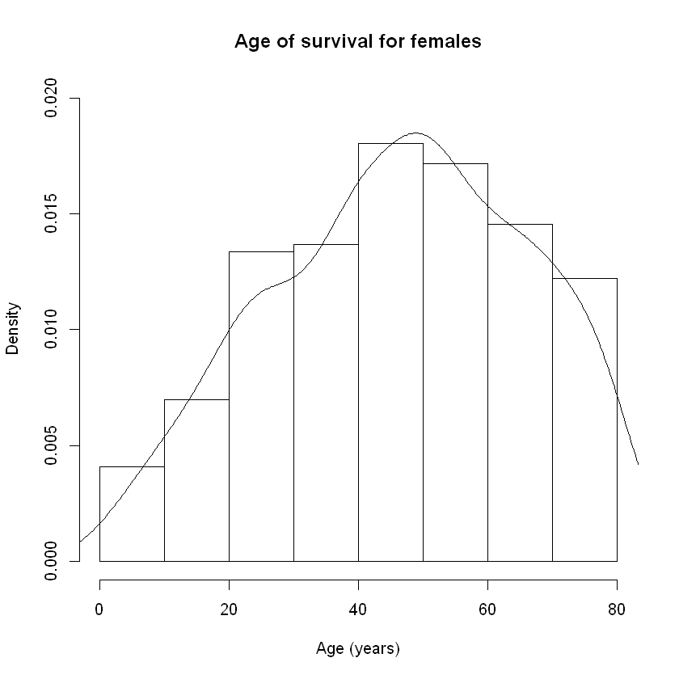

1. 95% bootstrap CI for median age of survival for females: **(46, 52)**.

# Males

|  |  |  |  |  |  |  |  |  |
| --- | --- | --- | --- | --- | --- | --- | --- | --- |
| n | s | se(x̅) | Min | 1st quartile | x̅ | x̃ | 3rd quartile | Max |
| 367 | 19.80 | 1.03 | 1.00 | 28.00 | 44.38 | 45.00 | 61.00 | 80.00 |

1. Summary of the data on the age of survival of males:
2. Density histogram of the age of survival for females with density line:

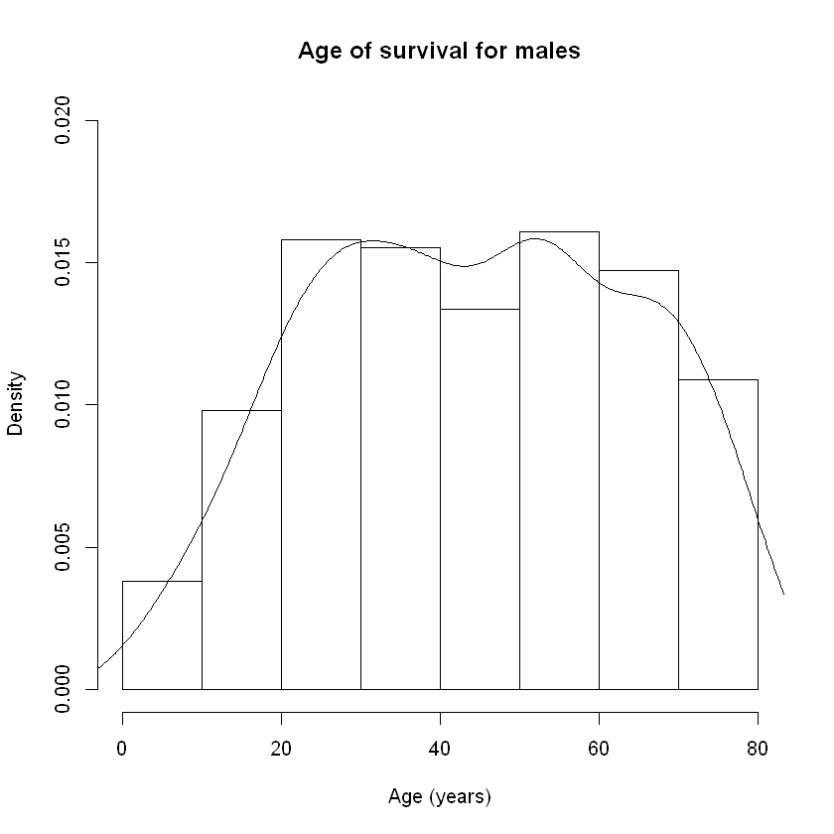

1. 95% bootstrap CI for median age of survival for males: **(42, 50)**.
2. Bootstrap of µ̃m - µ̃f :

* Estimate: **-1.93**
* Graphical summary:

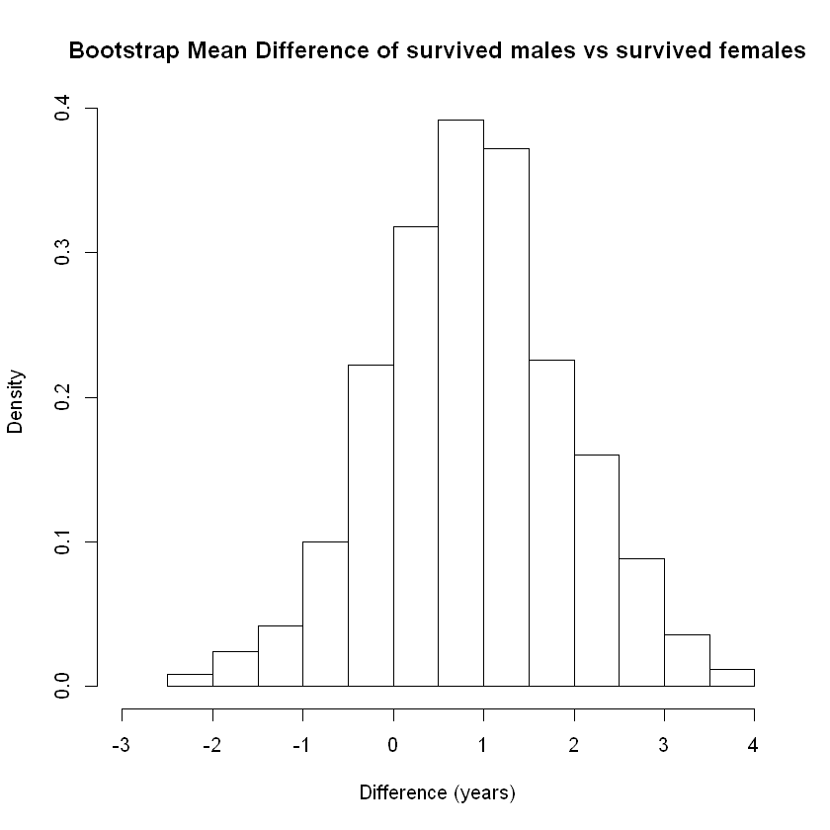

The sampling distribution looks like a **normal distribution**.

* 96% bootstrap CI: **-7.01 to -2.50**?

1. Bootstrap of difference in proportion of survived males and females over 35 years old:

* Estimate: **-0.562**
* SE: **0**
* 95% CI: **(-0.5621, -0.5621)**