Ngoc (Norah) Do

02-26-2018

**Report Sprint 8**

**1. Completed Tasks**

- Drew path from current position to the marker if the result is on the same floor as current position

- Created a mock bottom sheet to contain possible results if the search query matches to multiple results. I have only created a simple format bottom sheet.

- Worked with the person in the library to create an URL that I can use to make direct queries from the application.

- Created a message that shows which floor the user is currently on.

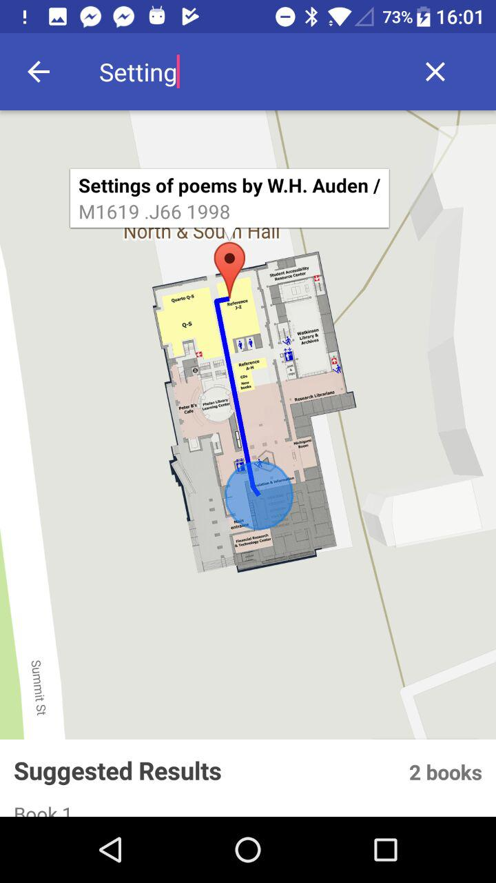

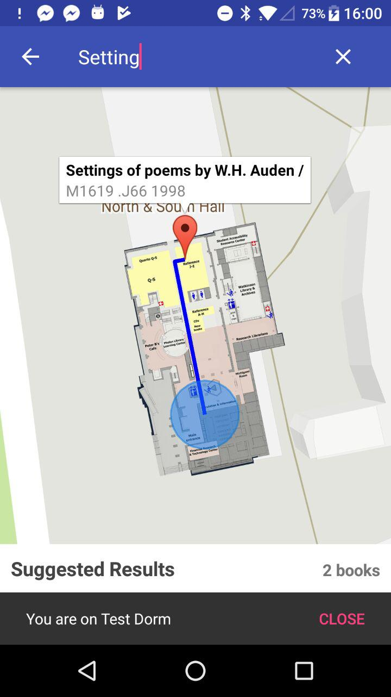

**2. Outstanding Tasks**

- Handle drawing path for multiple floors. I’m planning to have the UI works as follows: if the book is on a different floor, the marker will not appear (or appears near the elevator/stairs). The user will a message saying you need to go to Floor X. When the user gets to the right floor, the marker will appear on the correct position.

- Complete the UI for the bottom sheet.

- Worked on the URL

**3. Challenges**

- Make the UI user-friendly for the case when the book is on a different floor and when there are many possible results.

- When there are too many possible results, the request might cause a crash, so I’m thinking of only getting the first 25 results.

**4. Upcoming tasks**

- Finished the outstanding tasks