docker network create mqtt-kafka-net
docker-compose up -d
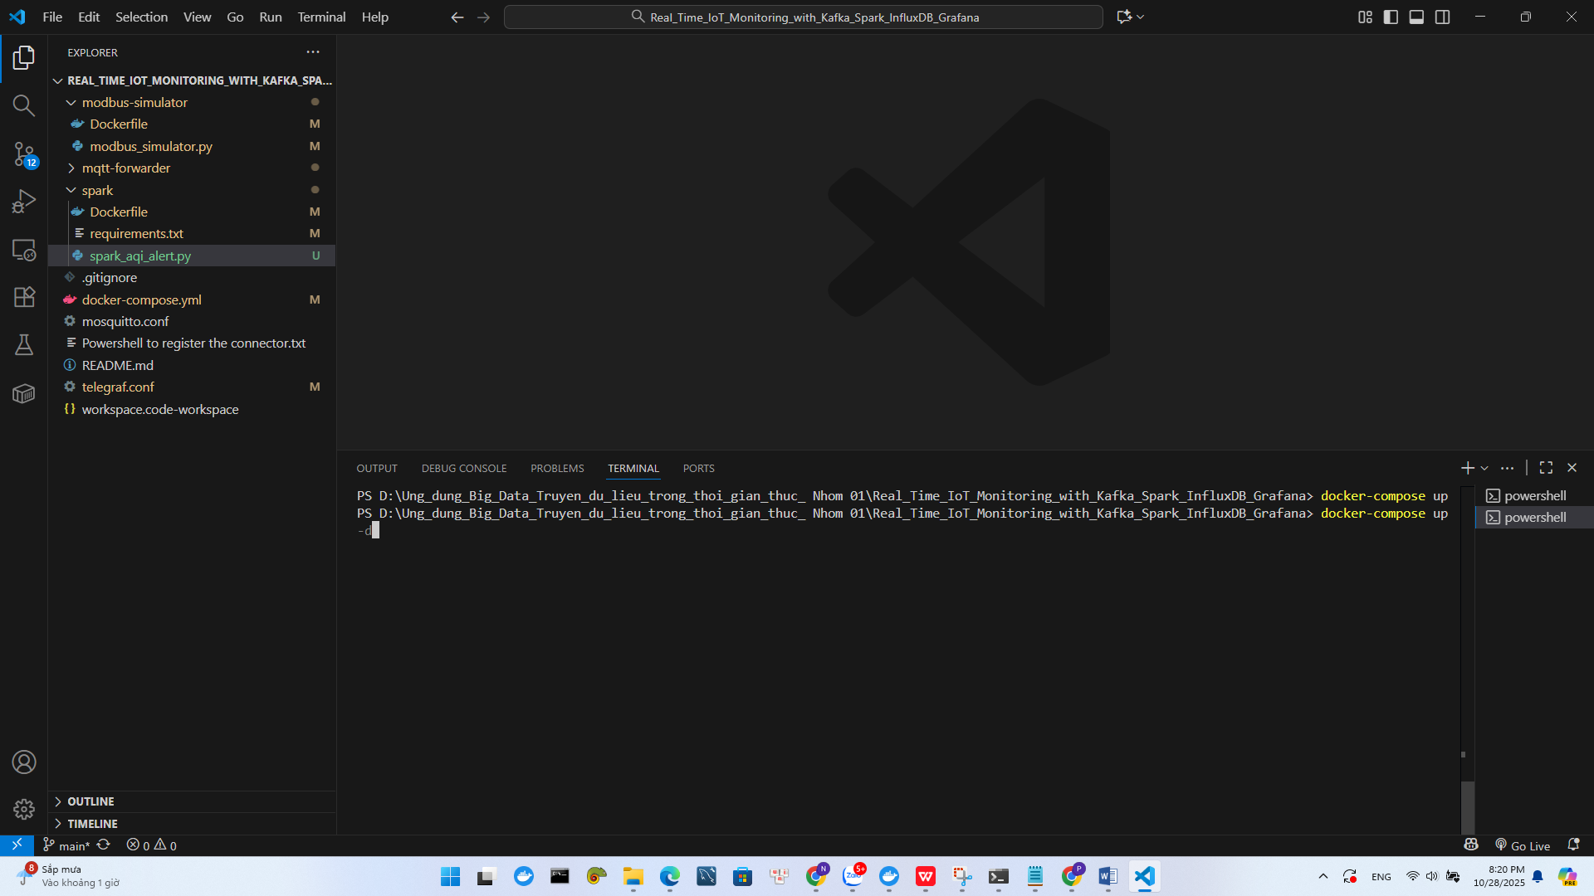
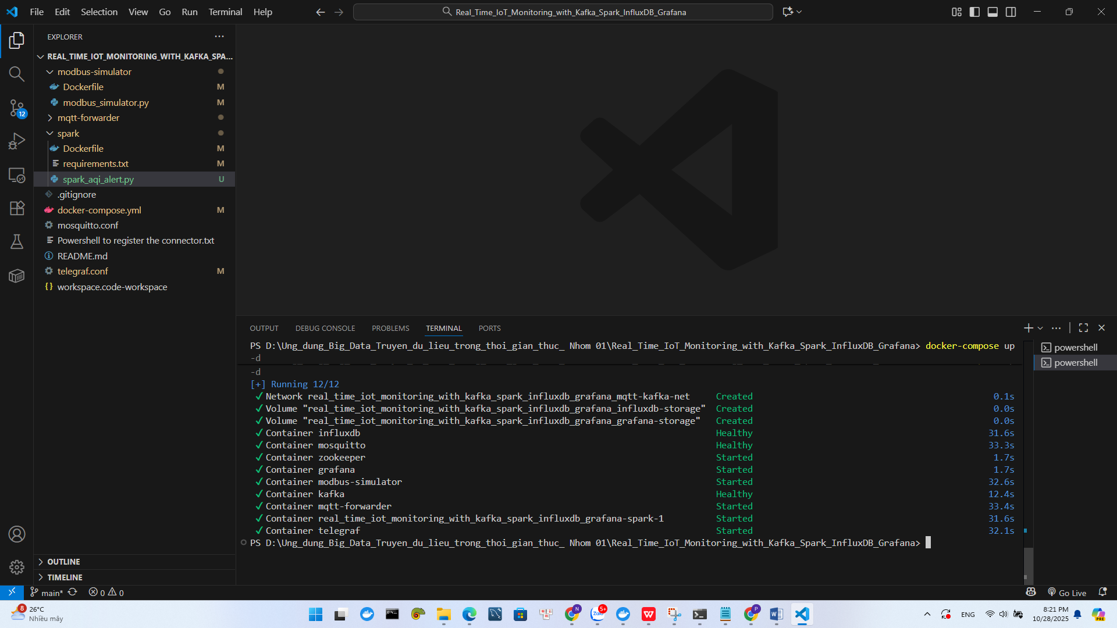

docker logs -f modbus-simulator
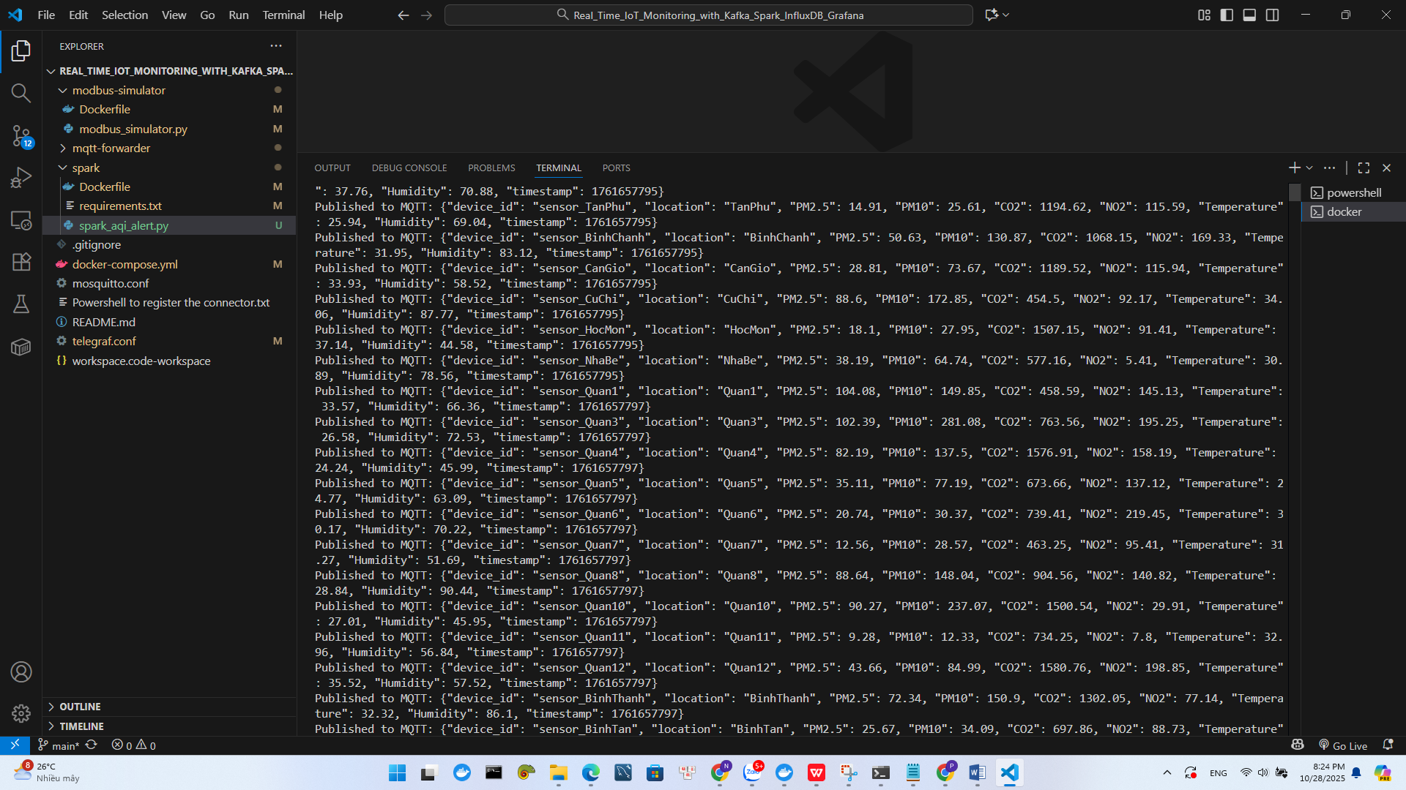

docker logs -f mqtt-forwarder
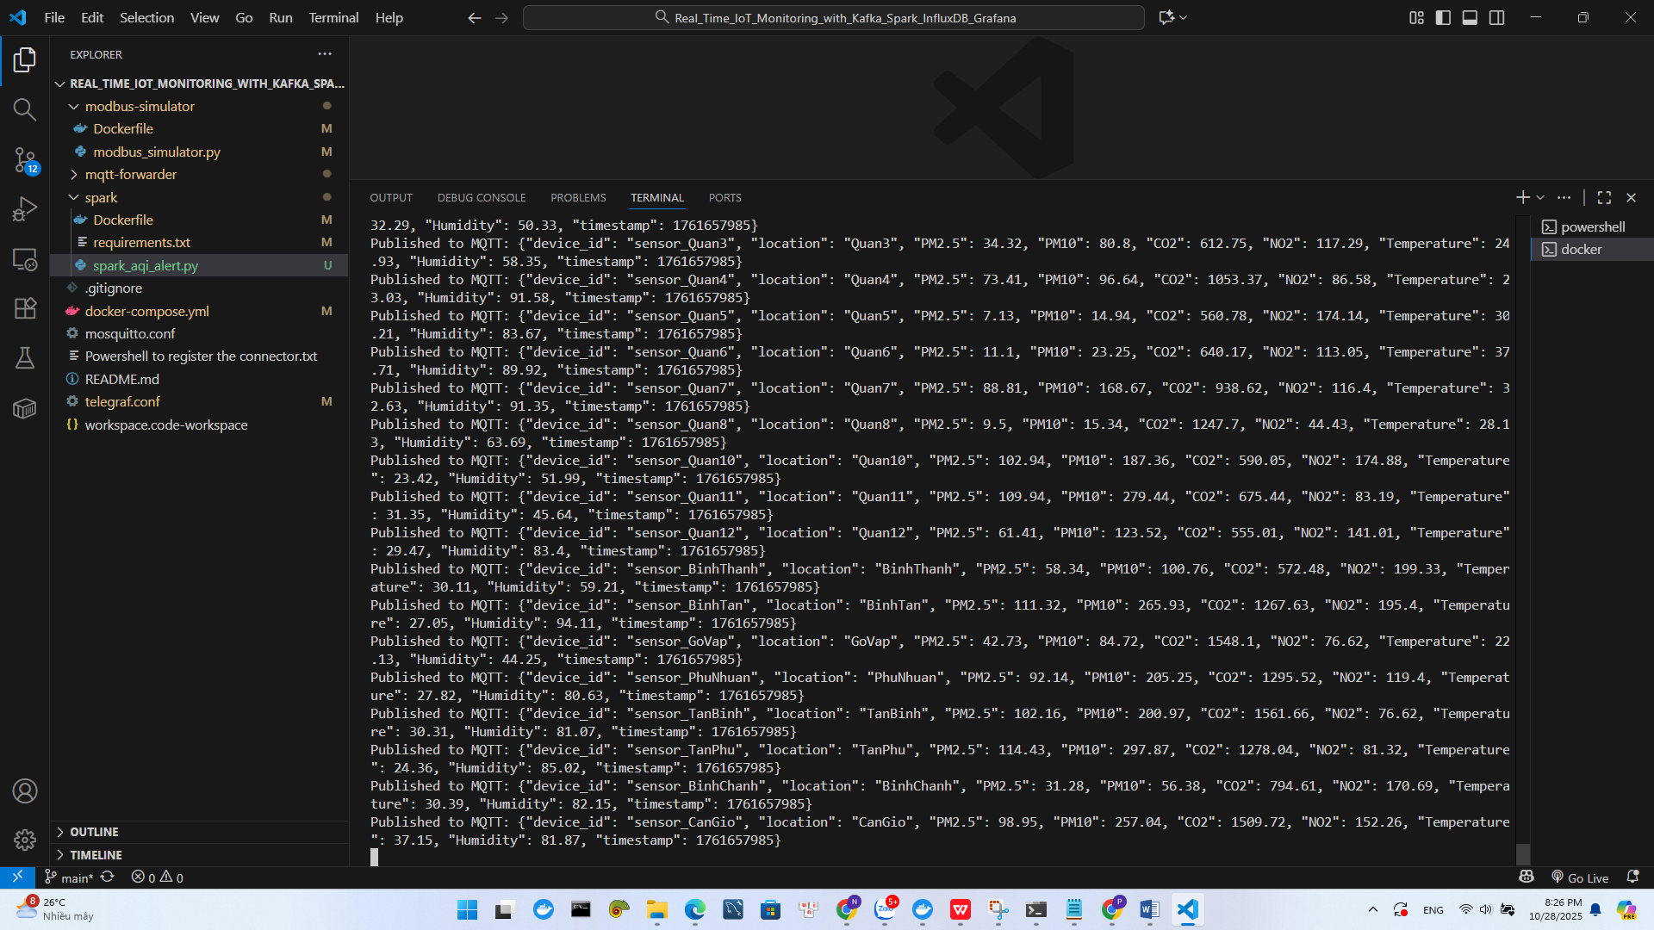

docker exec -it kafka bash
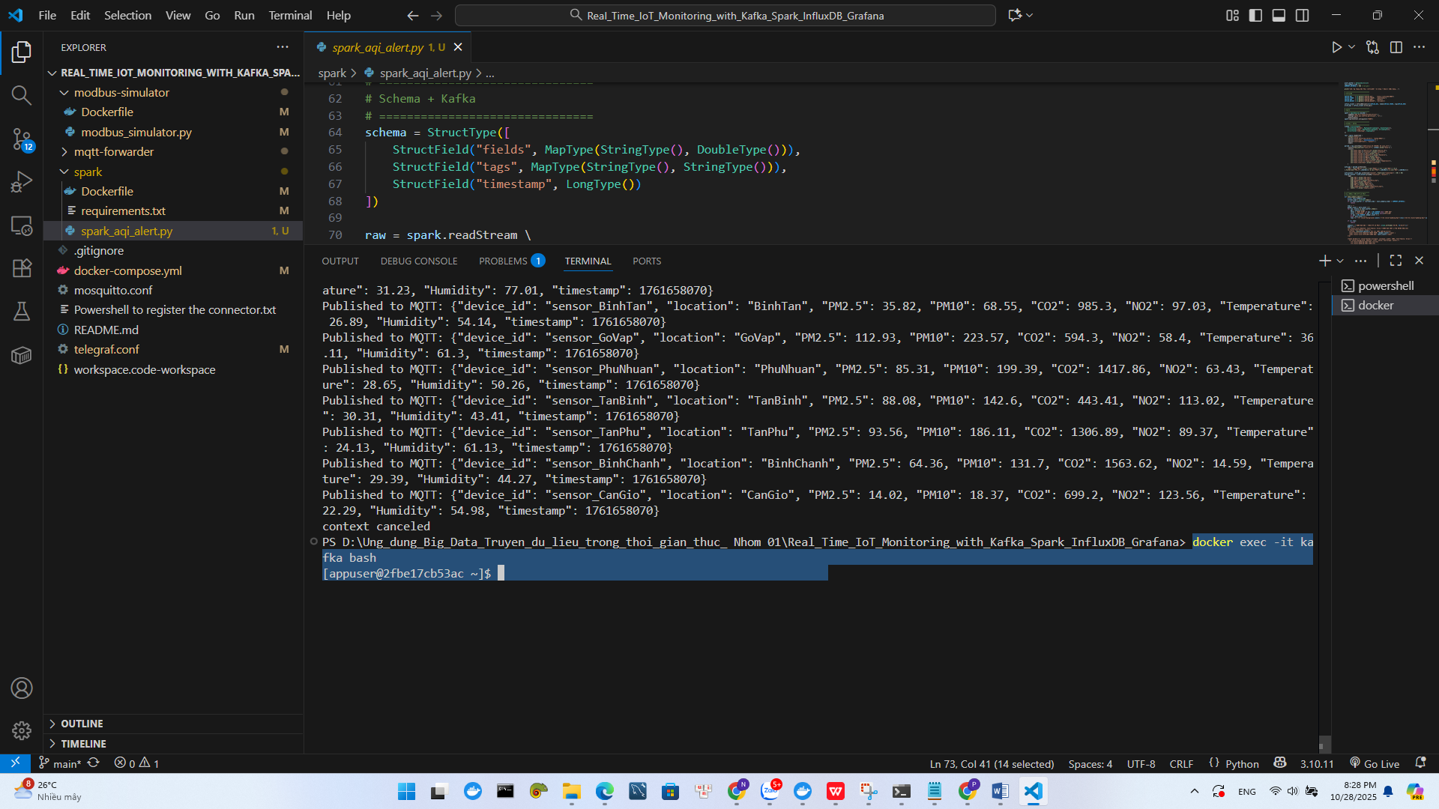

kafka-console-consumer --bootstrap-server localhost:19092 --topic airquality_raw --from-beginning
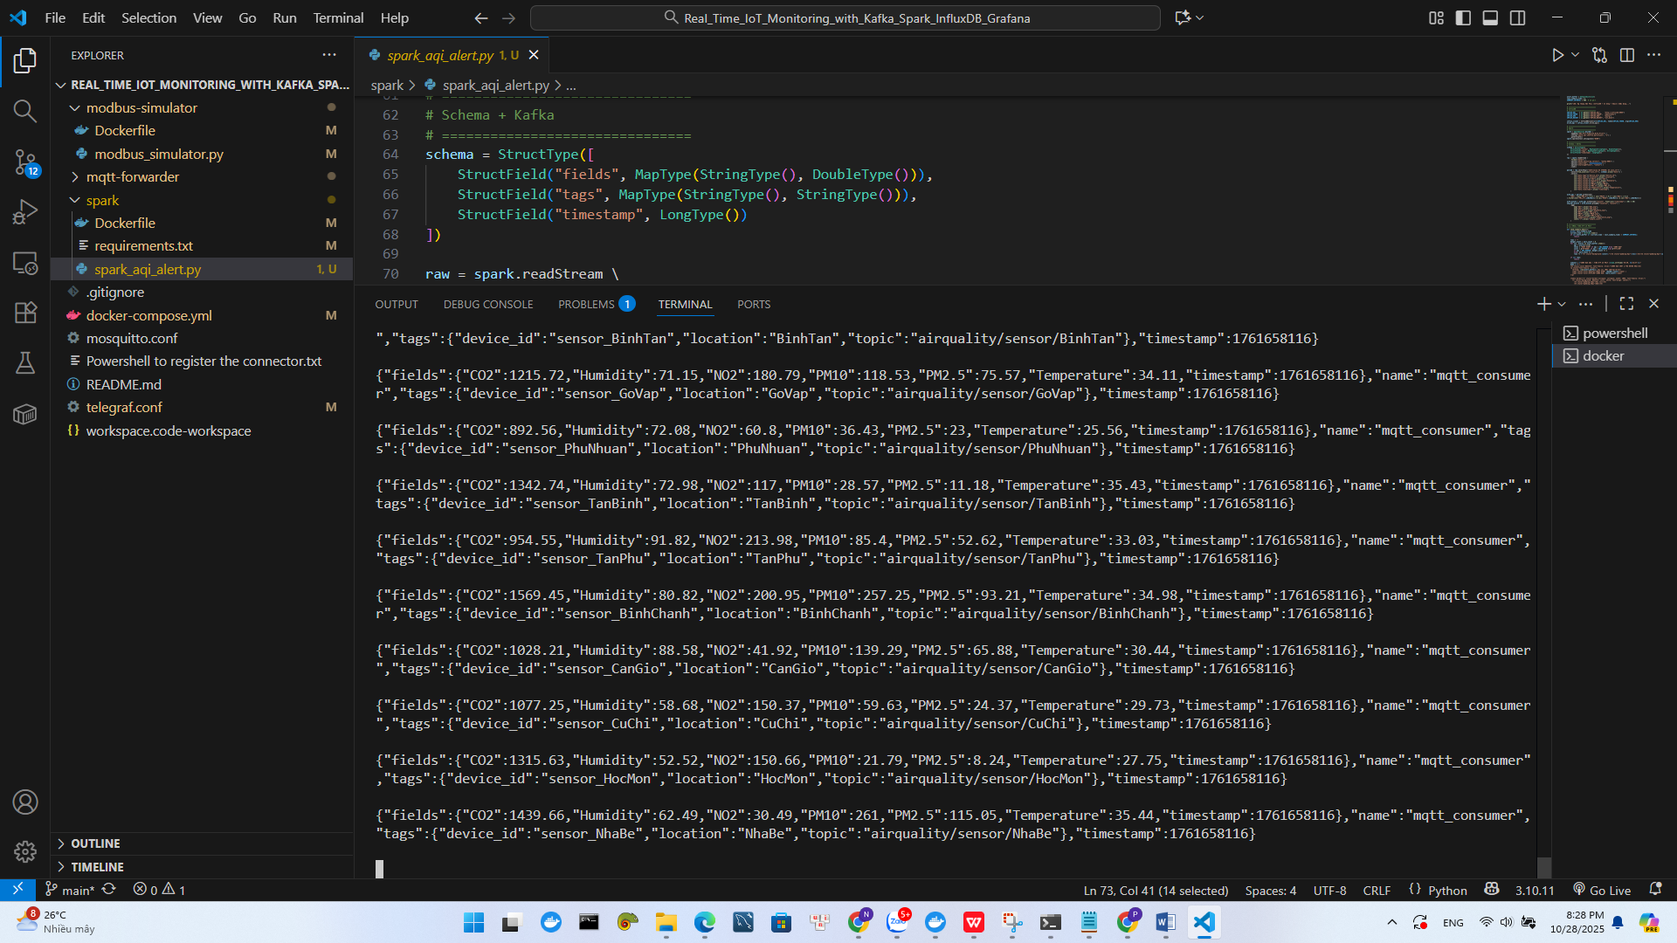

docker logs -f real_time_iot_monitoring_with_kafka_spark_influxdb_grafana-spark-1
