|  |  |
| --- | --- |
| Họ tên SV: Ngô Chí Thuận | MSSV: 523H0102 |
| Ngày thực hiện: 06/11/2023 | Ghi chú: |

Part 3:

**2-input Multiplexer Design**

Ex 3:

A/ Circuit:

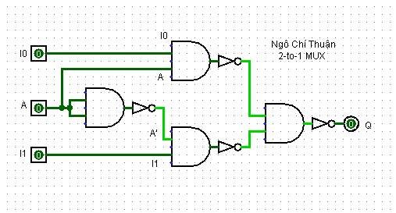

B/ Truth Table:

|  |  |  |  |
| --- | --- | --- | --- |
| Inputs | | | Q |
| A | I1 | I2 |
| 0 | 0 | 0 | 0 |
| 0 | 0 | 1 | 0 |
| 0 | 1 | 0 | 1 |
| 0 | 1 | 1 | 1 |
| 1 | 0 | 0 | 0 |
| 1 | 0 | 1 | 1 |
| 1 | 1 | 0 | 0 |
| 1 | 1 | 1 | 1 |

C, Expression:

Q = ((I0.A)’.(((.A)’).I1)’)’

= ((I0.A)’)’+(((A.A)’.I1)’)’

= (I0.A)+((A.A)’.I1)

= (I0.A)+(A’.I1)

**4-to-1 Channel Multiplexer**

**Ex4.**

A, Circuit

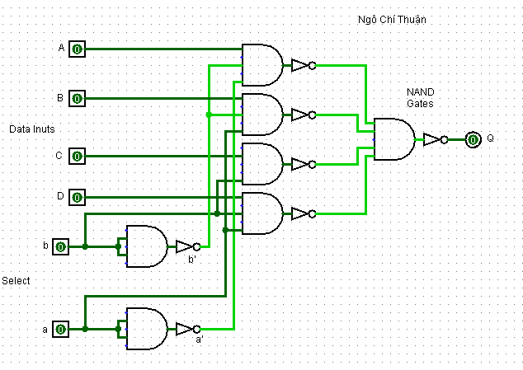

**B, Truth Table**

|  |  |  |  |  |  |  |
| --- | --- | --- | --- | --- | --- | --- |
| Select | | Inputs | | | |  |
| a | b | A | B | C | D | Q |
| 0 | 0 | 0 | 0 | 0 | 0 | 0 |
| 0 | 0 | 0 | 0 | 0 | 1 | 0 |
| 0 | 0 | 0 | 0 | 1 | 0 | 0 |
| 0 | 0 | 0 | 0 | 1 | 1 | 0 |
| 0 | 0 | 0 | 1 | 0 | 0 | 0 |
| 0 | 0 | 0 | 1 | 0 | 1 | 0 |
| 0 | 0 | 0 | 1 | 1 | 0 | 0 |
| 0 | 0 | 0 | 1 | 1 | 1 | 0 |
| 0 | 0 | 1 | 0 | 0 | 0 | 1 |
| 0 | 0 | 1 | 0 | 0 | 1 | 1 |
| 0 | 0 | 1 | 0 | 1 | 0 | 1 |
| 0 | 0 | 1 | 0 | 1 | 1 | 1 |
| 0 | 0 | 1 | 1 | 0 | 0 | 1 |
| 0 | 0 | 1 | 1 | 0 | 1 | 1 |
| 0 | 0 | 1 | 1 | 1 | 0 | 1 |
| 0 | 0 | 1 | 1 | 1 | 1 | 1 |

|  |  |  |  |  |  |  |
| --- | --- | --- | --- | --- | --- | --- |
| 0 | 1 | 0 | 0 | 0 | 0 | 0 |
| 0 | 1 | 0 | 0 | 0 | 1 | 0 |
| 0 | 1 | 0 | 0 | 1 | 0 | 0 |
| 0 | 1 | 0 | 0 | 1 | 1 | 0 |
| 0 | 1 | 0 | 1 | 0 | 0 | 1 |
| 0 | 1 | 0 | 1 | 0 | 1 | 1 |
| 0 | 1 | 0 | 1 | 1 | 0 | 1 |
| 0 | 1 | 0 | 1 | 1 | 1 | 1 |
| 0 | 1 | 1 | 0 | 0 | 0 | 0 |
| 0 | 1 | 1 | 0 | 0 | 1 | 0 |
| 0 | 1 | 1 | 0 | 1 | 0 | 0 |
| 0 | 1 | 1 | 0 | 1 | 1 | 0 |
| 0 | 1 | 1 | 1 | 0 | 0 | 1 |
| 0 | 1 | 1 | 1 | 0 | 1 | 1 |
| 0 | 1 | 1 | 1 | 1 | 0 | 1 |
| 0 | 1 | 1 | 1 | 1 | 1 | 1 |

|  |  |  |  |  |  |  |
| --- | --- | --- | --- | --- | --- | --- |
| 1 | 1 | 0 | 0 | 0 | 0 | 0 |
| 1 | 1 | 0 | 0 | 0 | 1 | 1 |
| 1 | 1 | 0 | 0 | 1 | 0 | 0 |
| 1 | 1 | 0 | 0 | 1 | 1 | 1 |
| 1 | 1 | 0 | 1 | 0 | 0 | 0 |
| 1 | 1 | 0 | 1 | 0 | 1 | 1 |
| 1 | 1 | 0 | 1 | 1 | 0 | 0 |
| 1 | 1 | 0 | 1 | 1 | 1 | 1 |
| 1 | 1 | 1 | 0 | 0 | 0 | 0 |
| 1 | 1 | 1 | 0 | 0 | 1 | 1 |
| 1 | 1 | 1 | 0 | 1 | 0 | 0 |
| 1 | 1 | 1 | 0 | 1 | 1 | 1 |
| 1 | 1 | 1 | 1 | 0 | 0 | 0 |
| 1 | 1 | 1 | 1 | 0 | 1 | 1 |
| 1 | 1 | 1 | 1 | 1 | 0 | 0 |
| 1 | 1 | 1 | 1 | 1 | 1 | 1 |

|  |  |  |  |  |  |  |
| --- | --- | --- | --- | --- | --- | --- |
| 1 | 0 | 0 | 0 | 0 | 0 | 0 |
| 1 | 0 | 0 | 0 | 0 | 1 | 0 |
| 1 | 0 | 0 | 0 | 1 | 0 | 1 |
| 1 | 0 | 0 | 0 | 1 | 1 | 1 |
| 1 | 0 | 0 | 1 | 0 | 0 | 0 |
| 1 | 0 | 0 | 1 | 0 | 1 | 0 |
| 1 | 0 | 0 | 1 | 1 | 0 | 1 |
| 1 | 0 | 0 | 1 | 1 | 1 | 1 |
| 1 | 0 | 1 | 0 | 0 | 0 | 0 |
| 1 | 0 | 1 | 0 | 0 | 1 | 0 |
| 1 | 0 | 1 | 0 | 1 | 0 | 1 |
| 1 | 0 | 1 | 0 | 1 | 1 | 1 |
| 1 | 0 | 1 | 1 | 0 | 0 | 0 |
| 1 | 0 | 1 | 1 | 0 | 1 | 0 |
| 1 | 0 | 1 | 1 | 1 | 0 | 1 |
| 1 | 0 | 1 | 1 | 1 | 1 | 1 |

**C, Expression**

Q = a.b.A + a.b.B + a.b.C + a.b.D

= (a.b).(A+B+C+D)

Ex5

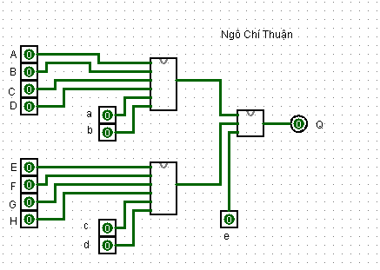

**Ex6:**

No we couldn’t

**Ex7:**

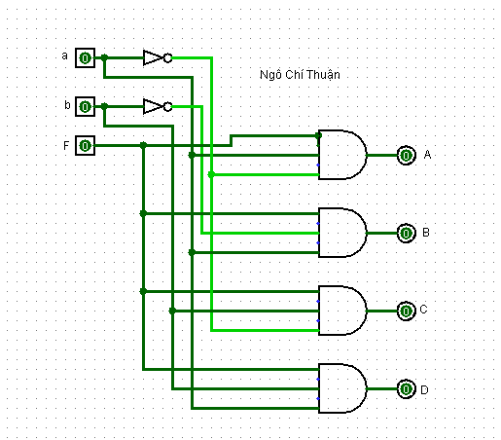1 – 4 DEMUX circuit:

**Part 6:**

**4-to-2 Bit Binary Encoder:**

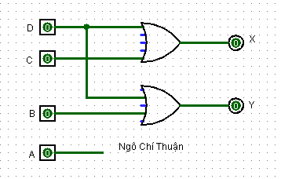

**Priority Encoder:**

**8-to-3 Bit Priority Encoder**

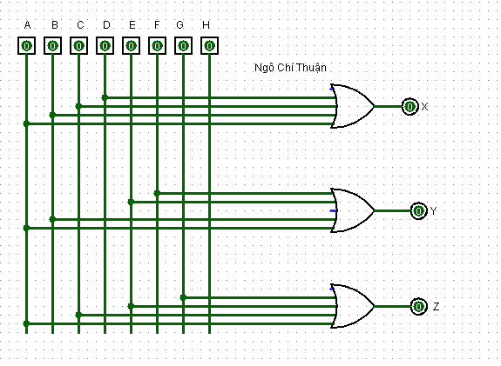

**2-to-4 Binary Decoders**

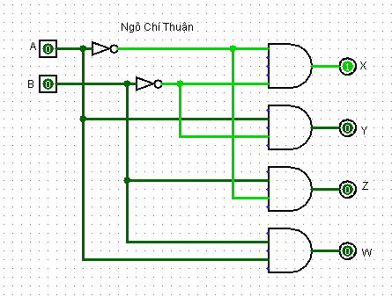

**4-to-16 Binary Decoder Configuration**