VIETNAM GENERAL CONFEDERATION OF LABOR

**TON DUC THANG UNIVERSITY**

**FACULTY OF INFORMATION TECHNOLOGY**



**NGUYEN QUOC THANG – 523H0094**

**NGO CHI THUAN – 523H0102**

**MID-TERM ESSAY**

**DISCRETE STRUCTURES**

**HO CHI MINH CITY, 2025**

VIETNAM GENERAL CONFEDERATION OF LABOR

**TON DUC THANG UNIVERSITY**

**FACULTY OF INFORMATION TECHNOLOGY**



**NGUYEN QUOC THANG – 523H0094**

**NGO CHI THUAN – 523H0102**

**MID-TERM ESSAY**

**DISCRETE STRUCTURES**

Advised by

**M.S Nguyen Quoc Binh**

**HO CHI MINH CITY, 2025**

**ACKNOWLEDGEMENT**

We sincerely express our gratitude to Ton Duc Thang University for providing us with a conductive learning and research environments. Especially thanks to the Faculty of Information Technology and the Software Engineering Department for organizing our study program and we would like to express our gratitude to Master Nguyen Quoc Binh for teaching, sharing knowledge and providing valuable experiences to us during our learning process. We also appreciate her guidance in addressing our inquiries while working on our reports.

*Ho Chi Minh city, 30th April 2025.*

*Author*

*(Signature and full name)*

***Thang***

Nguyen Quoc Thang

***Thuan***

Ngo Chi Thuan

**DECLARATION OF AUTHORSHIP**

We hereby declare that this is our own project and is guided by Mr. Nguyen Quoc Binh; The content research and results contained herein are central and have not been published in any form before. The data in the tables for analysis, comments and evaluation are collected by the main author from different sources, which are clearly stated in the reference section.

In addition, the project also uses some comments, assessments as well as data of other authors, other organizations with citations and annotated sources.

**If something wrong happens, we will take full responsibility for the content of my project.** Ton Duc Thang University is not related to the infringing rights, the copyrights that We give during the implementation process (if any).

*Ho Chi Minh city, 30th April 2025*

*Author*

*(Signature and full name)*

***Thang***

Nguyen Quoc Thang

***Thuan***

Ngo Chi Thuan

**TABLE OF CONTENT**

CHAPTER 1. THE TASKS OF EACH MEMBER 1

CHAPTER 2. TRUTH TABLE 2

2.1 Theory of Basic logic 2

2.1.1 Negation 2

2.1.2 Conjunction 2

2.1.3 Disjunction 2

2.1.4 Implication 3

2.1.5 Logical Equivalence 3

2.2 Explain the testcases 3

2.3 Theory of Reverse Polish 6

2.4 Explanation the implementation 6

2.4.1 Explanation for Infix2Postfix(Infix) function 7

2.4.2 Explanation for Postfix2Truthtable(Postfix) function 8

CHAPTER 3. QUANTIFIED REASONING OVER REAL-WORLD DATA USING PREDICATE LOGIC 10

3.1 Dataset 10

3.2 Output 10

CHAPTER 4. RSA CRYPTOSYSTEM 11

4.1 RSA Introduction 11

4.2 Implementation 11

4.3 Discussion 16

4.3.1 Advantages and disadvantages 16

4.3.2 Applicability of RSA 17

4.3.3 Conclusion 17

4.4 Recommend 18

REFERENCES 19

# THE TASKS OF EACH MEMBER

|  |  |  |  |
| --- | --- | --- | --- |
| **#** | **Activities / Tasks / Items** | **Priority** | **Assigned to** |
| 1 | Task 1 - Implement code | High | Thuan |
| 2 | Task 2 - Implement code | High | Thuan |
| 3 | Task 3 - Implement code | High | Thang |
| 4 | Search for theoretical documents | High | Thuan |
| 5 | Collect images for document | Low | Thang |
| 6 | Create dataset for task 2 | High | Thang |
| 7 | Find and write references | Low | Thuan |
| 8 | Explain task 1 code | High | Thang |
| 9 | Explain task 3 code | High | Thang |
| 10 | Task 3 - Discussion | High | Thang, Thuan |
| 11 | Task 3 - Recommendation | Medium | Thang, Thuan |
| 12 | Assign tasks to each member | Medium | Thuan, Thang |
| 13 | Task1 - Calculate and verify the testcases | High | Thang |
| 14 | Write the acknowledgements section | Medium | Thang |

# TRUTH TABLE

## Theory of Basic logic

### Negation

Definition: If $p$ is a statement variable, the **negation** of *p* is “not *p*” or “it is not the case that *p*” and is denoted $\sim p$.

Truth table:

|  |  |
| --- | --- |
| $$P$$ | $$\sim P$$ |
| F | T |
| T | F |

### Conjunction

Definition: If $p$ and $q$ are statement variables, the **conjunction** of $p$ and $q$ is “*p* and *q*”, denoted $p\bigwedge{q}$.

Truth table:

|  |  |  |
| --- | --- | --- |
| $$P$$ | $$Q$$ | $$P ⋀ Q$$ |
| F | F | F |
| F | T | F |
| T | F | F |
| T | T | T |

### Disjunction

Definition: If $p$ and $q$ are statement variables, the **disjunction** of $p$ and $q$ is “*p* or *q*”, denoted $p \bigvee{q}$.

Truth table:

|  |  |  |
| --- | --- | --- |
| $$P$$ | $$Q$$ | $$P ⋁ Q$$ |
| F | F | F |
| F | T | T |
| T | F | T |
| T | T | T |

### Implication

Definition: If $p$ and $q$ are statement variables, the **conditional** of *q* by *p* is “if *p* then *q*” or “*p* implies *q*”, denoted $p→q$.

It is false when $p$ is true and $q$ is false; otherwise, it is true. We called $p$ the hypothesis (or antecedent) of the conditional and *q* the conclusion (or consequent).

Truth table:

|  |  |  |
| --- | --- | --- |
| $$P$$ | $$Q$$ | $$P→Q$$ |
| F | F | T |
| F | T | T |
| T | F | F |
| T | T | T |

### Logical Equivalence

Definition: Two statement forms are called **logically equivalent** if, and only if, they have identical truth values for each possible substitution of statements for their statement variables. The logical equivalence of statement forms *P* and *Q* is denoted by $P≡Q$.

Example:

|  |  |  |  |
| --- | --- | --- | --- |
| $$a$$ | $$b$$ | $$a ⋀ b$$ | $$b ⋀ a$$ |
| F | F | F | F |
| F | T | F | F |
| T | F | F | F |
| T | T | T | T |

$a ⋀ b$ and $b ⋀ a$ always have the same truth values, hence they are logically equivalent.

## Explain the testcases

Test case 1: R|(P&Q)

|  |  |  |  |  |
| --- | --- | --- | --- | --- |
| $$P$$ | $$Q$$ | $$R$$ | $$P ⋀ Q$$ | $$R ⋁ (P ⋀ Q)$$ |
| F | F | F | F | F |
| F | F | T | F | T |
| F | T | F | F | F |
| F | T | T | F | T |
| T | F | F | F | F |
| T | F | T | F | T |
| T | T | F | T | T |
| T | T | T | T | T |

Test case 2: ~P|(Q&R)>R

|  |  |  |  |  |  |  |
| --- | --- | --- | --- | --- | --- | --- |
| $$P$$ | $$Q$$ | $$R$$ | $$∼P$$ | $$Q ⋀ R$$ | $$∼P ⋁ (Q ⋀ R)$$ | $$(∼P ⋁ (Q ⋀ R)) → R$$ |
| F | F | F | T | F | T | F |
| F | F | T | T | F | T | T |
| F | T | F | T | F | T | F |
| F | T | T | T | T | T | T |
| T | F | F | F | F | F | T |
| T | F | T | F | F | F | T |
| T | T | F | F | F | F | T |
| T | T | T | F | T | T | T |

Test case 3: P|(R&Q)

|  |  |  |  |  |
| --- | --- | --- | --- | --- |
| $$P$$ | $$Q$$ | $$R$$ | $$R ⋀ Q$$ | $$P ⋁ (R ⋀ Q)$$ |
| F | F | F | F | F |
| F | F | T | F | F |
| F | T | F | F | F |
| F | T | T | T | T |
| T | F | F | F | T |
| T | F | T | F | T |
| T | T | F | F | T |
| T | T | T | T | T |

Test case 4: (P>Q) &(Q>R)

|  |  |  |  |  |  |
| --- | --- | --- | --- | --- | --- |
| $$P$$ | $$Q$$ | $$R$$ | $$P → Q$$ | $$Q → R$$ | $$(P → Q) ∧ (Q → R)$$ |
| F | F | F | T | T | T |
| F | F | T | T | T | T |
| F | T | F | T | F | F |
| F | T | T | T | T | T |
| T | F | F | F | T | F |
| T | F | T | F | T | F |
| T | T | F | T | F | F |
| T | T | T | T | T | T |

Test case 5: (P|~Q)>~P=(P|(~Q))>~P

|  |  |  |  |  |  |
| --- | --- | --- | --- | --- | --- |
| $$P$$ | $$Q$$ | $$P ∨ \sim Q$$ | $$(P ⋁ \sim Q)→\sim P$$ | $$(P ⋁ (\sim Q) →\sim P$$ | $$(P ⋁ \sim Q)→\sim P≡(P ⋁(\sim Q))→\sim P$$ |
| F | F | T | T | T | T |
| F | T | F | T | T | T |
| T | F | T | F | F | T |
| T | T | T | F | F | T |

Requirements:

* Write **Infix2Postfix(Infix)** function
* Write **Postfix2Truthtable(Postfix)** function

Calculate:

1. R|(P&Q)
2. ~P|(Q&R)>R
3. P|(R&Q)
4. (P>Q)&(Q>R)
5. (P|~Q)>~P=(P|(~Q))>~P

## Theory of Reverse Polish

**Reverse Polish notation** (**RPN**), also known as **reverse Łukasiewicz notation**, **Polish postfix notation** or simply **postfix notation**, is a mathematical notation in which operators *follow* their operands, in contrast to prefix or Polish notation (PN), in which operators *precede* their operands. The notation does not need any parentheses for as long as each operator has a fixed number of operands.

In reverse Polish notation, the operators follow their operands. For example, to add 3 and 4 together, the expression is 3 4 + rather than 3 + 4. The conventional notation expression 3 − 4 + 5 becomes 3 (enter) 4 − 5 + in reverse Polish notation: 4 is first subtracted from 3, then 5 is added to it.

## Explanation the implementation

### Explanation for Infix2Postfix(Infix) function

**Input:** Infix (A string containing the infix logical expression)

**Input data type:** str (string).

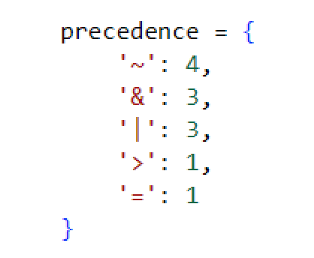

To begin with, we declare the precedence of logical operators using a dictionary, with decreasing precedence. NOT (~) has the highest precedence, and the lowest is IF AND ONLY IF (=) and IMPLIES (>).

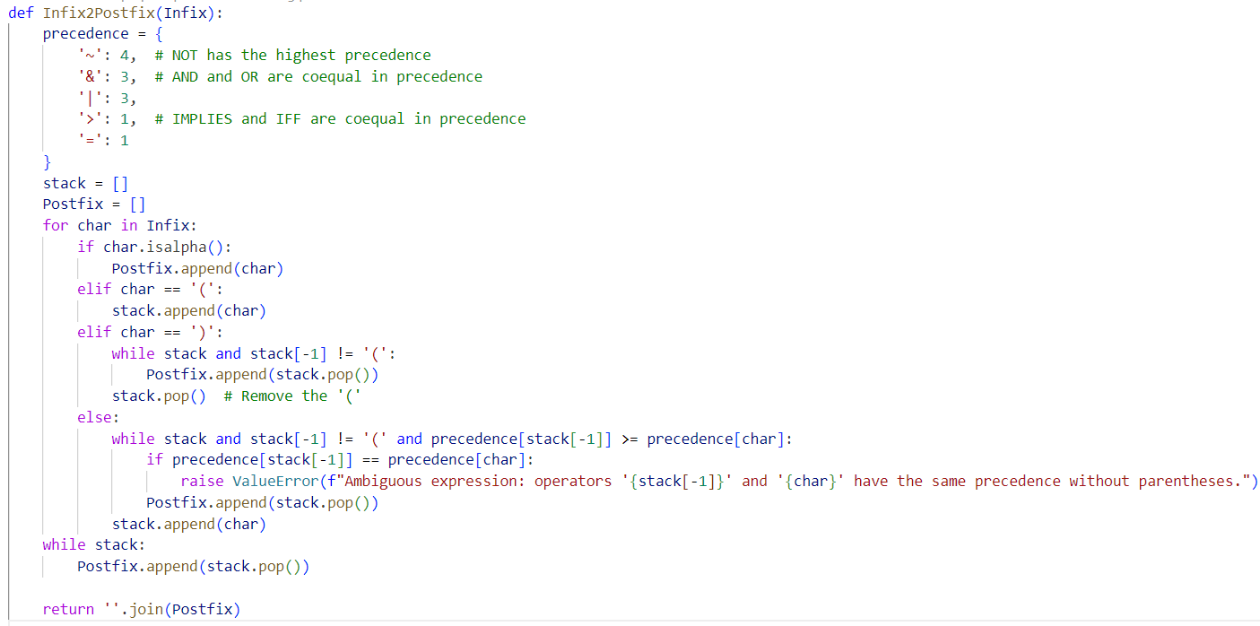

Next, initialize 2 lists, stack (containing mathematical expressions), and Postfix to store returned output.

Then, perform a loop through each character in the input string:

* If it is an operand, add it to Postfix
* If it is an open parenthesis, add it to the Stack.
* If it is a closing parenthesis, take all the operators from the stack and put them into postfix until you reach the opening parenthesis. Remove the opening parenthesis.
* Otherwise, compare operator precedence and put it in postfix

After that, get the remaining operators in the stack.

Finally, Return the postfix string by concatenating the elements in the Postfix list.

### Explanation for Postfix2Truthtable(Postfix) function

**Input:** Postfix (A string containing the postfix logical expression)

**Input data type:** str (string).

Keep in mind that Postfix can be got via **Infix2Postfix(Infix**) function.

To begin with, we need to get variables from the postfix expression (Postfix parameter).

variables = sorted(set(filter(str.isalpha, Postfix)))

Where:

* filter(str.isalpha, Postfix): Filter out alphabetic characters (logical variables) from a postfix expression.
* [set()](vscode-file://vscode-app/c:/Users/LG/AppData/Local/Programs/Microsoft%20VS%20Code/resources/app/out/vs/code/electron-sandbox/workbench/workbench.html): Transform​ list to set for the purpose of removing duplicate variables
* [sorted()](vscode-file://vscode-app/c:/Users/LG/AppData/Local/Programs/Microsoft%20VS%20Code/resources/app/out/vs/code/electron-sandbox/workbench/workbench.html): Sort variables in alphabetical order.
* num_vars: Count the number of logic variables.

Generate all truth value combinations

truth_combinations = list(product([False, True], repeat=num_vars))

Where:

* product([False, True], repeat=num_vars): Generates all possible combinations values (True/False) ​​for logical variables.
* [list()](vscode-file://vscode-app/c:/Users/LG/AppData/Local/Programs/Microsoft%20VS%20Code/resources/app/out/vs/code/electron-sandbox/workbench/workbench.html): Convert results to list.

Definition of local functions of logical operations:

Use a dictionary to map logical operators to functions.

Print table header:

Iterate through each combination of truth values

Where:

* [combination](vscode-file://vscode-app/c:/Users/LG/AppData/Local/Programs/Microsoft%20VS%20Code/resources/app/out/vs/code/electron-sandbox/workbench/workbench.html): A combination of truth values ​​(e.g. (False, True)).
* zip(variables, combination): Match each variable with its corresponding truth value.
* [dict()](vscode-file://vscode-app/c:/Users/LG/AppData/Local/Programs/Microsoft%20VS%20Code/resources/app/out/vs/code/electron-sandbox/workbench/workbench.html): Creates a dictionary mapping variables to truth values.

Calculate the result based on the postfix expression:

Where:

* [stack](vscode-file://vscode-app/c:/Users/LG/AppData/Local/Programs/Microsoft%20VS%20Code/resources/app/out/vs/code/electron-sandbox/workbench/workbench.html): Stack to compute the value of postfix expression.
* [char.isalpha()](vscode-file://vscode-app/c:/Users/LG/AppData/Local/Programs/Microsoft%20VS%20Code/resources/app/out/vs/code/electron-sandbox/workbench/workbench.html): Check if all the characters in the text are letters. In this case, this is used to check if an element in the postfix expression​ is a variable (e.g. P, Q, R, …)
* char in operations: If the character is an operator, perform the corresponding operation by calling the function in operations.

# QUANTIFIED REASONING OVER REAL-WORLD DATA USING PREDICATE LOGIC

## Dataset

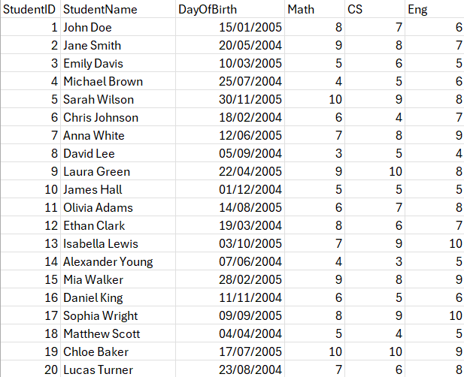We created “student.csv” dataset contains these fields: StudentID, StudentName, DayOfBirth, Math, CS, Eng.

## Output

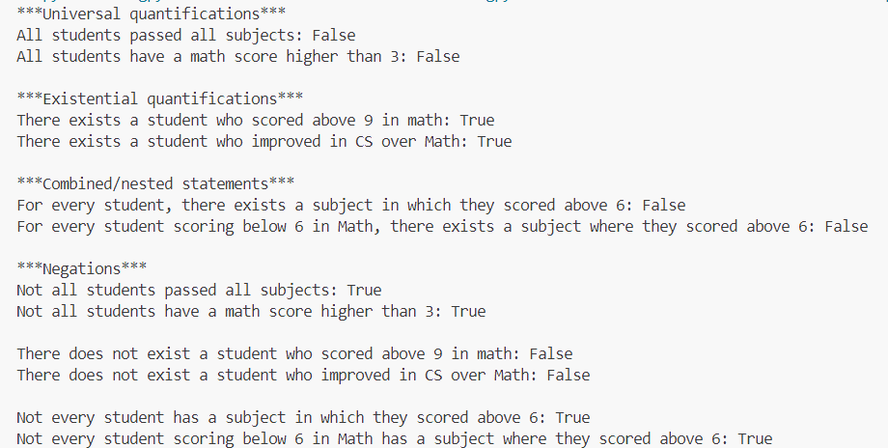

# RSA CRYPTOSYSTEM

## RSA Introduction

In cryptography, RSA is a public-key cryptography algorithm. It was the first algorithm suitable for generating digital signatures as well as encryption. It marked a major advance in the field of cryptography in the use of public keys. RSA is widely used in electronic commerce and is considered secure provided the key length is sufficiently large.

In a public-key cryptosystem, the encryption key is public and distinct from the decryption key, which is kept secret (private). An RSA user creates and publishes a public key based on two large prime numbers, along with an auxiliary value. The prime numbers are kept secret. Messages can be encrypted by anyone, via the public key, but can only be decrypted by someone who knows the private key.

## Implementation

Import libraries used in the code:

Where:

* time: Used to measure the encrypting and decrypting time
* [matplotlib.pyplot](vscode-file://vscode-app/c:/Users/LG/AppData/Local/Programs/Microsoft%20VS%20Code/resources/app/out/vs/code/electron-sandbox/workbench/workbench.html): Used to draw performance graph.
* [Crypto.PublicKey.RSA](vscode-file://vscode-app/c:/Users/LG/AppData/Local/Programs/Microsoft%20VS%20Code/resources/app/out/vs/code/electron-sandbox/workbench/workbench.html): Used to generate and manage RSA keys
* [Crypto.Cipher.PKCS1_OAEP](vscode-file://vscode-app/c:/Users/LG/AppData/Local/Programs/Microsoft%20VS%20Code/resources/app/out/vs/code/electron-sandbox/workbench/workbench.html): Used to perform RSA encryption and decryption in PKCS1_OAEP mode.
* Crypto.Random.get_random_bytes: Used to generate a random message of a specific length.

Define **generate_keys()** function to generate private and public keys:

**Purpose**: Generate an RSA key pair (public key and private key).

**Note that:**

* [RSA.generate(2048)](vscode-file://vscode-app/c:/Users/LG/AppData/Local/Programs/Microsoft%20VS%20Code/resources/app/out/vs/code/electron-sandbox/workbench/workbench.html): generate an RSA key pair with a length of 2048 bit. It must be at least 1024, but **2048 is recommended.** Note that **RSA.generate(bits)** will generate a different key each time it is run.
* [key.export_key()](vscode-file://vscode-app/c:/Users/LG/AppData/Local/Programs/Microsoft%20VS%20Code/resources/app/out/vs/code/electron-sandbox/workbench/workbench.html): Export private key as a byte string.
* [key.publickey().export_key()](vscode-file://vscode-app/c:/Users/LG/AppData/Local/Programs/Microsoft%20VS%20Code/resources/app/out/vs/code/electron-sandbox/workbench/workbench.html): Export public key as a byte string.
* Return: A tuple contains private and public keys.

Define **encrypt_message(public_key, message)** function to encrypt the message:

**Purpose:** Encrypt the message with RSA pubic key.

**Note that:**

* [RSA.import_key(public_key)](vscode-file://vscode-app/c:/Users/LG/AppData/Local/Programs/Microsoft%20VS%20Code/resources/app/out/vs/code/electron-sandbox/workbench/workbench.html): Import public key from byte string.
* [PKCS1_OAEP.new(rsa_key)](vscode-file://vscode-app/c:/Users/LG/AppData/Local/Programs/Microsoft%20VS%20Code/resources/app/out/vs/code/electron-sandbox/workbench/workbench.html): Create new encrypted RSA object with PKCS1_OAEP mode.
* chunk_size = rsa_key.size_in_bytes() - 42: Calculate the maximum size of each message chunks (decrease 42 bytes for padding).

Then, perform a loop:

* Split message into small chunks which is smaller than chunk_size.
* Encrypt each chunk and concatenate the encrypted chunks.
* Return: Encrypted message (ciphertext).

Define **decrypt_message(private_key, ciphertext)** function to decrypt the message:

**Purpose:** Decrypt encrypted message by using RSA private key.

**Note that:**

* [RSA.import_key(private_key)](vscode-file://vscode-app/c:/Users/LG/AppData/Local/Programs/Microsoft%20VS%20Code/resources/app/out/vs/code/electron-sandbox/workbench/workbench.html): Import public key from byte string.
* [PKCS1_OAEP.new(rsa_key)](vscode-file://vscode-app/c:/Users/LG/AppData/Local/Programs/Microsoft%20VS%20Code/resources/app/out/vs/code/electron-sandbox/workbench/workbench.html): Create new encrypted RSA object with PKCS1_OAEP mode.
* chunk_size = rsa_key.size_in_bytes(): Calculate the size of each ciphertext chunk.

Then, perform a loop:

* Split ciphertext (encrypted message) into small chunks whose size is equal to chunk_size.
* Decrypt each chunk and concatenate the decrypted chunks.
* Return: Original message (plaintext).

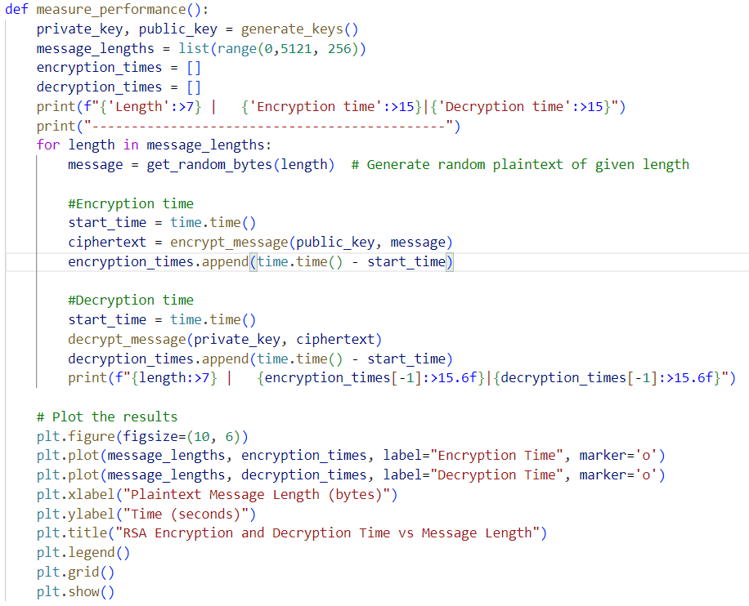Define **measure_performance()** function to measure the performance, data statistics and draw graph:

**Purpose:** Measure encrypt and decrypt tine of messages with different lengths.

**Note that:**

* [message_lengths](vscode-file://vscode-app/c:/Users/LG/AppData/Local/Programs/Microsoft%20VS%20Code/resources/app/out/vs/code/electron-sandbox/workbench/workbench.html): List of messages lengths (from 0 to 5120 bytes, with step equals 256 bytes).
* [get_random_bytes(length)](vscode-file://vscode-app/c:/Users/LG/AppData/Local/Programs/Microsoft%20VS%20Code/resources/app/out/vs/code/electron-sandbox/workbench/workbench.html): Generate a random message of length **length (byte)**.

**Measure time:**

* Encrypt: Record the start and end times when encrypting the message.
* Decrypt: Record the start and end times when decrypting the ciphertext.
* Output: Print encrypting and decrypting time of each message with different lengths.

**Draw graph:**

* X axis: Lengths of messages (bytes).
* Y axis: Encrypting and decrypting time (second).

## Discussion

### Advantages and disadvantages

|  |  |  |  |
| --- | --- | --- | --- |
| **Advantages** | **Explain** | **Disadvantages** | **Explain** |
| **High security** | Based on large integer factorization problem, very difficult to solve with long key (>2048-bit). | **Slow speed** | Encryption/decryption takes longer than AES, especially with large data. |
| **No need to exchange secret keys** | Only public key is required for encryption, no need to share secret key over secure channel. | **Data size limit** | Encrypts only small data (≈200 bytes/time with 2048-bit key). |
| **Wide application** | Used in SSL/TLS, digital signatures, blockchain, secure email, etc. | **Long key required** | Must use ≥2048-bit key to be secure, consumes computational resources. |
| **Ensuring integrity and authenticity** | Used to create digital signatures, verify the origin and integrity of data. | **Vulnerable to attack if installed incorrectly** | If padding, key generation or checksum are incorrect, it can be easily exploited. |
| **High standard compatibility** | Support safety padding (OAEP), easy to integrate with other systems. | **Not quantum resistant (exhaustive)** | If the quantum computer is powerful enough (Shor’s algorithm), RSA will be broken. |

### Applicability of RSA

RSA is the foundation of many modern security systems that support high performance and security. RSA application icons include:

|  |  |
| --- | --- |
| **Field of application** | **Description** |
| **Secure web communication (HTTPS/SSL/TLS)** | RSA is used during the SSL/TLS **handshake** to encrypt the session key. Ensuring a secure connection between the browser and the server. |
| **Digital Signature** | Use RSA to sign documents, emails, or electronic contracts. Helps verify the sender's identity and the integrity of the content. |
| **Secure Email (PGP, S/MIME)** | RSA is used for email encryption and digital signatures, helping to secure email communications. |
| **Blockchain and Cryptocurrency** | Use RSA (or similar) to sign and validate transactions on the blockchain, ensuring security and tamper resistance. |
| **Session Key Encryption (Hybrid Encryption)** | In practice, RSA is used to encrypt an AES key (or other symmetric key) → combining the security advantages of RSA and the speed of AES. |
| **Authentication** | RSA is used in OTP systems, digital signatures to authenticate users or devices. |

### Conclusion

RSA is an asymmetric encryption algorithm of great historical significance and still plays an important role in many security systems today. With high security, the ability to not need to exchange secret keys, along with flexible application capabilities (session key encryption, digital signatures, authentication...), RSA is trusted and standardized in many modern protocols such as SSL/TLS, PGP, Blockchain.

However, RSA also has obvious limitations such as: slow speed, data size limit, long key requirement, and the possibility of being broken in the future by quantum computers by exhausting the data.

## Recommend

Although RSA is highly secure, it is inefficient for encrypting large messages due to its slow processing speed and limited input size (around 190–220 bytes with a 2048-bit key). To overcome this, the hybrid encryption method is widely used: RSA encrypts a session key (e.g., AES key), while AES — a fast symmetric algorithm — encrypts the full message. The process involves generating a random AES key, using it to encrypt the data, then encrypting the AES key with RSA. The receiver decrypts the AES key using their RSA private key, then uses it to decrypt the message. This approach preserves RSA’s security while leveraging AES’s speed for large data. It is the standard model in modern protocols like SSL/TLS, PGP, and VPN.

# REFERENCES

Eijs, H. (2014, June 24). *PyCryptodome 3.22.0 documentation*. Retrieved from Read the Docs: https://pycryptodome.readthedocs.io/en/latest/

Johnson, J. (2001, September 26). *Logical connective*. Retrieved from Wikipedia: https://en.wikipedia.org/wiki/Logical_connective

Szopen. (2002, January 10). *Reverse Polish notation*. Retrieved from Wikipedia: https://en.wikipedia.org/wiki/Reverse_Polish_notation

WojPob. (2001, February 21). *RSA cryptosystem*. Retrieved from Wikipedia: https://en.wikipedia.org/wiki/RSA_cryptosystem