Problem 7:

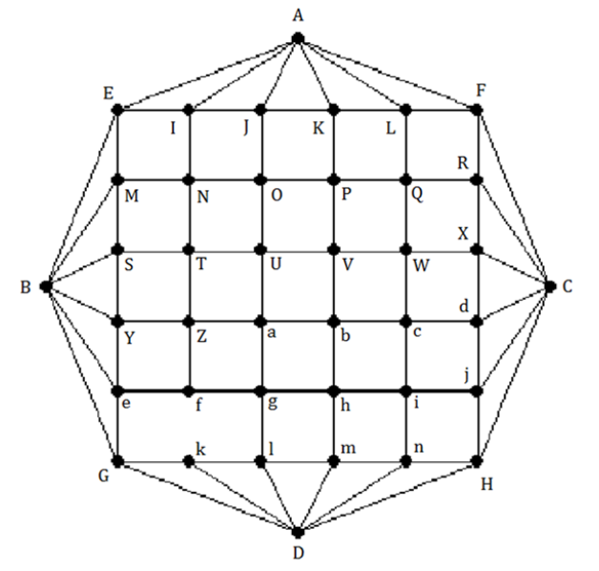

Does the following graph have an Eulerian circuit or Eulerian trail? Why?

For the graph above to have an Eulerian circuit, when all vertices of the graph have even positive degrees but vertices f and k have odd degrees, the graph above does not have an Eulerian circuit

The graph above has an Eulerian trail because this graph has exactly 2 vertices with positive odd degrees, f and k

If the graph has an Eulerian trail, based on the idea of Hierholzer's algorithm, find an Eulerian trail of the graph. Present your solution step by step.

Step 1: Choose a path (R1) starting at k, ending at f and the edges are traversed only once and are marked in yellow

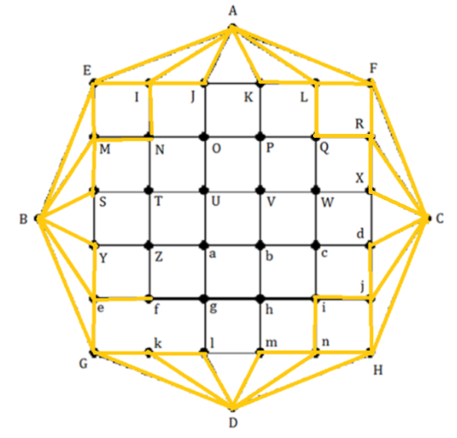

R1: k, G, D, k, l, D, m, n, D, H, n, I, j, H, C, j, d, C, X, R, C, F, R, Q, L, F, A, L, K, A, J, I, A, E, I, N, M, E, B, M, S, B, Y, e, G, B, e, f

Since does not contain all the edges of graph , the Eulerian trail has not been found yet.

Step 2: Choose vertex as a vertex on that is adjacent to an unmarked edge (edge ).

Step 3: Create a circuit () starting from vertex and using edge lm. Mark the edges of .

Q1: l, m, h, c, d, X, W, Q, P, K, J, O, N, T, S, Y, Z, f, g, h, b, c, W, V, P, O, U, V, P, O, U, V, b, a, U, T, Z, a, g, l

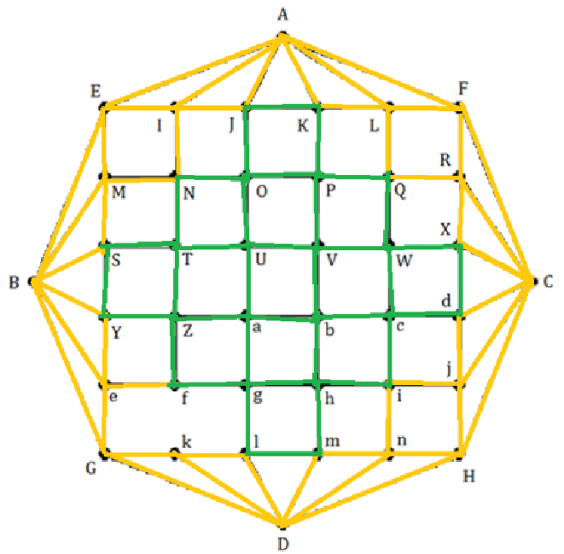

Step 4: Create trail by patching into at vertex

R2: k, G, D, k, l, m, h, c, d, X, W, Q, P, K, J, O, N, T, S, Y, Z, f, g, h, b, c, W, V, P, O, U, V, P, O, U, V, b, a, U, T, Z, a, g, l, D, m, n, D, H, n, I, j, H, C, j, d, C, X, R, C, F, R, Q, L, F, A, L, K, A, J, I, A, E, I , N, M ,E ,B ,M, S, B, Y, e, G, B, e, f

Stop Hierholzer's algorithm because already covers all edges of graph   
Problem 8:

1. 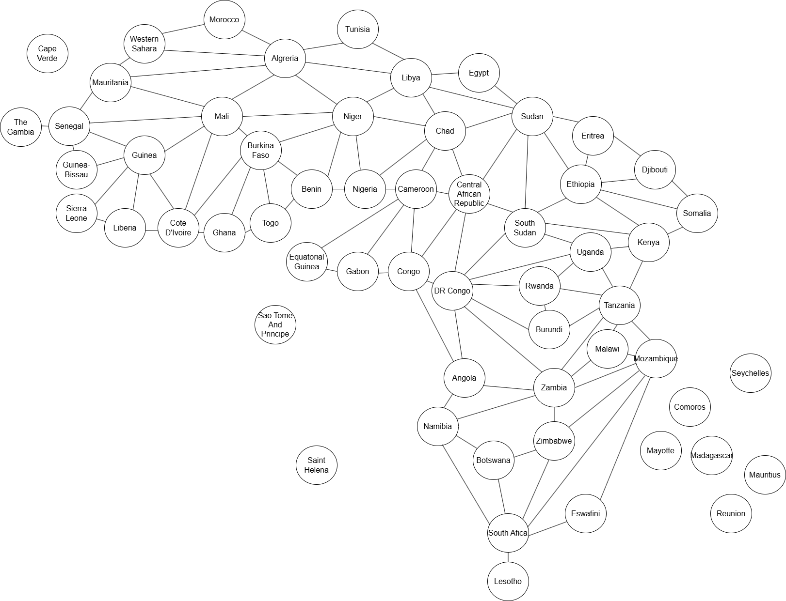The map after being modeled as graph:
2. Map coloring

Since we will color the graph from Chad, this is a “Planar Graph” because it is drawn on a plane and the edges do not intersect so the number of colors needed for this graph is

Step 1:

First, we will choose any color to color Chad, in this case yellow.

Next, we can consider the countries adjacent to Chad in the following order: Sudan, Central African Republic, Cameroon, Nigeria, Niger, Libya, Egypt respectively:

* Sudan: Because it has a common edge with Chad, it is not allowed to have the same color as Chad, so we need to color it a new color, in this case blue
* Central African Republic: Because it is adjacent to both Chad and Sudan, it is not allowed to have the same color as the above two countries (yellow and blue), so we must create a new color, in this graph it is green
* Cameroon: Although it has a common edge with Chad and Central African Republic, it is not adjacent to Sudan, so we can choose blue again while still ensuring that it does not have the same color as neighboring countries
* Nigeria, Niger, Libya we can choose alternating colors in turn green, blue, green. This will ensure that these countries do not overlap with the neighboring countries we have previously considered without adding new colors
* Egypt: Since the Sudan and Libya vertices are already colored blue and green respectively, to avoid overlapping, the color of Egypt must be yellow.

Countries such as Cape Verde, Sao Tome and Principe, Comoros, Mayotte, Madagascar, Seychelles, Mauritius, Reunion do not border other countries and do not have common edges in the graph, so we can color them without considering overlapping colors, in this graph they are colored yellow

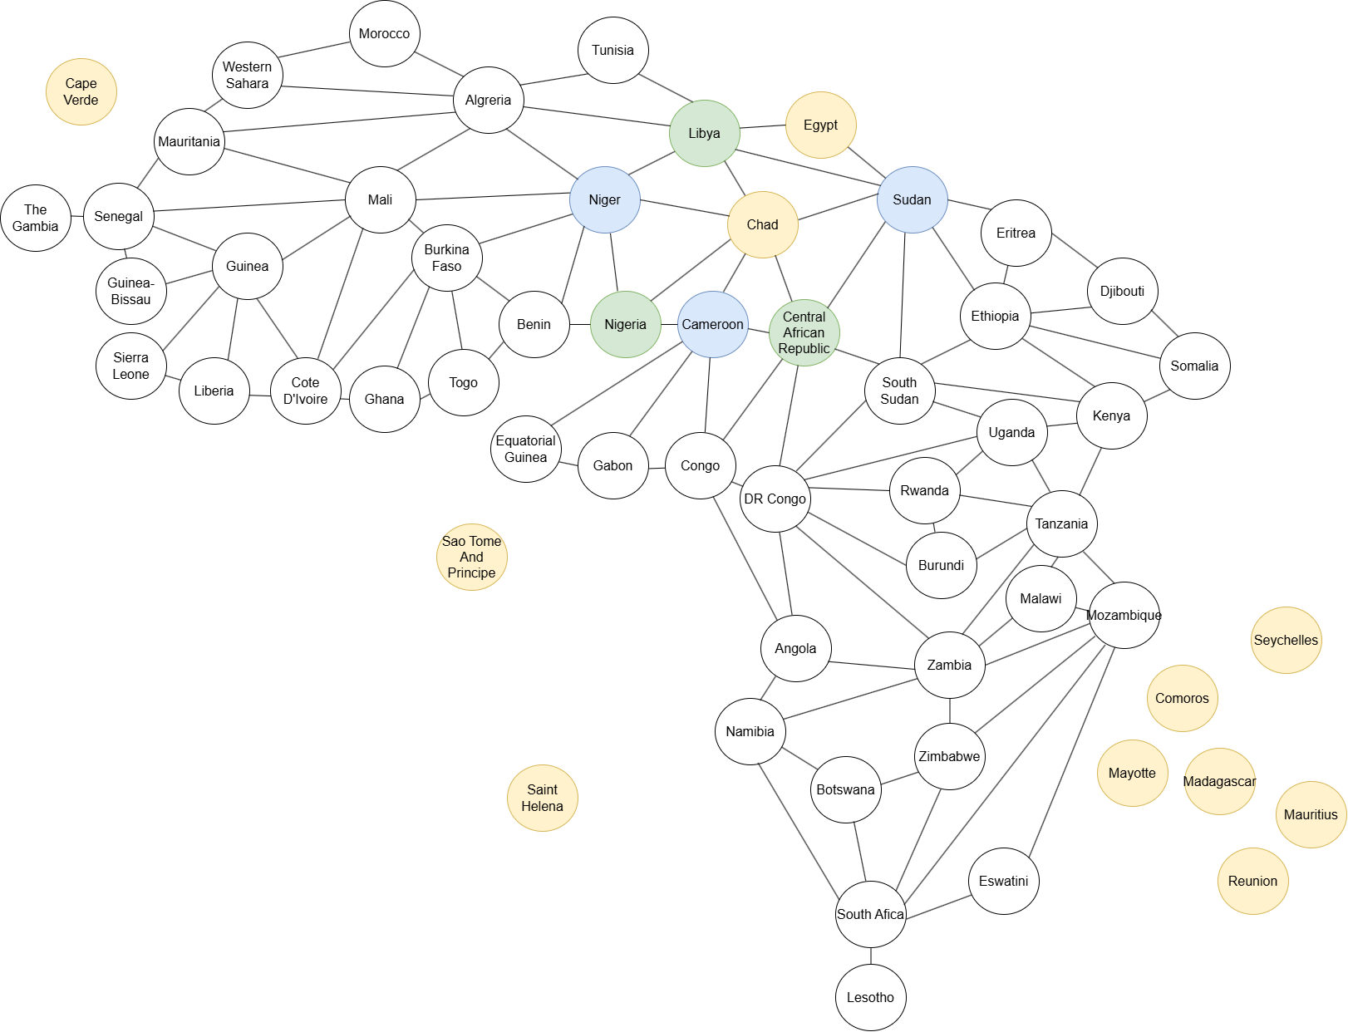

Step 2: Based on the small steps in step 1, we can consider clockwise starting from the right and in order of color priority from high to low respectively: yellow, blue, green, red (not necessarily applied, just need to ensure that adjacent vertices do not have the same color) but for the Algeria vertex, because the adjacent vertices (Tunisia, Libya, Niger, Mali) have used the previous colors (yellow, green, blue), so we have to choose a new color for the Algeria vertex to ensure that the colors between these vertices are adjacent but do not have the same color (here choose red) we have:

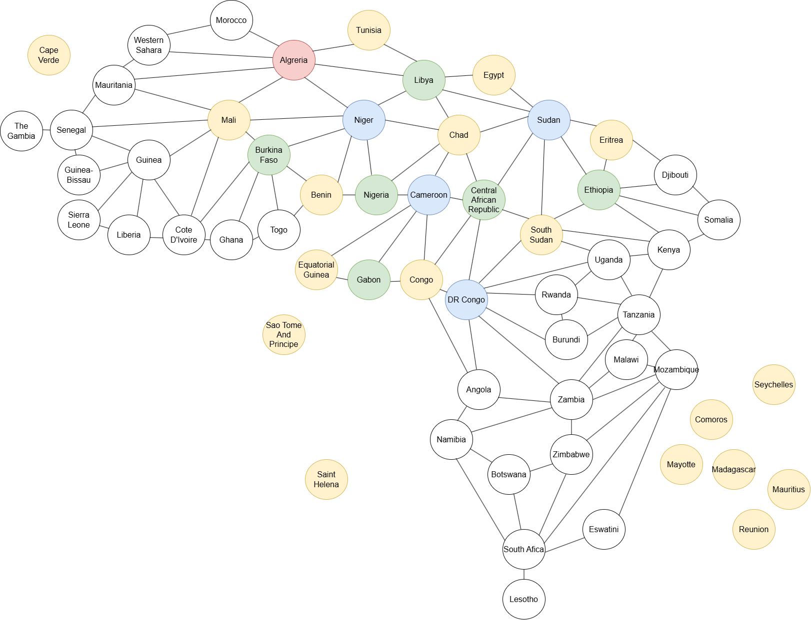

Continue the above steps to color by spreading to the vertices adjacent to the colored vertices, we get the following graph:

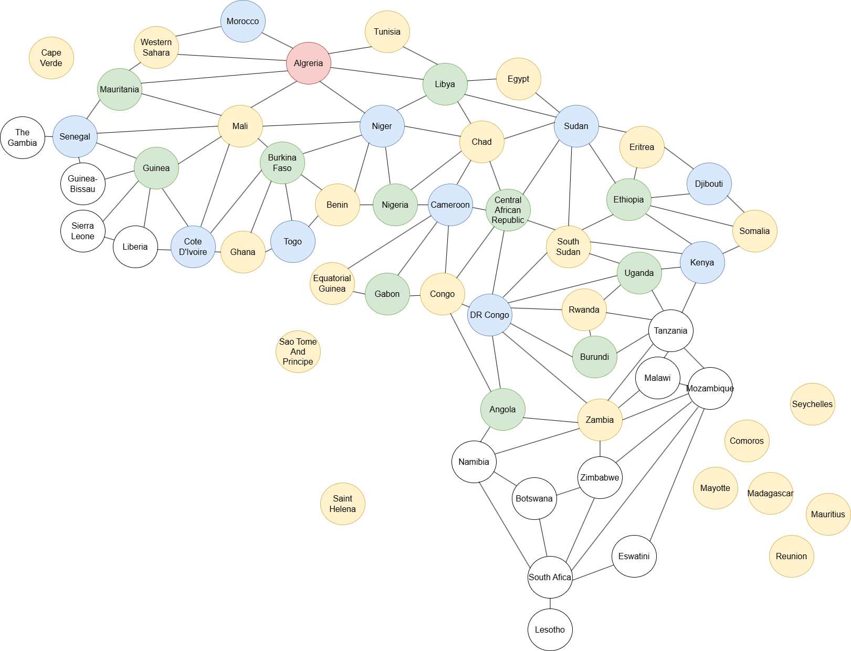

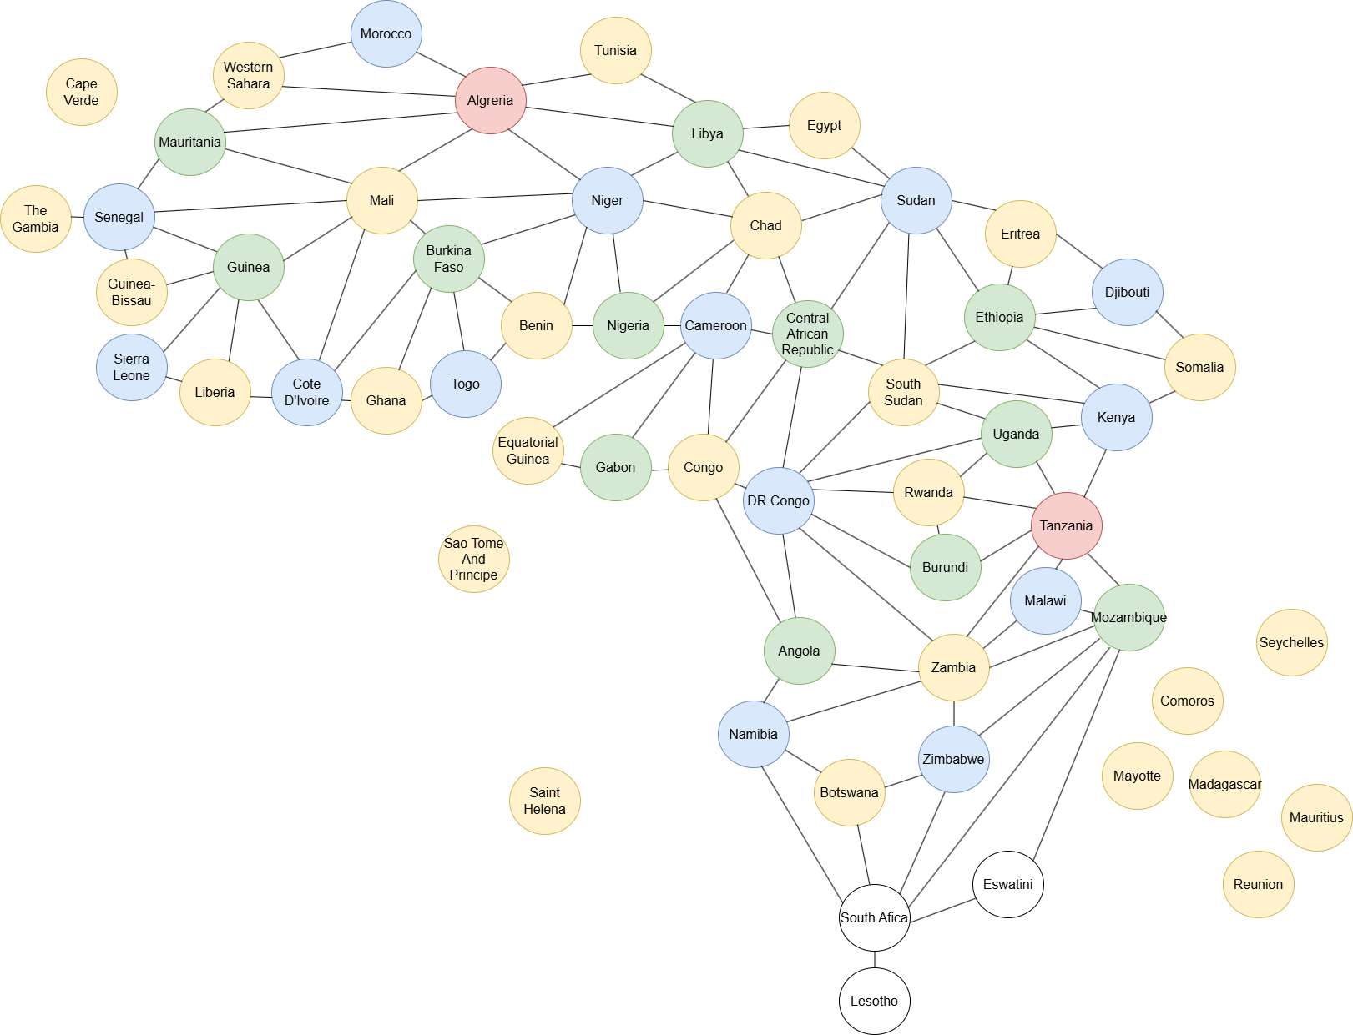

Finally we will get the colored graph as follows:

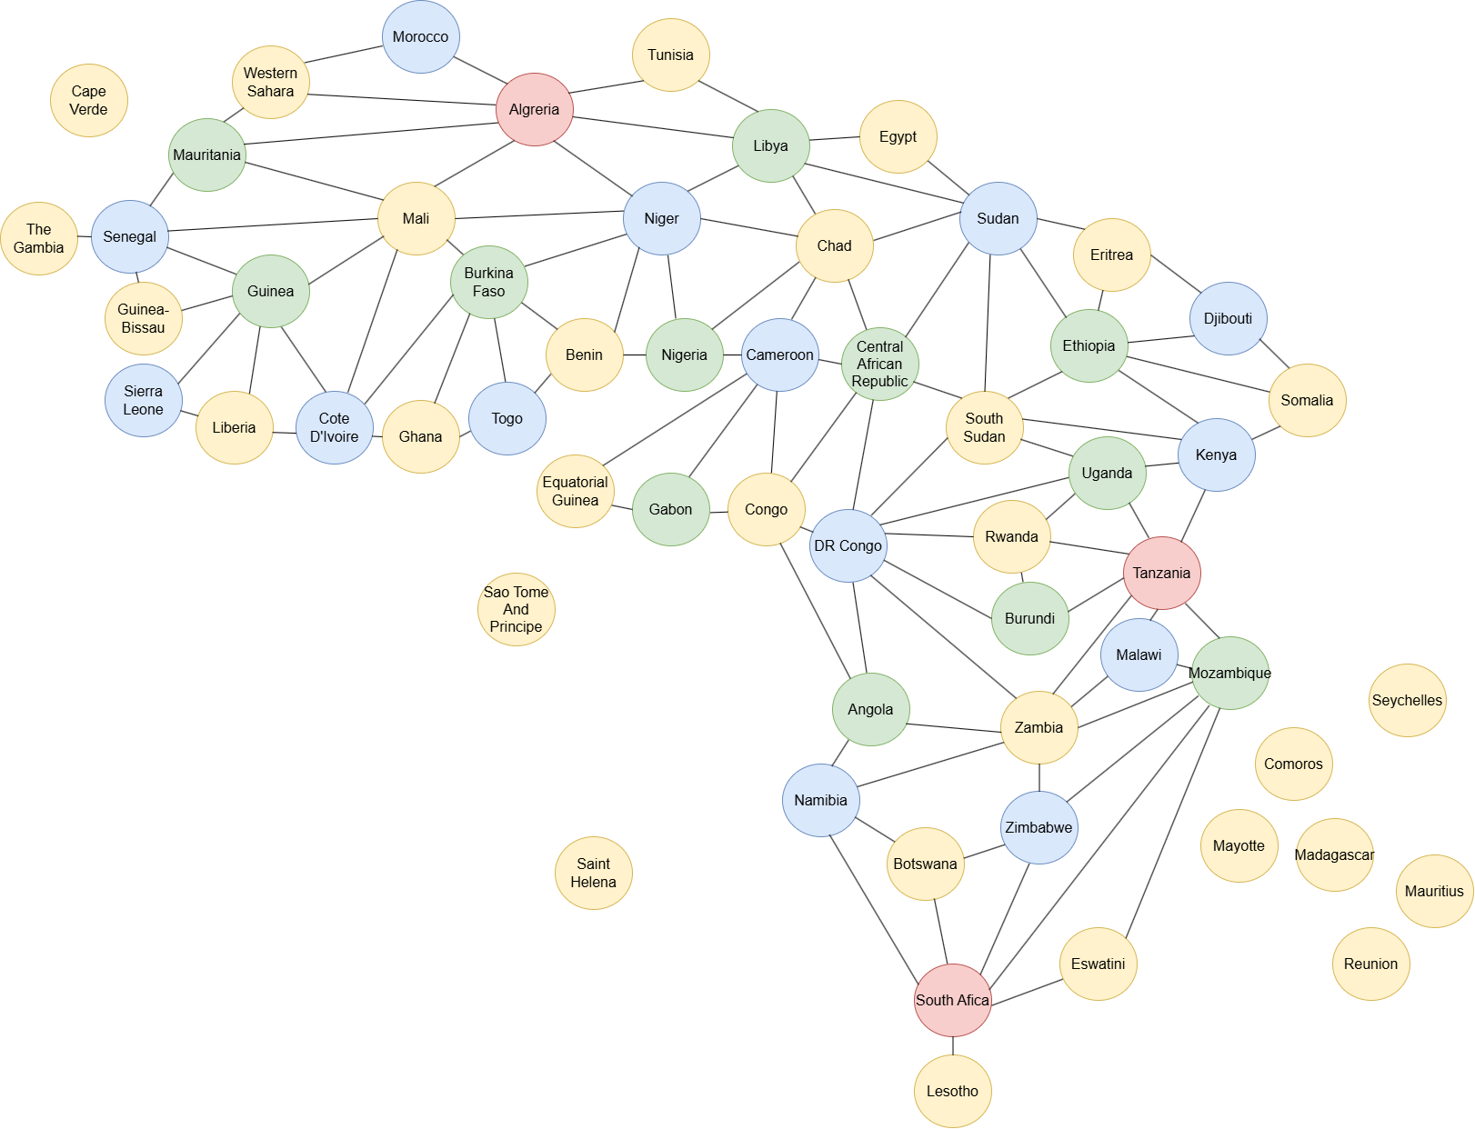

Then, based on the colored graph, convert the original map into a coloring map.

