BSQL Assignment 101

**1. Exercise 1**

**Questions to answer**:

1. Draw an ER diagram that captures this information.

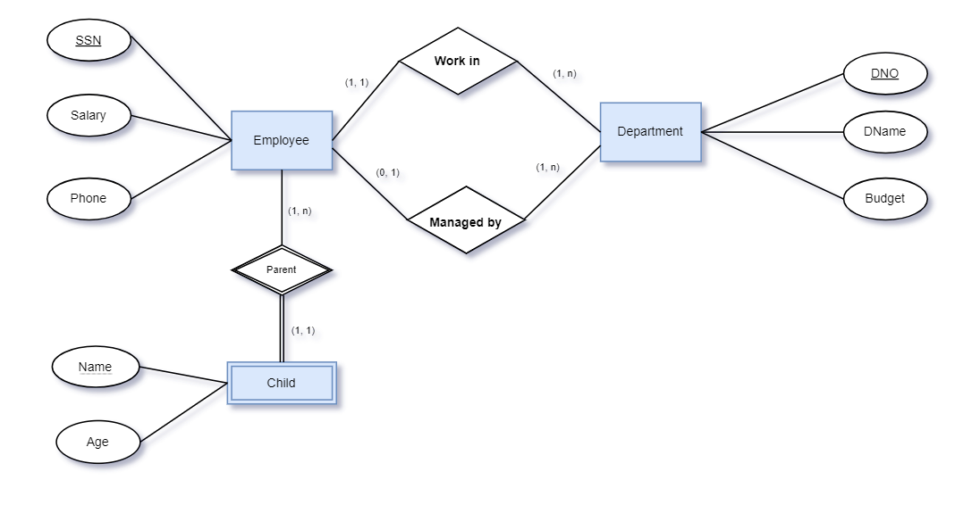

2. Convert from ER diagram to relational schema.

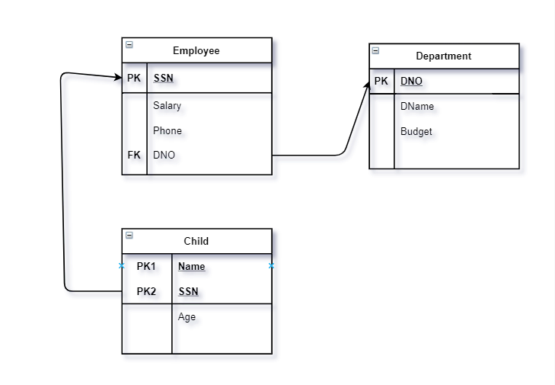

**2. Exercise 2**

Questions to answer:

Draw a relational schema diagram specifying the foreign keys for this schema.

