BSQL Assignment 103

1. Exercise 1

**Questions to answer**:

Draw the appropriate entity-relationship (E-R) diagram.

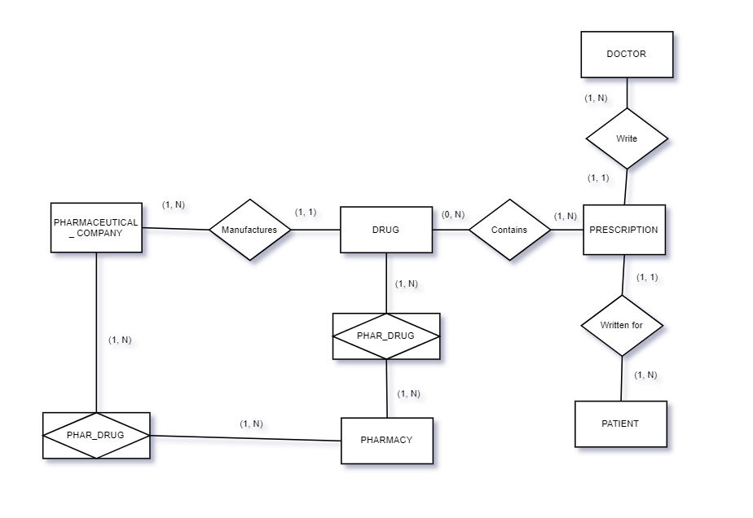

#### 2. Exercise 2

**Questions to answer**:

Draw a relational schema diagram specifying the foreign keys for this schema.

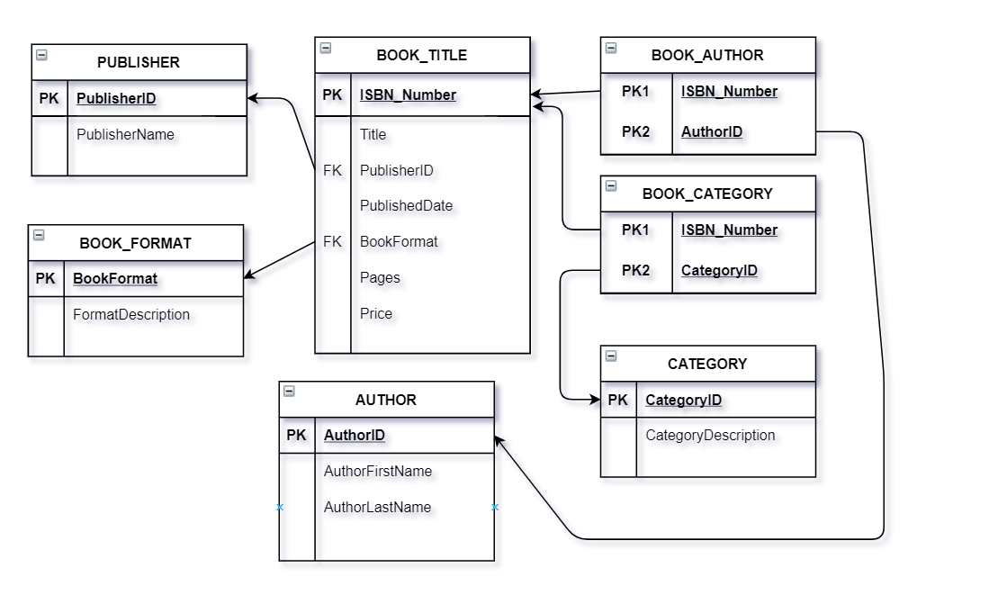

#### **3. Exercise 3**

**Questions to answer:**

You have to choose approxiate data types for these columns in order to minimize the amount of space used to store each row.

|  |  |
| --- | --- |
| Column | Data type |
| ID | serial |
| Name | varchar(100) |
| Code | char(5) |
| ModifiedDate | datetime |

#### **4. Exercise 4**

**Questions to answer**:

You have to choose approxiate data types for these columns in order to minimize the amount of space used to store each row.

|  |  |
| --- | --- |
| **Column** | Data type |
| ID | **serial** |
| Name | **nvarchar(100)** |
| BirthDate | **date** |
| Gender | **bit** |
| IsDeletedFlag | **bit** |