**Ati-Atihan Festival: The Mother of All Philippine Festivals**

Dubbed as the Mother of All Philippine Festivals, the Ati-Atihan Festival is widely known not just in the Philippines but across the world. Ati-Atihan Festival meaning is “to be like Atis or Aetas (Aklan Province’s natives).”

The celebration consists of multiple events that happen in various parts of Kalibo town. You’ll never run out of things to do because Ati-Atihan has all kinds of events— from solemn masses, loud marching bands to partying on the streets.

So if you plan to visit Boracay in January, you might as well watch the locals masquerading as Negritos in colorful costumes, chanting “Hala Bira!” while doing the Ati-Atihan Dance in Aklan.

**Ati-Atihan Festival History**

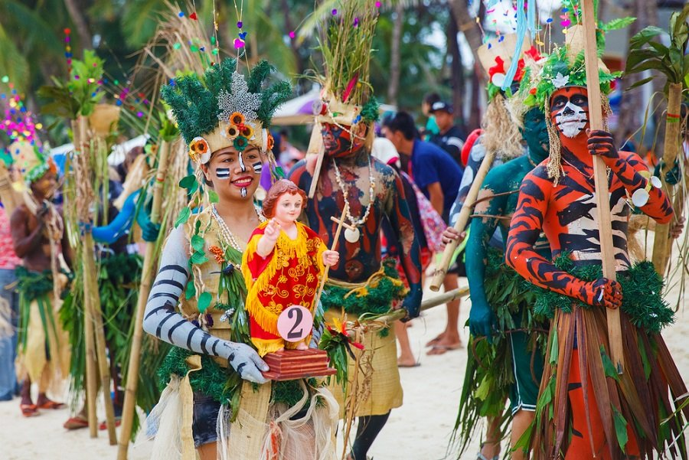

In 1975, a Catholic priest named Msgr. Jose Iturralde wrote that the origin of the Ati-Atihan Festival started from an old couple who lives in the western part of Aklan.

Msgr. Iturralde said that in the early-1700s, a fisherman went fishing in a river but caught a piece of wood instead. He threw the wood away, but it repeatedly returned to his net. The fisherman was dismayed so he just went home and decided to bring the wood. He threw it in a pile to use as fuel to cook their meal. While sleeping, the fisherman and his wife heard a beating sound. When they search where it’s coming from, they found a carving of a child on the piece of wood from the river.

The fisherman placed it in their altar. Since then, the family received blessings, including good fish harvests. After a few weeks, the fisherman sought advice from a priest  
.

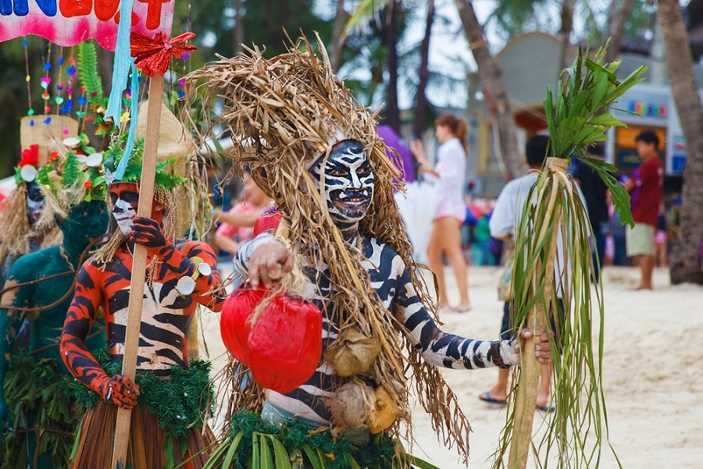

The priest asked the fisherman to place the wood at the Ibajay Parish but the wood was repeatedly disappearing and was always found at the roof of the fisherman’s house.

The Ibajay residents believed that the incident was a call for them to seek forgiveness of their sins. Part of their penance was to blacken their faces with coal and to dress in rags which later on became the Ati-Atihan Festival costume. After doing this, the piece of wood has remained and never disappeared in the church.

One day, a group of Spaniards known as the Moros from the Mindoro province tried to invade Ibajay. The residents fought back and dedicated their victory to the piece of wood.

Until now, the fight between the natives against the Spaniards is being commemorated as part of the Ibajay Ati-Atihan.

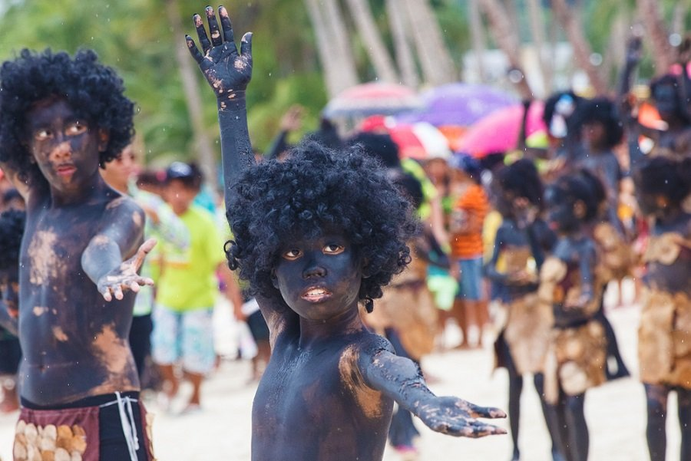

In 1798 Padre Fernando de Legaspi, a priest based in Malinao town, heard about the yearly celebration being held in Ibajay. Upon witnessing the revelry, he decided to do it, too, in the towns of Malinao and Kalibo in 1800.

And on June 11, 1871, a testament was signed by a Kalibo priest with businessmen in town to institutionalize the holding of the annual Ati-Atihan Festival.

On the other hand, there’s another legend connected to the Ati-Atihan Festival history. It was said that 10 Bornean datus sailed to Aklan to escape the dictatorship of their ruler. They accidentally landed on Panay Island and welcomed by the Aetas.

The 10 Bornean datus were believed to have bought the entire Panay Island from the Aetas with gold jewelry. This legend was, however, officially declared a myth by the National Commission for Culture and the Arts (NCCA).

**Ati-Atihan Festival 2020 Guide**

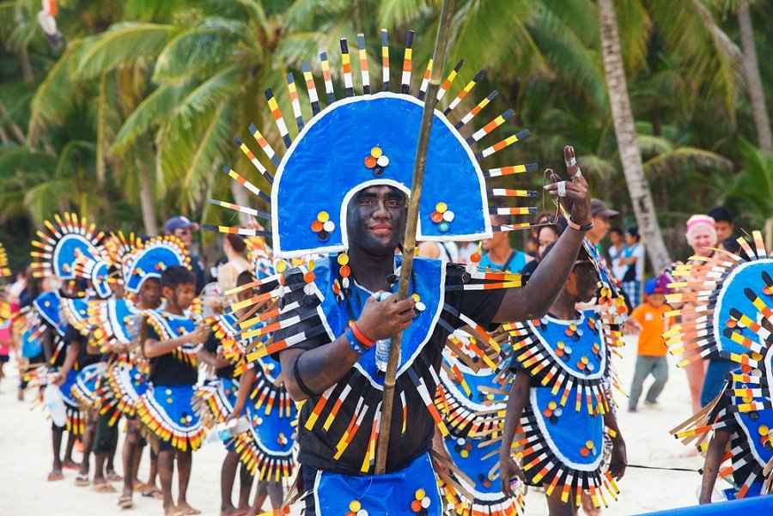

Just like any other festival, Ati-Atihan will be so much fun and tiring! But don’t let the heat and crowd spoil your trip and make the most out of your Ati-Atihan Festival 2020 experience with the help of these guides.

**1. Mind your valuables**

Though there will be security personnel around the areas of the celebration, they can’t keep an eye on each and everyone in the crowd. So keep your belongings at your sight and hold them carefully.

**2. Bring water**

Always bring water with you to keep yourself hydrated. Because most of the time, you’ll be outdoors and with the many fun activities waiting for you, for sure, you’ll get tired at some point so stay hydrated.

**3. Wear appropriate clothes**

Sure, style is a plus when going on a trip especially for the Instagrammable OOTDs but never compromise comfort for it. Wear anything comfortable and you’re willing to soil.

**4. Wear sunscreen**

Protect your skin from harmful UV rays of the sun by putting on sunblock. Don’t leave the hotel without sunblock if you don’t want to have burnt skin at the end of the day. Trust us, it hurts!

*Source: Internet*