Mid-Autumn Festival

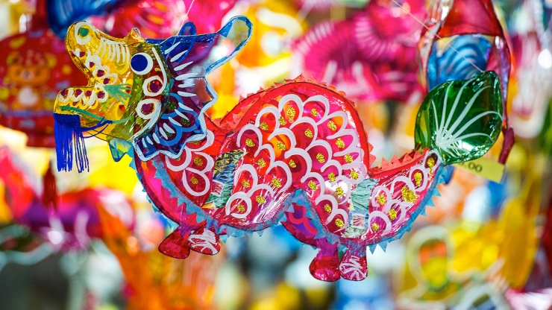

The Mid–Autumn Festival, also known as Moon Festival or Mooncake Festival, is a traditional festival celebrated by many East and Southeast Asian people.

It is the second-most important holiday after the Chinese New Year with a history dating back 3,000 years, when China's emperors worshipped the moon for bountiful harvests. The celebration is called Chuseok (autumn eve) in Korea and Tsukimi (moon-viewing) in Japan.

Lanterns of all size and shapes, are carried and displayed – as beacons to light our way to prosperity and good luck. Mooncakes, a rich pastry typically filled with sweet-bean or lotus-seed paste, are traditionally eaten during the festival.

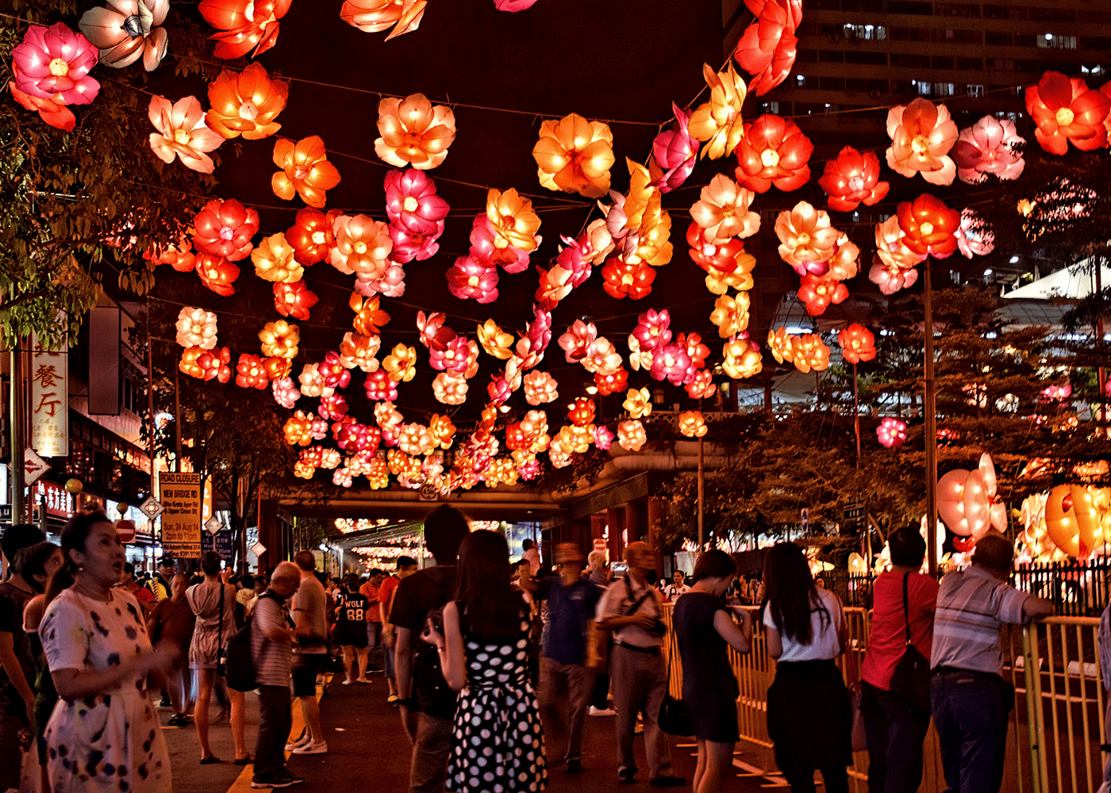

Also known as Lantern festival, Mid-Autumn festival is one of the most popular Singapore festivals. It celebrates the legend of Chang Er – the lady who, apparently floated to the moon after swallowing the elixir of eternal life and now resides on the moon. Be a part of this exciting festival in Singapore.

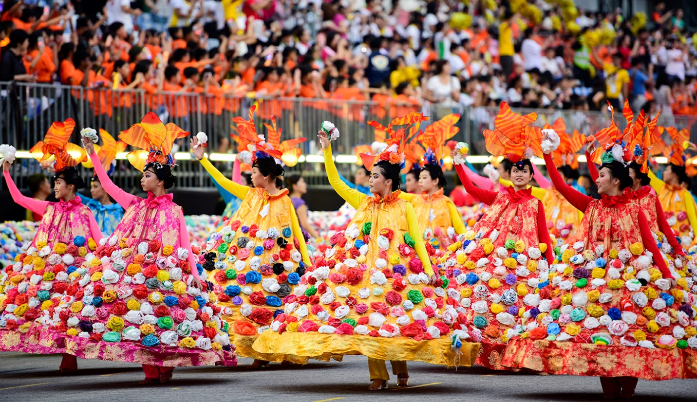

**Lantern Painting Competitions**  
Lanterns were hand-made in the early days, but are now mass-produced and purchased by parents for their children to save time. Some lanterns are in the shape of animals, and rabbit-shaped ones are the most popular in Singapore.

The lanterns on sale in stores are high-quality and of various colors, types, and patterns, including round, square, tall, and short ones.

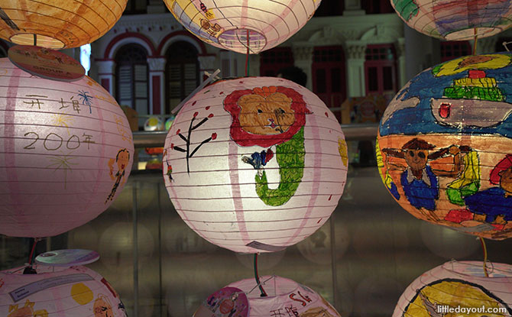

The winning lanterns will be displayed along Pagoda Street until the Mid-Autumn Festival night.

**Don’t miss:**Opening ceremony, and the beautifully decorated lantern in various shapes design  
**When:**1st October 2020