IELTS Listening Practice - Test 12

Part 1: Questions 1-10
Complete the notes below. Write NO MORE THAN TWO WORDS AND/ OR A NUMBER for each answer.
Harry’s Hire Company
Hire for: birthday party
Equipment hire:
Day and date of event: (1) _______ November
Number attending event: (2) _______
Rental: 5 dozens dinner plates, bowls
5 dozens sets of (3) _______ and _______
40 plastic (4) _______
4 dozen each small/ medium glasses
Six (5) _______
Costings:
Weekend package: 5pm Friday – 10am Monday: $1600 + tax
(6) _______ package: 5pm Saturday – 10am Monday: $1350 + tax
(7) _______ $50 (within 10Km)
Breakage allowance: $60
Replacement costs: plates, bowls – $3.55 per item
Small glasses – (8) _______ per item
Medium glasses – $4.40 per item
Customer details:
Full name: (9) _______
Address: 28B, sandstone close, martinsborough
Contact number: (10) 084 _______
Part 2: Questions 11-15
Match the creatures to their behavior. Write the correct letter A, B, C or D next to questions 11-15.
A swifts
B bats
C cockroaches
D centipedes
11. feed on the guardrail beside the path _______
12. are dangerous to people _______
13. collect in large groups _______
14. fly only at night _______
15. live on the roof of the cave _______
Questions 16 and 17
Answer the questions below. Write ONE WORD ONLY for each answer.
16. What is the guano from the caves used for? _______
17. What are the birds’ nests from the cave used for? _______
Questions 18-20
Complete the sentences below. Write NO MORE THAN TWO WORDS for each answer.
In the cave you should:
18. carry a _______
19. wear a _______ and a hat.
20. keep to the _______ at all times.
Part 3: Questions 21-23
Choose the correct letter A, B or C.
21. Mary has been called in for a meeting because
[ ] A she has been working too hard
[ ] B she has offered to lead an activity
[ ] C she is going on a training programme
22. The most important part of planning a field trip is:
[ ] A to organize activities for everyone
[ ] B to know about the official rules for field trips
[ ] C to think about and plan for problems
23. Leaders must develop
[ ] A a tailored trip plan
[ ] B an adventure activities plan
[ ] C a hazard management plan
Questions 24 and 25
Complete the sentences below. Write NO MORE THAN TWO WORDS for each answer.
24. Mary’s plan must consider _______ such as local rain or wind, the land and the party members.
25. Mary’s plan does not need to consider things such as tropical storms or serious illnesses, which are known as _______
Questions 26-30
Complete the notes below. Write NO MORE THAN TWO WORDS for each answer.
Field trip plan
Weather:
• Everyone needs warm clothing and a (26) _______
Activities:
• Hiking – first aid kit, map and a (27) _______
• Avoid routes where an avalanche, mudslide or (28) _______ is possible
Group members
• Think about the fitness and (29) _______ of the group
• Do not allow (30) _______ to be responsible for transport
Part 4: Questions 31-34
Label the diagrams below. Write NO MORE THAN TWO WORDS for each answer.
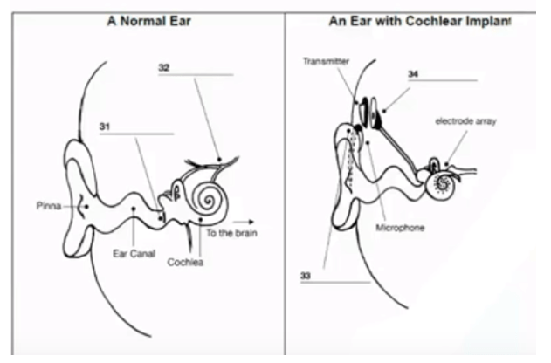
(31) _______ (32) _______
(33) _______ (34) _______
Questions 35-40
Complete the summary below. Write NO MORE THAN TWO WORDS for each answer.
Cochlear implants – Advantages, disadvantages and factors
Hearing aids (35) _______ normal sounds, so they are good for mild hearing loss but not for severe loss. Cochlear implants help some people a lot, but do not work so well for everyone. The brain gets different (36) _______ from an implant, so users must relearn how to hear. Cochlear implants are not a cure. Users need ongoing training in (37) _______ , lip-reading and sign language. The surgery can damage nerves. It may also destroy any (38) _______ ; in such cases, those users cannot go back to using a hearing aid. The most important factor for selecting users is the (39) _______ of their deafness and also age and previous speaking ability. Finally, the condition of the nerve cells in the cochlea is a factor because (40) _______ can damage these cells.

ANSWER KEY
1. Saturday 25
2. 55
3. knives/ forks
4. (garden) chairs
5. ice buckets
6. same day
7. home delivery
8. $3.50
9. Susan Millins
10. 3987695
11. C
12. D
13. B
14. B
15. A
16. fertilizer
17. soup
18. light/ torch
19. jacket
20. trails/ path
21. B
22. C
23. C
24. factors
25. events
26. raincoat
27. compass
28. flash flood
29. experience
30. student drivers
31. ear drum
32. auditory nerve
33. speech processor
34. receiver
35. amplify
36. sound signals
37. speech therapy
38. natural hearing
39. duration
40. disease

