IELTS Listening Practice - Test 15

Part 1: Questions 1-5
Complete the notes below. Write NO MORE THAN THREE WORDS OR A NUMBER.
Sunshine tours
Type of holiday: Cruise
Customers’ names: Keith Waters Age: 32
(1) _______ Waters Age: (2) _______
Interests and hobbies: travelling, swimming, jogging, (3) _______ history, reading
Budget: $7000 – $(4) _______
Dates: 1st July – 16th July
Cruise duration: at least (5) _______
Questions 6-10
Complete the notes below. Write NO MORE THAN TWO WORDS AND/ OR A NUMBER for each answer.
Maria Cristina
• Spanish boat
• Starts in Barcelona
• Cost – $10,500 (not including (6) _______ )
• All foods and drinks included
• Inside cabin (upgrade to sea view for $800)
• On board cinema (different films every night)
• (7) _______ on destinations
• Classes (ie. Painting, cooking, art appreciation and others)
• (8) _______ included
Sea Queen
• Spanish boat
• Starts in Marseille
• Length – 2.5 week cruise
• Cost – $(9) _______ (including flights)
• Sea view cabin
• Food included but not drinks
• Cinema
• (10) _______ + gym
Part 2: Questions 11-15
Complete the sentences below. Write NO MORE THAN TWO WORDS AND OR A NUMBER for each answer.
11. The Read for All charity especially targets _______ parents.
12. The Read for All charity mainly tries to contact parents at _______
13. Parents who want help with finding books can go to the Read for All charity’s centre or visit their _______
14. The Read for All charity’s app costs _______ to download to a smartphone.
15. _______ families can also benefit the Read for All charity in terms of improving English for the whole family.
Questions 16-18
Choose the correct letter A, B or C.
16. The Read for All charity gets most of its operating funds from
[ ] A the government
[ ] B one individual
[ ] C the general public
17. Jake suggests radio listeners can make a donation to the Read for All charity
[ ] A online
[ ] B by dropping into one of the charity’s centres
[ ] C by post
18. The Read for All charity can sometimes pay
[ ] A a modest hourly rate for people who work for them
[ ] B for some overnight accommodation if volunteers live far from a centre
[ ] C for workers’ expenses if they provide a receipt
Questions 19 and 20
Below is a basic map used to show where the Read for All charity’s offices are. The map has 12 locations marked A-L. Match the locations in questions 19-20 with the correct locations on the map.
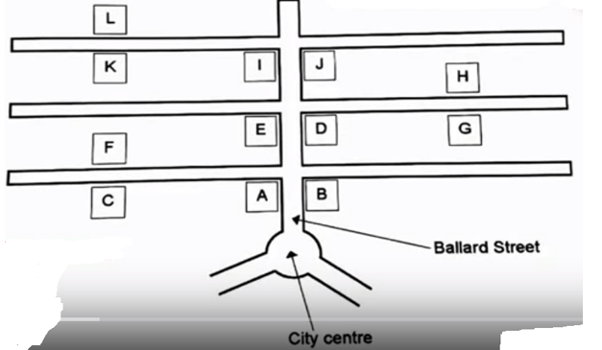
19. Cinema _______
20. Main town post office _______
Part 3: Questions 21-25
Complete the table below. Write NO MORE THAN TWO WORDS for each answer.
 | Subject | Problems | Recommendations
AMY | World (21)………………..and the car industry | (22)………………..of her sources | Check the (23)………………on the department website
WILLIAM | How (24)…………………..affects employment in northern territory | Written too much | Focus on the (25)……………..of his essay – going through the essay
(21) _______ (22) _______
(23) _______ (24) _______
(25) _______
Questions 26-30
Choose the correct letter A, B or C.
26. Why was Anna delayed starting her essay this month?
[ ] A she was sick
[ ] B she had other work to prepare
[ ] C her parents were visiting
27. Where does Mr. Stevenson recommend that Anna study?
[ ] A library
[ ] B Mr. Stevenson’s dedicated study periods
[ ] C quietly at home
28. What does Mr. Stevenson ask Anna to provide him with for an extension?
[ ] A a copy of the department rules
[ ] B a paper from her doctor
[ ] C an application form for the extension
29. What was Anna’s first possible topic to write about?
[ ] A foreign investment helped by reduces tax deals offered by the Australian government
[ ] B Australian taxes invested in overseas investment
[ ] C how foreign governments’ tax deals help Australian business investment overseas
30. What was Anna’s second possible topic to write about?
[ ] A the travel business in Australia and New Zealand
[ ] B taxation issues between Australia and New Zealand
[ ] C a history of trade between Australia and New Zealand
Part 4: Questions 31-35
Match the person with their actions (A-G).
31. The Sumerians _______
32. The Roman Emperor Valentinian _______
33. Camilo Baldi _______
34. Jean Michon _______
35. Wilheim Preyer _______
A stressed the importance of the link between handwriting and brain functions
B was the first paid for his autograph
C wrote the first signature in handwriting that we still have
D used seals to identify ownership
E started a social graphology
F first wrote about the science that was to be called graphology
G interpreted handwriting for police
Questions 36-40
Complete the summary below. Write NO MORE THAN TWO WORDS for each answer.
The development of e-signature
E-signatures have made the hand-writing signature (36) _______ Technologies such as fax and internet created a need for contracts and agreements to be signed without the presence of the signer. E-signatures did not satisfy previous basic law requirements for handwritten signatures as they did not create a (37) _______ The UN created a (38) _______ in 1996 that set out rules that allowed electronic business to go ahead as e-contracts and paper contracts would meet with (39) _______ in law. Although online businesses can use click-to-agree there is still demand for an electronic hand written signature as it can help (40) _______ in law and create human touch. This kind of hand written signature is available on software used to create electronic signatures.

ANSWER KEY
1. Melissa 2. 30 3. cinema 4. 11,000 5. 14 nights 6. flights 7. lectures 8. (travel) insurance 9. 9,000 10. (swimming) pool 11. low income 12. hospitals 13. website 14. a dollar 15. immigrant 16. B 17. A 18. C 19. D 20. G 21. oil prices 22. citations 23. (guidance) sheet 24. immigration 25. revision 26. A 27. B 28. B 29. A 30. C 31. D 32. C 33. F 34. E 35. A 36. obsolete 37. (physical) mark 38. framework 39. equal treatment 40. (legal) verification

