IELTS Listening Practice - Test 2

Part 1: Questions 1-10
Complete the form below. Write ONE WORD AND/OR A NUMBER.
ACCOMODATION FORM – STUDENT INFORMATION
Type of accommodation: hall of residence
Name: Anu (1) _______
Date of birth: (2) _______
Part 2: Questions 11-13
Complete the table below. Write NO MORE THAN THREE WORDS.
PARKS AND OPEN SPACES
Name of place | Of particular interest | Open
Halland Common | Source of River Ouse | 24 hours
Hot Island | Many different (11)……………………. | Between (12)……………..and…………….
Longfield Country Park | Reconstruction of a 2000 year old (13)……………….with activities for children | Daylight hours
(11) _______
(12) _______ and _______
(13) _______
Questions 14-16
Choose the correct letter, A, B or C.
Longfield Park
14. As part of Monday’s activity, visitors will
[ ] A prepare food with herbs
[ ] B meet a well-known herbalist
[ ] C dye cloth with herbs
15. For the activity on Wednesday,
[ ] A only group bookings are accepted
[ ] B visitors should book in advance
[ ] C attendance is free
16. For the activity on Saturday, visitors should
[ ] A come in suitable clothing
[ ] B make sure they are able to stay for the whole day
[ ] C tell the rangers before the event what they wish to do
Questions 17-20
Label the map below. Write the correct letter A-I next to questions 17-20.
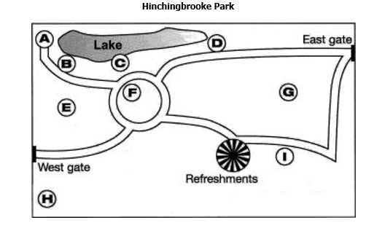
(17) bird hide _______
(18) dog-walking area _______
(19) flower garden _______
(20) wooded area _______
Part 3: Questions 21-24
Choose the correct letter, A, B or C.
Self-Access Centre
21. Students want to keep the Self-Access Centre because
[ ] A they enjoy the variety of equipment
[ ] B they like being able to work on their own
[ ] C it is an important part of their studies
22. Some teachers would prefer to
[ ] A close the Self-Access Centre
[ ] B move the Self-Access Centre elsewhere
[ ] C restrict access to the Self-Access Centre
23. The students’ main concern about using the library would be
[ ] A the size of the library
[ ] B difficulty in getting help
[ ] C the lack of materials
24. The Director of Studies is concerned about
[ ] A the cost of upgrading the centre
[ ] B the lack of space in the centre
[ ] C the difficulty in supervising the centre
Questions 25-30
Complete the notes below. Write NO MORE THAN TWO WORDS.
Necessary improvements to the existing Self-Access Centre
Equipment
Replace computers to create more space
Resources
The level of the (25) _______ materials, in particular, should be more clearly shown.
Update the (26) _______ collection.
Buy some (27) _______ and divide them up.
Use of the room
Speak to the teachers and organize a (28) _______ for supervising the centre.
Install an (29) _______
Restrict personal use of (30) _______ on computers.
Part 4: Questions 31-40
Complete the notes below. Write ONE WORD ONLY.
BUSINESS CULTURE
Power Culture
Characteristics of organization: small
(31) _______ power source
Few rules and procedures
Communication by (32) _______
Advantage: can act quickly
Disadvantage: might not act (33) _______
Suitable employee: not afraid of (34) _______
Does not need job security
Role Culture
Characteristic of organization: large, many (35) _______
Specialized departments
Rules and procedures e.g. job (36) _______ and rules for discipline
Advantages: economies of scale
Successful when (37) _______ ability is important
Disadvantages: slow to see when (38) _______ is needed
Slow to react
Suitable employee: values security
Does not want (39) _______
Task Culture
Characteristic of organization: project oriented
In competitive market or making product with short life
Advantages: (40) _______

ANSWER KEY
1. Bhatt
2. 31 March
3. nursing
4. 2
5. meat
6. bedsit
7. theatre
8. mature/ older
9. town
10. shared
11. trees
12. Friday/ Sunday
13. farm
14. C
15. B
16. A
17. A
18. I
19. F
20. E
21. C
22. B
23. B
24. C
25. reading
26. CD
27. workbooks
28. timetable/ schedule
29. alarm
30. email(s)
31. central
32. conversation(s)
33. effectively
34. risk(s)
35. levels
36. description(s)
37. technical
38. change
39. responsibility
40. flexible

