IELTS Listening Practice - Test 23

Part 1: Questions 1-5
Complete the notes below. Write NO MORE THAN TWO WORDS.
Tauber Insurance Company
Insurance type: vehicle
Policy#: (1) _______
Questions 6-10
Complete the notes below. Write NO MORE THAN TWO WORDS.
Notes to be added to policy:
Add new driver:
• Name: Samuel Michaels
• Age: 28
• Relationship to main driver: (6) _______
Reason:
• (7) _______
Client/ new driver to provide:
• Verified (8) _______ of driver’s licence
• Clean driving (9) _______
Start date:
• (10) _______ cover for 2 weeks from today
• Full cover when paperwork approved
Part 2: Questions 11-16
Complete the sentences below. Write NO MORE THAN TWO WORDS for each answer.
11. You can become more confident by using _______
12. More confidence results in better _______
13. A good strategy to build confidence is to get rid of negative memories of mistakes and failures and instead concentrate on _______
14. Frequent _______ of positive imagery is necessary for success.
15. Mental positivity is not enough-you also have to act in a confident manner-so _______ is important too.
16. Setting and achieving goals results in brain activity that brings about an experience of _______
Questions 17-20
Complete the flow chart below. Write NO MORE THAN TWO WORDS for each answer.
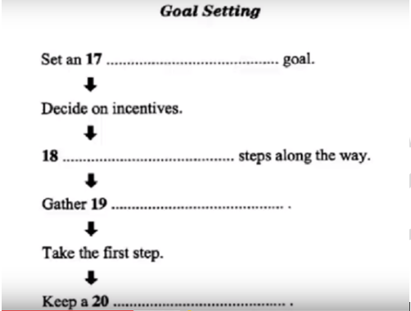
(17) _______ (18) _______
(19) _______ (20) _______
Part 3: Questions 21-23
Choose the correct letter A, B or C.
21. Julia and Bob’s science project is due
[ ] A next week
[ ] B next month
[ ] C next year
22. All the materials they use must be
[ ] A recycled
[ ] B inexpensive
[ ] C available in the lab
23. A Cartesian diver was called a devil by some people because
[ ] A they saw it was black
[ ] B they believed in the supernatural
[ ] C they wanted the inventor to be famous
Questions 24 and 25
Choose TWO letters A-E.
Julia and Bob find some of the items they need
[ ] A in Bob’s pencil case and the recycling bin
[ ] B in the cafeteria and the Resource Centre
[ ] C in the shop and Julia’s locker
[ ] D in Bob’s bag and his pocket
[ ] E in Tara’s packet and on the floor
Questions 26-30
Complete the notes below. Write NO MORE THAN TWO WORDS for each answer.
Assembly
Step 1: fold (26) _______ in half
Step 2: use (27) _______ to secure the ends
Step 3: attach (28) _______ to diver
Step 4: fill bottle with water and replace (29) _______
Step 5: demonstrate by squeezing and releasing bottle. Compression causes diver to sink because diver becomes (30) _______
Part 4: Questions 31-35
Answer the questions below. Write NO MORE THAN THREE WORDS AND/ OR A NUMBER for each answer.
31. When did Mt. Pinatubo erupt for the first time? _______
32. When was the earthquake measuring 7.8 recorded? _______
33. When did the experts begin to study Mt. Pinatubo? _______
34. What fell on the local villages on 2nd April? _______
35. What does a ‘level 5’ alert mean? _______
Questions 36-40
Complete the sentences below. Write NO MORE THAN THREE WORDS AND/ OR A NUMBER for each answer.
Several large earthquakes were triggered by the eruption of Pinatubo on 15th June 1991 because of the (36) _______ of the summit. The caldera thus created considerably reduced the height of the mountain. At the same time (37) _______ was passing by and the rain associated with it mixed with the cinders in the air to form a substance called tephra which fell on the (38) _______ of homes causing them to collapse, crushing hundreds of people.
During the eruption large amounts of Sulphur dioxide gas were emitted, which combined with (39) _______ to make sulphuric acid which was responsible for a great deal of ozone depletion above Antarctica. The overall effect of the cloud from this great eruption was the lowering of (40) _______

ANSWER KEY
1. ZQW5009
2. 2500cc
3. 22 August
4. Jack 1897
5. 15000
6. Son-in-law
7. family
8. (photo) copy
9. record
10. temporary
11. positive thinking
12. performance
13. successful outcomes
14. rehearsal
15. body language
16. happiness
17. appropriate
18. work out
19. resources
20. progress log
21. A
22. B
23. B
24. D
25. E
26. straw
27. rubber band
28. paper clips
29. cap/ lid
30. heavier
31. 5500 years ago
32. July 1990
33. mid-march 1991
34. ash
35. eruption in progress
36. collapse
37. tropical storm
38. roofs
39. water and oxygen
40. global temperatures

