IELTS Listening Practice - Test 24

Part 1: Questions 1-10
Complete the form below. Write NO MORE THAN TWO WORDS OR A NUMBER.
Short stay accommodation
Family name: Mackinlay
First name: (1) _______
Country of origin: (2) _______
Part 2: Questions 11-14
Choose the correct letter A, B or C.
11. Refreshments will be served
[ ] A at the front counter
[ ] B in the lobby
[ ] C at the back of the hall
12. Nick Noble advertise
[ ] A on the radio
[ ] B on a billboard
[ ] C in the newspaper
13. The original number of founding members was about
[ ] A 12
[ ] B 20
[ ] C 200
14. The club provides activities primarily for reasonably fit
[ ] A males up to 75
[ ] B females with young children
[ ] C males and females of any age
Questions 15-20
Complete the table below. Write NO MORE THAN ONE WORD AND/ OR A NUMBER for each answer.
Activity | Days | Duration | Contact person
(15)………….. | Tuesday and Saturday | About 3-5 hours | Coordinator
(16)………………. | Thursday and Sunday | Up to 3 hours | (17)………………
Wanderers | Sunday | (18)………………… | Leader
(19)…………..weekends | Saturday and Sunday | All weekend | (20)……………….
(15) _______ (16) _______
(17) _______ (18) _______
(19) _______ (20) _______
Part 3: Questions 21-26
Complete the notes below. Write NO MORE THAN TWO WORDS for each answer.
Globalization and educational change
• New Code (21) _______
• Aims-analysis of educational problems arising from globalization
• Chance to research and (22) _______ progress of educational change
• Investigate influence of culture and (23) _______ on education
• Argue advantages and disadvantages of reorganization of public education in own country with regard to globalization
• Consider the (24) _______ of globalization on diversity of national curricula across richer and poorer countries
• Assignment 1 – power point presentation (ungraded) + (25) _______ (30%)
• Assignment 2 – take part in (26) _______ (20%) + essay (50%)
Questions 27-30
Complete the table below. Write NO MORE THAN TWO WORDS AND/ OR A NUMBER for each answer.
Author | Title | Date
(27)………………. | Comparative education | 2007
Elliot | Educational issues of the new millennium | (28)………………..
(29)………………… | Education and globalization | 2009
York | Globalization and (30)………………………. | 2010
(27) _______ (28) _______
(29) _______ (30) _______
Part 4: Questions 31-37
Complete the summary below. Write NO MORE THAN TWO WORDS for each answer.
Everyday the human body is fighting off (31) _______ by destructive pathogens. A person in good health has natural protection in the form of an immune system which works best against familiar microorganisms which may have been encountered during a previous (32) _______ or passed on by the mother before or after birth.
Vaccination is a way to cause (33) _______ immunisation by introducing a small amout of pathogen into the body – just enough for the body’s (34) _______ to react by making antibodies. Passive immunization can be used as a way of treating someone who is already sick. Proteins from animal (35) _______ are introduced into the patient to give him the necessary antibodies to fight the disease.
Dr. Edward Jenner observed that people who had suffered and recovered from a serious disease called smallpox did not get it again. He also noted that victims of milder disease, cowpox which they caught from (36) _______ were immune to smallpox. He carried out a successful (37) _______ by deliberately giving a child cowpox in order to make him immune to smallpox.
Questions 38-40
Complete the diagram below. Choose your answers from the box below and write the letters A-F next to questions 38-40.
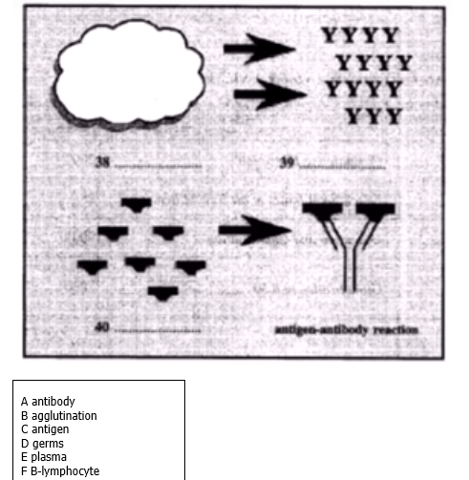
(38) _______
(39) _______
(40) _______
_______ _______ _______ Show Answers

ANSWER KEY
1. Sylvia
2. England
3. 26 July
4. 2
5. (on) holiday
6. apartment
7. secure
8. motorway
9. palm beach
10. 1500
11. B
12. A
13. A
14. C
15. tramping
16. walking
17. organiser
18. variable
19. mystery
20. chairman
21. ED995
22. document
23. socio-economic structures
24. impact
25. written reviw
26. seminar
27. tower
28. 2008
29. brown
30. knowledge policy
31. attacks
32. illness/ disease
33. active
34. defence
35. blood
36. infected cows
37. experiment
38. F
39. A
40. C

