IELTS Listening Practice - Test 28

Part 1: Questions 1 and 2
Complete the notes below. Write NO MORE THAN THREE WORDS AND/ OR A NUMBER for each answer.
Report on abandoned vehicle
Name of caller: Mrs Shefford
Address: 41, (1) _______
Part 2: Questions 11-17
Complete the sentences below. Write NO MORE THAN TWO WORDS AND/ OR A NUMBER for each answer.
The story of John Manjiro
11. Manjiro started work as a _______ when he was still a young boy.
12. He spent _______ on a deserted island before he was rescued.
13. He became friends with William Whitefield who was a ship’s _______
14. The cost of Manjiro’s _______ in America was covered by the Whitefield family.
15. Manjiro eventually returned to Japan, where he carried out important work as a teacher and _______
16. Fairhaven and Tosashimizu are now officially _______
17. Every two years, the John Manjiro _______ is held in Fairhaven.
Questions 18-20
Label the map below. Write the correct letter A-I next to questions 18-20.
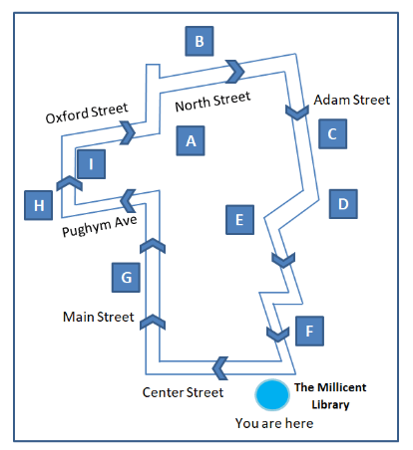
18. Whitefield family house _______
19. Old Oxford school _______
20. School of Navigation _______
Part 3: Questions 21-23
Choose the correct letter A, B or C.
21. What is the main thing Julia feels she has gained from her experience in retail?
[ ] A better understanding of customer attitudes
[ ] B improved ability to predict fashion trends
[ ] C more skill in setting priorities in her work
22. Why is Julia interested in doing the postgraduate course?
[ ] A it will enable her to develop new types of technology
[ ] B it will allow her to specialize in a design area of her choice
[ ] C it will provide managerial training focusing on her needs
23. What would Julia like to do after she has completed the postgraduate course?
[ ] A work overseas
[ ] B start her own business
[ ] C stay in an academic environment
Questions 24-27
What does each university facility have?
Choose your answers from the box and write correct letter A-G next to questions 24-27.
A laboratories
B rooms for individual study
C inter-disciplinary focus
D introductory course
E purpose built premises
F cafeteria
G emphasis on creative use
24. Library _______
25. Computer centre _______
26. Photomedia _______
27. Time based media _______
Questions 28-30
Complete the summary below. Write NO MORE THAN TWO WORDS for each answer.
MA in fashion design: Assessment
Assessment includes three (28) _______ which take place at the end of the stages of the degree. Final assessment is based on a project and includes the students’ (29) _______ in the form of a written report and the (30) _______ to which representatives of fashion companies are invited.
Part 4: Questions 31-40
Complete the notes below. Write NO MORE THAN THREE WORDS for each answer.
Laughter
The nature of laughter
• Laughter is a (31) _______ process – involves movement and sound
• It is controlled by our (32) _______
Reasons for laughter
• Only 10% of laughter is caused by jokes or funny stories
• May have begun as sign of (33) _______ after a dangerous situation
• Nowadays may help to develop (34) _______ within a group
• Connected to (35) _______ (e.g. use of humor by politicians or bosses)
• May be related to male/ female differences (e.g. women laugh more at male speakers)
• May be used in a (36) _______ way to keep someone out of a group
Benefits of laughter
• Safe method for the (37) _______ of emotions such as anger and sadness
• Provides good aerobic exercise
• Leads to drop in levels of stress-related (38) _______
• Improved the (39) _______
• Can stop (40) _______ and improve sleep

ANSWER KEY
1. lower green street
2. 01778552387
3. field
4. van
5. flyer 2000
6. blue
7. flat tyre
8. 8
9. hill farm estate
10. local
11. fisherman
12. 6 months
13. captain
14. education
15. interpreter
16. sister cities
17. festival
18. I
19. B
20. E
21. A
22. B
23. B
24. D
25. G
26. C
27. E
28. progress reviews
29. (critical) reflection
30. exhibition
31. physical
32. instincts
33. relief
34. (social) bonds
35. power
36. negative
37. release
38. hormones
39. immune system
40. bad dreams

