IELTS Listening Practice - Test 29

Part 1: Questions 1-5
Complete the table below. Write NO MORE THAN THREE WORDS AND/ OR A NUMBER for each answer.
Main programme Day 1
Time | Place | Activity
9 am | (1)……………………… | Welcome talk by Director of Studies
9.30 am |  | Talk by the (2)……………..
10am |  | Break
(3)………………..am | Classroom 4 | (4)………………….
12.30 am | (5)………………….. | Lunch
(1) _______
Questions 6-10
Label the places on the map below.
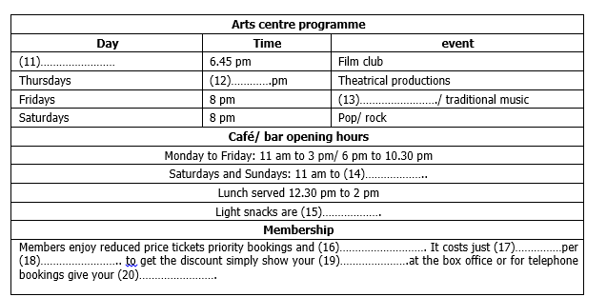
(6) _______ (7) _______
(8) _______ (9) _______
(10) _______
Part 2: Questions 11-20
Complete the notes below. Write NO MORE THAN TWO WORDS AND/ OR A NUMBER for each answer.
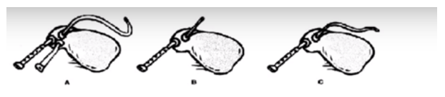
(11) _______ (12) _______
(13) _______ (14) _______
(15) _______ (16) _______
(17) _______ (18) _______
(19) _______ (20) _______
Part 3: Questions 21-28
Complete the notes below. Write NO MORE THAN TWO WORDS AND/ OR A NUMBER for each answer.
Name: John Evans
Degree: French with (21) _______
Duration of studies: 4 years
NOTE: (22) _______ months spent in Bruges, Belgium
Previous employment 1
Job: translator for restoration projects
Organization: (23) _______
Duties: liaising between building owners and (24) _______
Duration of job: (25) _______ months
Previous employment 2
Job: translator and translation (26) _______
Organization: BCFC
Duties: translation, coordinating translations in other (27) _______
Duration of job: (28) _______ months
Questions 29 and 30
Choose the correct letter A, B or C.
29. John hoped to train as a teacher because
[ ] A he hated working in the bank
[ ] B he wants to return from Paris
[ ] C he has always wanted to
30. John says living in France improved his
[ ] A French
[ ] B cultural awareness
[ ] C French and cultural awareness
Part 4: Question 31
Which picture shows the instrument described?

A. [ ]
B. [ ]
C. [ ]
Questions 32-35
Complete the notes below. Write NO MORE THAN TWO WORDS for each answer.
Part | Material | Original or new?
Blowpipe | (32)………………….. | New
Air bag | Leather | (33)……………………
Main pipe | (34)………………….. | Original
Reed | Reed | (35)……………………
(32) _______
(33) _______
(34) _______
(35) _______
Questions 36-40
Choose the correct letter A, B or C.
36. The Kentish pipe can be played
[ ] A in one way only
[ ] B in two ways
[ ] C in several ways
37. The air bag allows the player to play
[ ] A without pauses
[ ] B for a very long time
[ ] C in many different styles
38. Music originally written for Kentish pipe
[ ] A is very traditional
[ ] B is very fast
[ ] C no longer exists
39. Geoffrey will play 17th century music
[ ] A written by his colleagues
[ ] B found by his colleagues
[ ] C adapted by his colleagues
40. He will also play
[ ] A classic rock tunes
[ ] B a range of modern music
[ ] C some familiar classical pieces

ANSWER KEY
1. Hervill Hall
2. social organiser
3. 10.45
4. placement test
5. (indian) restaurant
6. P
7. S
8. R
9. B
10. C
11. sunday
12. 7.30
13. classical
14. 12 am
15. served all day
16. (monthly) newsletter
17. £15
18. year
19. (membership) card
20. (membership) number
21. film (studios)
22. 9/ nine
23. restoration vacations
24. volunteers
25. 6
26. coordinator
27. offices
28. 18
29. C
30. C
31. C
32. plastic
33. new
34. wood
35. new
36. B
37. A
38. C
39. C
40. B

