IELTS Listening Practice - Test 31

Part 1: Questions 1 and 2
Choose the correct letter A, B or C.
1. What is the name of the pub?
[ ] The Lines Ahead
[ ] B The Lion’s Shed
[ ] C The Lion’s Head
2. Which map shows Jack’s route to Margaret’s party?
[ ] A
[ ] B
[ ] C
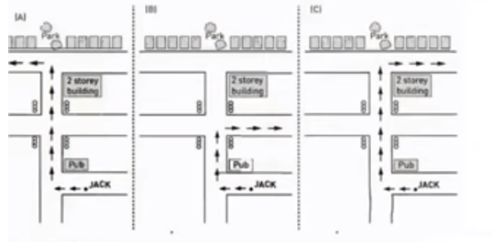
Questions 3-5
Complete the notes below. Write NO MORE THAN ONE WORD OR A NUMBER for each answer.
Complete the details for Margaret’s address:
3. Street: _______
4. Number: _______
5. Location: _______ house on the left
Questions 6 and 7
Choose the correct letter A, B or C.
6. Which statement is correct?
[ ] A Jack has got Mike’s camera
[ ] B Mike has got Jack’s camera
[ ] C Mike has sent Jack a text message
7. Jack is worried that Mike may be
[ ] A late
[ ] B lost
[ ] C early
Question 8
What is Mike’s mobile number? _______
Questions 9 and 10
Choose TWO letters A-E.
Jack cannot find the house because
[ ] A it is dark
[ ] B it is hidden
[ ] C the letterbox was behind a bush
[ ] D someone is coming down the street
[ ] E he has to call Mike
Part 2: Questions 11-13
Choose the correct letter A, B or C.
11. Who provides the money to run the park?
[ ] A the owners
[ ] B the government
[ ] C the visitors
12. When did the park move to the public open space?
[ ] A 1987
[ ] B 2000
[ ] C 2003
13. How much do primary school children pay?
[ ] A $23
[ ] B $10
[ ] C $16
Questions 14 and 15
Write T (true) or F (false)
14. Once you pay the entry fee, there are no extra costs _______
15. The park is open every day of the year _______
Questions 16-18
Complete the table below. Write NO MORE THAN ONE WORD OR A NUMBER for each answer.
Attractions
Animal | Viewing Time | Special Features
Koalas | 10 am to 4.30 pm | View koalas in natural (16)……………………………
Kangaroos | 9 am to 5.30 pm | Walk through kangaroo (17)……………………….
Wombats | 11 am, 2 pm and (18)…………………….. | Join in interactive show
(16) _______
(17) _______
(18) _______
Questions 19 and 20
Choose TWO letters A-E.
Which TWO other attractions are also mentioned?
[ ] A farmyard
[ ] B children’s show
[ ] C working farm
[ ] D country show
[ ] E volunteer program
Part 3: Questions 21-23
Complete the sentences below. Write NO MORE THAN TWO WORDS for each answer.
21. The project is about _______
22. It includes a group of fuels called _______
23. This type of fuel affects the weather by creating _______
Questions 24-26
What percentage of each fuel is used in the world?
Write the correct letter A-D next to questions 24-26.
A natural gas
B nuclear
C oil
D other
24. 45 percent _______
25. 20 percent _______
26. 8 percent _______
Questions 27-30
Choose the correct letter A, B or C.
27. Richard believes that the main problem with using fossil fuels is
[ ] A they affect everybody through global warming
[ ] B their supply will eventually run out
[ ] C they create gases that pollute the air and damage all living things
28. Shirley wants to research nuclear energy because
[ ] A the fuels used in nuclear energy release radiation even after they have been used
[ ] B she wants to know how nuclear waste is disposed of
[ ] C of public concerns over nuclear power stations situated close to where they live
29. Regarding other energy sources Richard
[ ] A is going to research renewable energy sources
[ ] B is not going to research renewable energy sources
[ ] C has not decided if he is going to research renewable energy sources
30. For the next meeting Shirley will find some information about
[ ] A the benefits of coal and oil
[ ] B alternative energy sources
[ ] C nuclear power stations
Part 4: Questions 31-40
Complete the summary below. Write NO MORE THAN THREE WORDS for each answer.
Although we cannot do anything about the plants and animals that are already (31) _______ we can do something about the many species in the world today that are in danger of becoming extinct in the future.
The main reason for the growing number of (32) _______ species is the destruction of their (33) _______ The rapidly (34) _______ human population needs more land and resources for (35) _______ This is changing and destroying the habitats that plant and animal species need for (36) _______
One way we can save endangered species and permanently (37) _______ these habitats is to create and support national parks and reserves. National parks encourage people to enjoy the (38) _______ of species without harming them.
People who visit these parks must be sure to obey few rules. These include following fire regulations, leaving (39) _______ placing all rubbish in a bin, not picking the flowers and not taking birds’ eggs.
Public (40) _______ will help ensure the survival of our plant and animal species.

ANSWER KEY
1. C
2. C
3. Wesley
4. 70
5. fifth
6. A
7. B
8. 2563379
9. A
10. C
11. C
12. C
13. B
14. T
15. F
16. environment
17. enclosure
18. 3.45 pm
19. A
20. C
21. energy consumption
22. fossil fuels
23. global warming
24. C
25. A
26. D
27. B
28. B
29. B
30. C
31. extinct
32. endangered
33. habitats
34. increasing
35. housing and food
36. survival
37. protect
38. beauty and diversity
39. pets at home
40. support (and awareness)

