IELTS Listening Practice - Test 36

Part 1: Questions 1 and 2
Complete the notes below. Write NO MORE THAN TWO WORDS AND/ OR A NUMBER for each answer.
The caller works as a teacher
1. There will be _______
Questions 3-8
Complete the notes below. Write NO MORE THAN THREE WORDS AND/ OR A NUMBER for each answer.
Name of client: (3) _______
Address: Down Language School, Down House, (4) _______ Brighton
Contact number: (5) _______ to be contacted on 01273512634
Pick-up time: (6) _______
Return time: (7) _______
Purpose of hire: visit to Stonehenge and (8) _______
Questions 9 and 10
Answer the questions below using NO MORE THAN THREE WORDS for each answer.
9. What does the cost of hiring the coach include? _______
10. Who does the customer have to speak to before confirming the booking? _______
Part 2: Questions 11-15
Map the places and write correct letter next to questions 11-15.
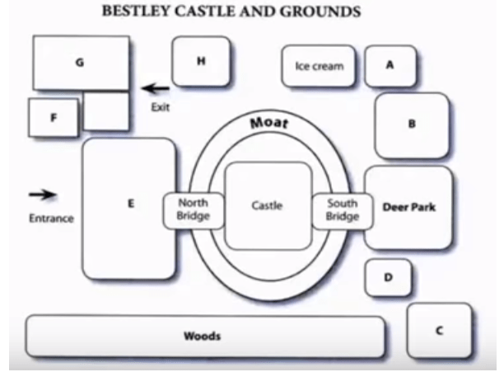
11. tourist information _______
12. Car park _______
13. Museum _______
14. picnic area _______
15. Gift shop _______
Questions 16-18
Which THREE activities or events do you need to pay to get in?
Choose THREE letters A-F.
[ ] A museum
[ ] B castle
[ ] C fireworks
[ ] D gardens
[ ] E rock concert
[ ] F jazz concert
Questions 19 and 20
Answer the questions below. Write NO MORE THAN TWO WORDS AND/ OR A NUMBER for each answer.
19. How often is the charity event held? _______
20. Who does the Age Concern help? _______
Part 3: Questions 21-26
Choose the correct letter A, B or C.
21. Before giving his presentation Paul is worried about
[ ] A choosing what information to use
[ ] B not remembering what to say
[ ] C organizing the projection equipment
22. Paul’s friends advise him not to
[ ] A speak about popular periods
[ ] B talk at length about art history
[ ] C speak too quickly in the presentation
23. Why does Paul like the idea of the timeline?
[ ] A it will be visually pleasing
[ ] B it will save some time
[ ] C it will keep him focused
24. Paul is going to show famous works of art to
[ ] A show people that he has good taste
[ ] B make people think about what counts as art
[ ] C prove that modern art is not as good as classic art
25. Paul wants his presentation to
[ ] A change personal opinions
[ ] B create a big fight
[ ] C start an exciting debate
26. What does Isabel say about modern artists?
[ ] A they are skillful
[ ] B they paint like children
[ ] C they have a sense of freedom
Questions 27-30
Complete the notes below using NO MORE THAN TWO WORDS for each answer.
Tips to find pictures
• Go to fine art section in (27) _______
• Ask (28) _______ for access to slide bank
• If not, use the (29) _______
• Find pictures using a (30) _______
Part 4: Questions 31-33
Choose the correct letter A, B or C.
31. What does the speaker say about newspapers?
[ ] A they never report developments in science accurately
[ ] B he became interested in his subject because of a newspaper report
[ ] C they only report developments in renewable energy technology
32. What significant event took place in 1956?
[ ] A scientists discovered a new source of energy
[ ] B a new type of power station came into service
[ ] C Helium was first produced from hydrogen
33. What does the speaker consider to be the main problem with nuclear fusion?
[ ] A irresponsible scientists make false claims on the subject
[ ] B it takes too long to produce the required reaction
[ ] C the reaction has not produced usable quantities of energy
Questions 34 and 35
Complete the sentences below. Write NO MORE THAN TWO WORDS AND/ OR A NUMBER for each answer.
34. Temperatures of at least _______ degrees are needed for fusion to take place.
35. Creating the pressure required in a _______ is a major technological problem.
Questions 36-40
Complete the summary below. Write NO MORE THAN TWO WORDS for each answer.
In order for nuclear fusion to produce useful quantities of energy isotopes of hydrogen must be brought together at extremely high temperatures and pressures. A number of (36) _______ will suspend the fuel so that it does not come into contact with the sides of the (37) _______ Another one will raise the temperature of the fuel pellet to that required to start the (38) _______ Extra energy released in this process will be used to produce (39) _______ that can be used to generate electricity. It is believed that the amount of energy that can be produced from (40) _______ of fusion fuel is equivalent to that which can be produced from 10000 tonnes of fossil fuel.

ANSWER KEY
1. 34
2. on monday
3. Paul Scott
4. hill street
5. school secretary
6. 7.30
7. 11 pm
8. bath
9. tax and insurance
10. school accountant
11. F
12. G
13. D
14. B
15. H
16. B
17. C
18. E
19. every year
20. elderly people
21. A
22. B
23. B
24. B
25. C
26. C
27. library
28. staff
29. computers
30. search engine
31. B
32. B
33. C
34. 100 million
35. fusion reactor
36. lasers
37. reactor
38. reaction
39. steam
40. 1 kg

