IELTS Listening Practice - Test 39

Part 1: Questions 1-6
Complete the notes below. Write NO MORE THAN TWO WORDS AND/ OR A NUMBER for each answer.
Holiday booked in name of: (1) _______
Part 2: Questions 11-15
Complete the table below. Choose your answers from the box.
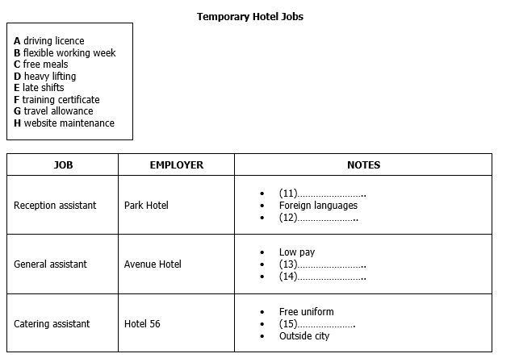
(11) _______ (12) _______
(13) _______ (14) _______
(15) _______
Questions 16-20
Complete the flow chart below. Write NO MORE THAN TWO WORDS for each answer.
Recruitment process
• Step 1: Complete a (16) _______ form
• Step 2: Do a (17) _______ questionnaire
• Step 3: If accepted go on a (18) _______ course – includes (19) _______ activities
• Step 4: Will be sent a (20) _______ about the hotel
Part 3: Questions 21-26
Complete the sentences below. Write NO MORE THAN THREE WORDS for each answer.
21. David feels that progress on the project has been slow because other members of the group are not _______
22. Jane thinks that _______ were not clearly established.
23. Dr. Wilson suggests that the group use the _______ available from the resource centre.
24. David doubts that the research will include an adequate _______
25. According to Dr. Wilson, the _______ is now the most important thing to focus on.
26. Jane believes the group could make more use of some _______
Questions 27-30
Complete the timetable below. Choose your answers for the box.
(27) _______ (28) _______
(29) _______ (30) _______
Part 4: Questions 31-35
Complete the summary below. Write NO MORE THAN TWO WORDS for each answer.
The architects who designed the London Eye originally drew it for a (31) _______ in 1993. Subsequently, they formed a partnership with (32) _______ to develop the project. As the biggest observation wheel ever built its construction involved 1700 people in five countries. Most of its components had to be (33) _______ and delivering them had to be coordinated with the (34) _______ in the River Thames. On average 350 hours a week are spent on maintenance of the Eye and only (35) _______ is used to clean the glass.
Questions 36-40
Label the diagram below. Write NO MORE THAN TWO WORDS for each answer.
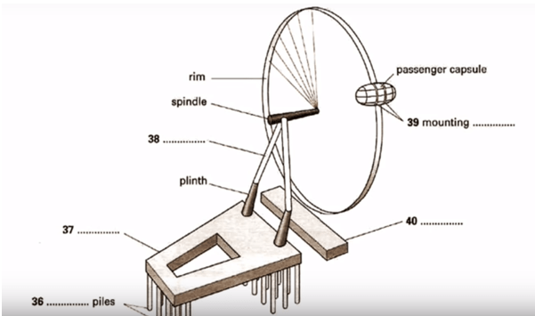
(36) _______ (37) _______
(38) _______ (39) _______
(40) _______

ANSWER KEY
1. Andrew Sharpe
2. beaconsfield house
3. 037455793
4. MH66G4
5. credit card
6. gold star
7. mid-winter
8. 16 january
9. taxi
10. bicycle
11. D
12. A
13. C
14. F
15. E
16. personal information
17. skills
18. general
19. role-play
20. video
21. following the plan
22. individual responsibilities
23. advise service
24. reference section
25. methodology
26. websites
27. H
28. B
29. G
30. E
31. competition
32. british airways
33. invented
34. tides
35. distilled water
36. tension
37. base cap
38. A-frame
39. rings
40. boarding platform

