IELTS Listening Practice - Test 4

Part 1: Questions 1-10
Complete the notes below. Write NO MORE THAN TWO WORDS OR A NUMBER.
WEST BAY HOTEL – DETAILS OF JOB
• Newspaper advert for temporary staff
• Vacancies for (1) _______
• Two shifts
• Can choose your (2) _______
Part 2: Questions 11-13
Choose the correct letter A, B or C.
Improvements to Red Hill Suburb
11. Community groups are mainly concerned about
[ ] A pedestrian safety
[ ] B traffic jams
[ ] C increased pollution
12. It has been decided that the overhead power lines will be
[ ] A extended
[ ] B buried
[ ] C repaired
13. The expenses related to the power lines will be paid by
[ ] A the council
[ ] B the power company
[ ] C local businesses
Questions 14-20
Label the map below. Write the correct letter A-H next to questions 14-20.
Road Hill Improvement Plan
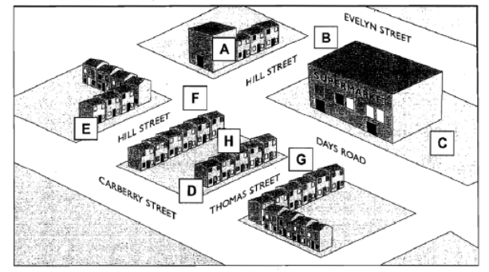
14. Trees _______
15. Wider footpaths _______
16. Coloured road surface _______
17. New sign _______
18. Traffic lights _______
19. Artwork _______
20. Children’s playground _______
Part 3: Questions 21 and 22
Choose TWO letters A-E.
In which TWO ways is Dan financing his course?
[ ] A He is receiving money from the government
[ ] B His family are willing to help him
[ ] C The college is giving him a small grant
[ ] D His local council is supporting him for a limited period
[ ] E A former employer is providing partial funding
Questions 23 and 24
Choose TWO letters, A-E.
Which TWO reasons does Jeannie give for deciding to leave some college clubs?
[ ] A She is not sufficiently challenged
[ ] B The activity interferes with her studies
[ ] C She does not have enough time
[ ] D The activity is too demanding physically
[ ] E She does not think she is any good at the activity
Questions 25 and 26
Choose the correct letter, A, B or C.
25. What does Dan say about the seminars on the course?
[ ] A The other students do not give him a chance to speak
[ ] B The seminars make him feel inferior to the other students
[ ] C The preparation for seminars takes too much time
26. What does Jeannie say about the tutorials on the course?
[ ] A They are an inefficient way of providing guidance
[ ] B They are more challenging than she had expected
[ ] C They are helping her to develop her study skills
Questions 27-30
Complete the flow chart below. Write NO MORE THAN TWO WORDS OR A NUMBER.
Advice on exam preparations
Step 1: Make sure you know the exam requirements
Step 2: Find some past papers
Step 3: Work out your (27)…………for revision and write them on a card
Step 4: Make a (28)……………and keep it in view
Step 5: Divide revision into (29)…………….for each day
Step 6: Write one (30)…………….about each topic
Step 7: Practice writing some exam answers
(27) _______ (28) _______
(29) _______ (30) _______
Part 4: Questions 31-36
Australian Aboriginal Rock Paintings
Which painting styles have the following features?
Write the correct letter A, B or C next to questions 31-36.
Features
31. figures revealing bones _______
32. rounded figures _______
33. figures with parts missing _______
34. figures smaller than life size _______
35. sea creatures _______
36. plants _______
Painting Styles
A Dynamic
B Yam
C Modern
Questions 37-40
Complete the notes below. Write NO MORE THAN TWO WORDS.
RAINBOW SERPENT PROJECT
Aim of project: to identify the (37) _______ used as the basis for the Rainbow Serpent
Yam Period:
• Environmental changes led to higher (38) _______
• Traditional activities were affected especially (39) _______
Rainbow Serpent Image
• Similar to a sea horse
• Unusual because it appeared in inland areas
• Symbolises (40) _______ in Aboriginal culture

ANSWER KEY
1. waiter(s)
2. day off
3. break
4. (free) meal
5. dark (colored)
6. jacket
7. 28 June
8. Urwin
9. 12.00 pm/ noon
10. reference
11. A
12. B
13. B
14. C
15. D
16. G
17. B
18. F
19. A
20. E
21. B
22. E
23. A
24. C
25. B
26. C
27. priorities
28. timetable
29. (small) tasks
30. (single) paragraph
31. C
32. B
33. C
34. A
35. B
36. B
37. animal/ creature
38. sea/ water level
39. hunting
40. creation

