IELTS Listening Practice - Test 43

Part 1: Questions 1-7
Complete the table below. Write ONE WORD AND/ OR A NUMBER for each answer.
Category | Details
Owner’s name | Bob
Model | (1)……………………….
Color | (2)……………………….
Number of cylinders | (3)……………………….
Number of doors | (4)……………………….
Extras | (5)……………………….
Price agreed ($) | (6)……………………….
Age (years) | (7)……………………….
(1) _______ (2) _______
Questions 8-10
Choose THREE answers from the list and write correct letter A-G next to questions 8-10.
Which THREE features does the owner say make his car worth buying?
A lots of registration
B being highly manoeuvrable
C being easy to park
D fuel efficiency
E quick acceleration
F good resale potential
G smoothly running engine
(8) _______
(9) _______
(10) _______
Part 2: Questions 11-16
Identify the areas on the map. Write correct letter A-J next to questions 11-16.
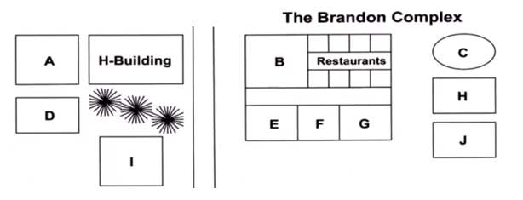
11. Wilsons _______
12. DVD shop _______
13. Student union office _______
14. Engineering institute _______
15. Fitness room _______
16. Bookshop _______
Questions 17-20
Complete the timetable. Write the correct letter A-I next to questions 17-20.
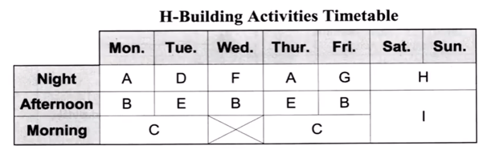
17. Yoga club _______
18. Aerobic dancing _______
19. Prayer centre _______
20. Chess club _______
Part 3: Questions 21-24
Complete the summary below. Write NO MORE THAN TWO WORDS for each answer.
The most important part of a presentation is the (21) _______ , thus it is important to use a hook, such as a surprising fact, (22) _______ , or a puzzling problem. The best presenters treat their audiences as (23) _______ and (24) _______ them in the subject matter, which they make interesting.
Questions 25-30
Complete the presentation plan. Write ONE WORD only for each answer.
Part | Subject | Details
One | (25)…………………..context | Cultural (26)………….and management styles
Two | Current perspectives | Complexity of (27)………………..workplace
Three | Mail dilemma | Review productive (28)………………..
Four | Recommendations | Theory of human (29)………………..
Five | Questions time | Prepare answers related to industrial (30)…………………..
(25) _______ (26) _______
(27) _______ (28) _______
(29) _______ (30) _______
Part 4: Questions 31-35
Complete the diagram labels. Write ONE WORD ONLY for each answer.
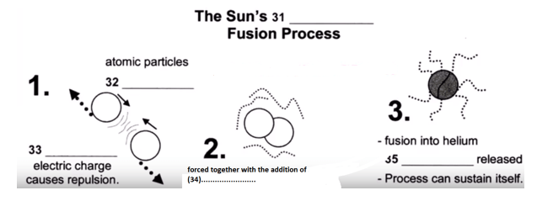
(31) _______ (32) _______
(33) _______ (34) _______
(35) _______
Questions 36-40
Complete the diagram below. Write NO MORE THAN TWO WORDS for each answer.
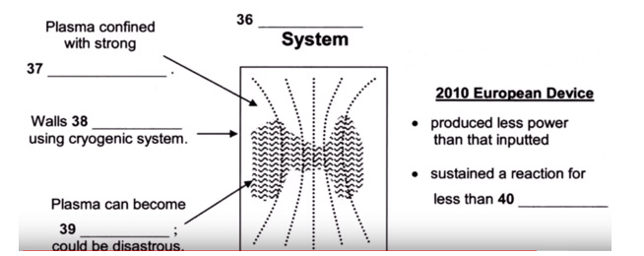
(36) _______ (37) _______
(38) _______ (39) _______
(40) _______
_______ _______ _______ Show Answers

ANSWER KEY
1. yaris
2. yellow
3. 4
4. 2
5. radio
6. 12,400
7. 3
8. C
9. B
10. F
11. B
12. G
13. E
14. I
15. H
16. F
17. C
18. E
19. I
20. G
21. first minute
22. interesting story
23. equals
24. involve
25. historical
26. differences
27. multicultural
28. diversity
29. universals
30. democracy
31. hydrogen
32. approach
33. similar
34. heat
35. energy
36. Tokamak
37. magnetic field
38. cooled
39. unstable
40. one second

