IELTS Listening Practice - Test 44

Part 1: Question 1
Complete the sentence below. Write NO MORE THAN TWO WORDS.
Mr. White is a personnel manager
1. Ms. Jones got to the interview _______
Questions 2-5
Complete the following form. Write NO MORE THAN TWO WORDS AND/ OR A NUMBER for each answer.
Personal details of applicant
Full name: Penny Ann (2) _______
Citizenship: (3) _______
Date of birth: Jan 3, 1980
Address: Flat 502, 56 (4) _______ Oxford
Home phone number: (5) _______
Email address: jenny27@hotmail.com
Question 6
Complete the following sentence with THREE WORDS.
6. Ms Jones has a degree in _______
Question 7
Choose the correct letter A-C.
7. Ms Jones says
[ ] A her major would help her satisfy various interests
[ ] B she was not at first interested in the health field
[ ] C her parents helped her to select her major
Questions 8-10
Write NO MORE THAN THREE WORDS for each answer.
8. Where is Ms Jones applying for a job? _______
9. What does Mr White call companies’ threats of job losses? _______
10. What does Ms Jones say can help companies reduce costs? _______
Part 2: Questions 11-13
Complete the following sentences with NO MORE THAN THREE WORDS for each answer.
The headmistress will first tell her visitors about her kindergarten’s (11) _______ and (12) _______
Maria Montessori is an (13) _______
Questions 14-16
Complete the following sentences with NO MORE THAN TWO WORDS for each answer.
The headmistress says playing with toys and other things can help children to develop (14) _______ She says things like (15) _______ and (16) _______ should be seen as valuable resources.
Questions 17 and 18
Write NO MORE THAN TWO WORDS for each answer.
On this map of school, A is the (17) _______ and B is the (18) _______
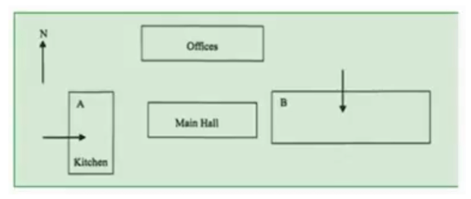
Questions 19 and 20
Complete the following sentences. Write NO MORE THAN TWO WORDS for each answer.
19. The headmistress says getting dirty in the garden is good for the children’s _______
20. There are inside the cupboard of the first classroom _______
Part 3: Questions 21 and 22
Choose TWO letters A-E.
Why was Jill late?
[ ] A she was busy doing something for Harry and Bob
[ ] B she needed to eat breakfast
[ ] C she had a problem with a shoe
[ ] D she had too many phone calls
[ ] E because of traffic jams
Questions 23-25
Answer the following questions in NO MORE THAN THREE WORDS.
23. Where does Jill say Bob and Harry go every night? _______
24. What does Jill say Bob and Harry should do first? _______
25. What does Jill consider her suggestions as? _______
Questions 26-28
Complete the following sentences with NO MORE THAN THREE WORDS for each answer.
For a few weeks, Jill wants Harry and Bob to stop (26) _______ and (27) _______ Jill wants the other two to (28) _______ timetable as soon as she leaves them.
Questions 29-30
Choose TWO letters A-F.
Jill says
[ ] A the time for reviewing is limited
[ ] B when reviewing, it is best to take a five minute break every hour
[ ] C when reviewing, one should walk around once an hour
[ ] D reviewing separately is not a good idea
[ ] E Harry and Bob should question each other regularly while reviewing
Part 4: Questions 31-35
Fill in the blanks on the following form. Use NO MORE THAN TWO WORDS AND/ OR A NUMBER for each answer.
Data collected on the town of: (31) _______
Number of households: (32) _______
(33) _______ : 31,000
Average annual household income: £83,000
No. of families with income over £50,000: (34) _______
No. of families surveyed: (35) _______
Questions 36-38
Complete the sentences below. Write NO MORE THAN TWO WORDS for each answer.
Two types of facilities that are planned to be added in the second and third years after the school opens are (36) _______ and (37) _______ And one of the most important facilities required by most parents is a (38) _______
Questions 39 and 40
Choose TWO letters A-E.
According to the talk which of the following are right?
[ ] A the club does not need a large golf practice range
[ ] B the range is close to the site of the proposed school
[ ] C the parents insist on no computer games
[ ] D the parents want a cafeteria selling fast food to save students’ time
[ ] E musical instruments are included in the budget

ANSWER KEY
1. by bus
2. Jones
3. Britosh
4. rose gardens
5. 7984865
6. public health management
7. A
8. US
9. political hot potato
10. adopting cleaner technologies
11. philosophy of education
12. teaching principles
13. educator and doctor
14. abstract ideas
15. waste
16. soil
17. dining hall
18. classroom block
19. healthy development
20. blankets
21. A
22. E
23. the bar
24. organise their time
25. basic stuff
26. going to parties
27. drinking
28. write down
29. A
30. B
31. green forest
32. 7500
33. population
34. 3200
35. 320
36. classrooms
37. residences
38. language lab
39. C
40. E

