IELTS Listening Practice - Test 50

Part 1: Questions 1-10
Complete the form below, using NO MORE THAN THREE WORDS AND/OR A NUMBER for each answer.
Area of interest: city centre
Rents: from (1) £ _______
Part 2: Questions 11-20
Complete the information below. Write NO MORE THAN THREE WORDS AND/ OR A NUMBER for each answer.
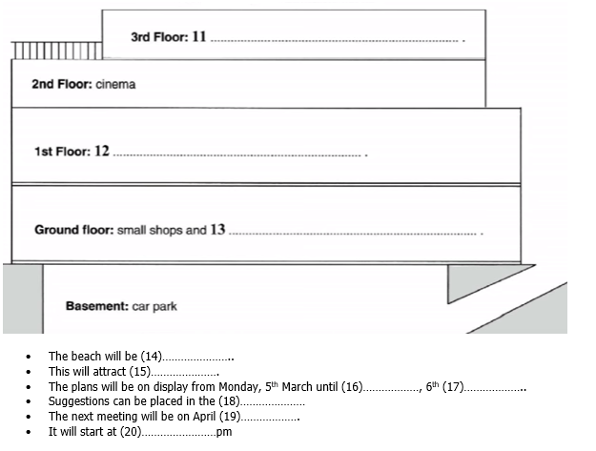
(11) _______ (12) _______
(13) _______ (14) _______
(15) _______ (16) _______
(17) _______ (18) _______
(19) _______ (20) _______
Part 3: Questions 21-25
Choose the correct letter A, B or C.
21. Maria’s essay is
[ ] A better than her previous one
[ ] B not quite as good as her previous one
[ ] C similar to her previous one
22. The tutor is impressed by
[ ] A the punctuation
[ ] B the spelling
[ ] C the style and choice of language
23. The tutor feels that Maria’s use of English is
[ ] A generally acceptable
[ ] B very poor
[ ] C perfect
24. How does Maria feel about this?
[ ] A she is very sad
[ ] B she is relieved
[ ] C she is delighted
25. How does the tutor suggest Maria can improve her spelling?
[ ] A use a dictionary
[ ] B use a computer spell checker
[ ] C avoid difficult to spell words
Questions 26-30
What suggestions does the tutor make?
Complete the list below with the correct letters A, B or C.
26. the introduction _______
27. information on the railways _______
28. the quotation from The Times _______
29. the conclusion _______
30. the bibliography _______
A Expand it
B Reduce it
C Delete it
Part 4: Questions 31 and 32
Choose the correct letter A, B or C.
31. The main problem is
[ ] A cats in towns
[ ] B the poor condition of feral cats
[ ] C public awareness
32. Emergency veterinary treatment is provided by
[ ] A the government
[ ] B a small number of people
[ ] C nobody
Questions 33-39
Complete the sentences below. Write NO MORE THAN THREE WORDS for each answer.
33. Sterilisation is usually performed only on _______
34. Sterilisation is carried out in _______
35. Cats remain there for _______
36. To show that an animal has been sterilized, one _______
Method | Message | When
Poster campaign | A kitten is not (37)……………. | now
(38)…………………. | Families may get bored with the responsibility of owning a pet | perhaps before next Christmas
Newspaper advertisements | Abandoned animals cause problems for other people | (39)………………….
(37) _______
(38) _______
(39) _______
Question 40
Choose the correct letter A, B or C.
40. A wider problem of feral cats is that they can
[ ] A injure children
[ ] B damage human health
[ ] C become infested with parasites

ANSWER KEY
1. 400
2. 2
3. 750
4. parking space
5. Cornell
6. Jayson
7. apartment
8. 5.15
9. employer
10. £60
11. cafe and restaurant
12. council offices
13. workshops
14. expanded
15. visitors
16. friday
17. april
18. box
19. 10
20. 7
21. A
22. C
23. C
24. B
25. B
26. B
27. A
28. C
29. A
30. B
31. C
32. B
33. females
34. temporary centres
35. about 24 hours
36. ear is clipped
37. just for christmas
38. radio ads
39. last year
40. B

