IELTS Listening Practice - Test 53

Part 1: Questions 1-10
Complete the notes below. Write NO MORE THAN ONE WORD OR A NUMBER.
Looking for driving lessons give during the weekends
Address: (1) _______
Part 2: Questions 11-15
Complete the sentences below. Write ONE WORD AND/OR A NUMBER for each answer.
Mount Rushmore
11. The government finally paid _______ to complete the heads of four United States Presidents.
12. The purpose of the construction of the president’s heads is to develop _______
13. The carvings face _______ to experience maximum exposure to sunlight.
14. In 1885, the mountain was renamed after a _______
15. It took _______ years to finish the project.
Questions 16-20
Label the map below. Write the correct letter A-E next to questions 16-20.
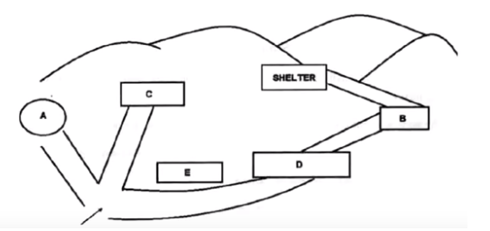
16. information centre _______
17. refreshment centre _______
18. gift shop _______
19. workshop _______
20. visitor centre _______
Part 3: Questions 21-25
Choose the correct letter A, B or C.
21. Why does the student want to study Tourism?
[ ] A good future
[ ] B good pay
[ ] C parents’ will
22.What kind of skill will the student gain in the course?
[ ] A time-management
[ ] B financial planning
[ ] C note-taking
23 The student has the ability of
[ ] A independence.
[ ] B communication
[ ] C coping well with statistics.
24 The teacher believes that the industry of tourism is
[ ] A shrinking
[ ] B seeing a bright future.
[ ] C growing popular.
25 How does the student compare the university course with polytechnics?
[ ] A There are summer schools.
[ ] B The course is structured in modules.
[ ] C The price is reasonable.
Questions 26-30
What features do the speakers identify for each of the following courses?
Choose FIVE answers from the box below and write correct letter A-G next to questions 26-30.
Features | Courses
A limited value  B useful  C relevant to career  D flexible admission  E intensive  F improving leadership  G self-control and time management | 26. Travel and business…………….  27. Japanese……………..  28. Medical care…………….  29. Computer…………….  30. Public relations……………
(26) _______ (27) _______
(28) _______ (29) _______
(30) _______
Part 4: Questions 31-40
Complete the notes below. Write NO MORE THAN TWO WORDS for each answer.
Company outsourcing
Case study – TCP Technologies:
• Manager: Manjeet Khanna
• Main target: to create a (31) _______ environment
Grading for staff:
• Every month grades are published on an (32) _______
• The cultural openness increased the quantity of incoming contracted opportunities.
• The cultural openness improved the level of (33) _______ of the company.
• The increased rate of staff satisfaction has led to growth of 32% in the (34) _______
Recent interview:
• A company is not one entity comprised of components, but a living organism composed of cells.
• Manjeet’s motto is (35) _______
Benefits of management style:
• The rate of staff turnover has been reduced.
• A (36) _______ can be from any other company.
• Grades are not used for (37) _______
Features of managing style:
• Personally, the manager wrote emails to respond to the complaints.
• The complaint form known as a (38) _______ has access to all employees online.
• The manager can receive any complaints concerning air conditioning, food quality and (39) _______ entitlement.
• A (40) _______ on the anonymous complaint was introduced in the new system.

ANSWER KEY
1. 67 King’s
2. north
3. sutcliffe
4. automatic
5. day
6. weather
7. licence
8. 50
9. 30
10. diary
11. 1 million
12. tourism
13. southeast
14. lawyer
15. 7
16. A
17. C
18. E
19. D
20. B
21. A
22. B
23. A
24. C
25. C
26. E
27. A
28. B
29. D
30. C
31. democratic
32. internal website
33. transparency
34. income
35. employee first
36. solution
37. promotion
38. ticket
39. vacation
40. ban

