IELTS Listening Practice - Test 55

Part 1: Questions 1-8
Write NO MORE THAN THREE WORDS AND/OR A NUMBER for each answer.
Country of destination: Ireland
Name: Tim (1) _______
Address to be collected from: (2) _______
Questions 9 and 10
Choose the correct letter A, B or C.
9. What is the minimum recommended cover by the agency?
[ ] A premium
[ ] B standard
[ ] C economy
10. Where does the customer want the goods delivered?
[ ] A port
[ ] B home
[ ] C business
Part 2: Questions 11-15
Label the plan below. Write NO MORE THAN THREE WORDS for each answer.
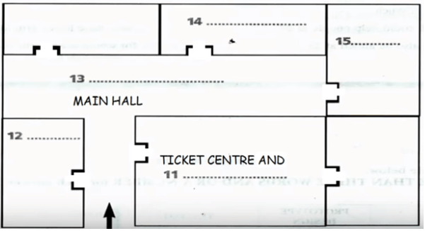
(11) _______ (12) _______
(13) _______ (14) _______
(15) _______
Questions 16-20
What does the tour guide tell her tour group about each of the following places on the day’s itinerary.
Write correct letter A, B or C next to questions 16-20. NB You may choose any letter more than once.
16. The Aquarium _______
17. Solheim country club _______
18. Milltown winery _______
19. The zoological gardens _______
20. The stout brewery _______
A They will definitely go there
B They might go there if time allows
C They certainly won’t go there
Part 3: Questions 21-25
Complete the sentences below. Write NO MORE THAN THREE WORDS for each answer.
Gyroscopes are used in laser devices and are found in many consumer (21) _______ The purpose of the project is to design a functional, (22) _______ and beneficial consumer product. The gyroscopic exercise ball can be set in motion by movements of the (23) _______ and wrist together in sync. The gyroscopic ball could help people in (24) _______ who have lower are injuries. The product could also be aimed at (25) _______ for whom lower arm strength is very important.
Questions 26-30
Complete the table below. Write NO MORE THAN THREE WORDS AND/ OR A NUMBER for each answer.
 | Prototype design | Testing
Estimated cost | £ 3,000 | (26)………………
Number of weeks | (27)………………….. | 6
 | number of test subjects | (28)……………….
 | breakdown of test subjects | 5 professional athletes
 |  | (29)……………..
 |  | 5 (30)…………….
(26) _______ (27) _______
(28) _______ (29) _______
(30) _______
Part 4: Questions 31-35
Choose the correct letter A, B or C.
31. Speakers have to know
[ ] A their material
[ ] B their audience
[ ] C their limitations
32. Experienced speakers
[ ] A always try to wing it
[ ] B never arrive unprepared
[ ] C give the best presentations
33. You should always rehearse
[ ] A with friends who can advise you
[ ] B with all the equipment you plan on using
[ ] C more than once
34. It is a good idea to
[ ] A be discreet with you audience
[ ] B meet your fans
[ ] C meet and welcome your audience
35. Taking a few deep breaths before you begin
[ ] A will stop you having a panic attack
[ ] B will guarantee that you feel more relaxed
[ ] C will help turn your tension into enthusiasm
Questions 36-40
Complete the sentences below. Write NO MORE THAN TWO WORDS for each answer.
• Try to (36) _______ yourself making a speech and imagine your voice loud and confident
• Even if you make mistakes avoid making (37) _______
• Pay attention to your (38) _______ your words carry less meaning than your delivery
• People usually remember less than (39) _______ of what they hear
• Be (40) _______ about yourself; You don’t become a perfect speaker overnight
_______ _______ _______ Show Answers

ANSWER KEY
1. Lafferty
2. Abbeyfield
3. BR89P3
4. 1.25 m
5. 1.20 m
6. music albums
7. stationery
8. £3,000
9. B
10. B
11. gift shop
12. art gallery
13. main exhibition centre
14. 3D theatre
15. modern art studio
16. B
17. A
18. C
19. A
20. B
21. appliances
22. practical
23. lower arm
24. rehabilitation
25. high performance athletes
26. £1500
27. 2
28. 15
29. 5 recovery patients
30. gym members
31. A
32. B
33. B
34. C
35. C
36. visualise
37. apologies
38. body language
39. 25%
40. realistic

