IELTS Listening Practice - Test 57

Part 1: Questions 1-5
Circle the appropriate letters A-D.
1. How long did Hannah think it would take her to find a place to live?
[ ] three weeks
[ ] B less than three weeks
[ ] C more than three weeks
[ ] D more than four weeks
2. There is not enough accommodation to rent because
[ ] A it is the end of the academic year
[ ] B Hannah is a new student
[ ] C the area has lots of new technology companies
[ ] D the town is small
3. £400 a month for rent is
[ ] A higher than Hannah has paid before
[ ] B lower than Hannah has paid before
[ ] C not cheap for the area
[ ] D cheap for the area
4. At the moment Hannah is living
[ ] A in a hostel
[ ] B in a suitcase
[ ] C in a hotel
[ ] D in a flat
5. Hannah’s new flat
[ ] A is a bit noisy
[ ] B is on the second floor
[ ] C has two bedrooms
[ ] D has a large roof terrace
Questions 6 and 7
Complete Dad’s note.
Hannah’s address:
(6) _______ Whitehart Road
(7) _______ 9RJ.
Questions 8-10
Write NO MORE THAN THREE WORDS to complete each space.
8. Hannah plans to travel to her parents’ house on Friday _______
9. Hannah’s Dad will return the van on _______
10. The journey time is about _______
Part 2: Questions 11-14
Circle FOUR letters A-H.
Which FOUR planned developments are mentioned?
[ ] A a village town hall
[ ] B a leisure centre
[ ] C a play area for children
[ ] D a hospital
[ ] E an industrial development
[ ] F extra houses
[ ] G a steel works
[ ] H a motorway
Questions 15-18
Tick Column A if the individual is in favour of the proposals. Tick Column B if the individual is against the proposals.
 | A | B
15. The Mayor
16. The conservation group spokesman
17. The local MP
18. The local shopkeeper
(15) _______ (16) _______
(17) _______ (18) _______
Questions 19 and 20
Circle the correct letter A-D.
19. Upton is
[ ] A close to Tartlesbury
[ ] B far from Tartlesbury
[ ] C connected by rail to Tartlesbury
[ ] D a town with a university
20. The College has
[ ] A never had a 100% success rate
[ ] B had a 100% success rate this year
[ ] C always been very successful
[ ] D never been successful
Part 3: Questions 21-25
Write NO MORE THAN FOUR WORDS or A NUMBER for each answer.
21. How many essays do the students have to write? _______
22. What percentage does the written exam account for? _______
23. How many marks did Carl get for his latest essay? _______
24. How many marks did Pamela get for her latest essay? _______
25. When was the marking system explained before? _______
Questions 26-30
Complete the table below. Write NO MORE THAN THREE WORDS for each answer.
 | Carl | Pamela
Research | very good, lots of (26)…………….examples | very good
Sources | very good | very good
Organization | very good | (29)……………….
Writing styles | (27)…………………… | slightly too informal in some places
Previous essay | disappointing but rewrite (28)……………….. | (30)………………….
(26) _______ (27) _______
(28) _______ (29) _______
(30) _______
Part 4: Questions 31-35
Circle the correct letters A-D.
31. The total number of lectures mentioned by the lecturer is
[ ] A ten
[ ] B thirteen
[ ] C six
[ ] D eight
32. The lunch break of the average British worker is
[ ] A on the increase
[ ] B shorter than it used to be
[ ] C 36 minutes
[ ] D precisely 30 minutes
33. Which graph shows the change as regards sick leave?
[ ] A
[ ] B
[ ] C
[ ] D
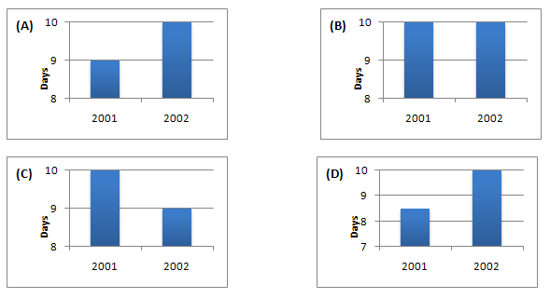
34. There will be another lecture on stress in work and study
[ ] A given by Professor Butt
[ ] B on the calendar
[ ] C in about a fortnight
[ ] D in a week’s time
35. Which of the following is mentioned?
[ ] A Most workers say they do not take all their holidays.
[ ] B Under half of the workers say they do not take all their holidays.
[ ] C Employers do not believe workers.
[ ] D About a third of healthy workers take days off sick.
Questions 36-39
Complete the table below. Write NO MORE THAN THREE WORDS for each answer.
Employees now working (36) _______ physically and mentally
Productivity up in many (37) _______
In 2002, local car plant vehicle per employee on rise to (38) _______
Car industry once though to be (39) _______
Question 40
Choose the correct letter A-D.
40. Dr Butt asks those students to see him who
[ ] A want to work at the plant
[ ] B have chosen to do the project
[ ] C want to write extra essays
[ ] D are new

ANSWER KEY
1. B
2. C
3. C
4. C
5. B
6. 22B
7. EX15
8. evening after work
9. saturday evening
10. 3 hours
11. B
12. E
13. F
14. H
15. A
16. A
17. B
18. B
19. A
20. B
21. 5
22. 50%
23. 18
24. 14
25. in first tutorial
26. relevant
27. elegant
28. impossible
29. excellent
30. much better
31. B
32. B
33. A
34. C
35. B
36. beyond their limits
37. areas of industry
38. 100
39. collapsing
40. B

