IELTS Listening Practice - Test 58

Part 1: Questions 1-3
Choose THREE letters B-H.
Which THREE other activities does the customer want to do?
A visit family
[ ] save money
[ ] C study geography
[ ] D study English
[ ] E do some winter sports
[ ] F go sailing
[ ] G join a walking tour
[ ] H meet young people
Questions 4-7
Complete the form below. Write NO MORE THAN THREE WORDS AND/OR A NUMBER for each answer.
CUSTOMER’S DETAILS
Name: Su Minx Lee
Address: (4) _______ Kew
Mobile: (5) 0402 _______
Day and date of departure: (6) _______
Length of course (7) _______
Method of payment credit card
Questions 8-10
Label the map below. Write the correct letter A-G next to questions 8-10.
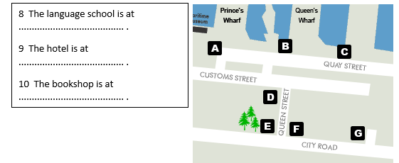
(8) _______
(9) _______
(10) _______
Part 2: Question 11-13
Complete the sentences below. Write NO MORE THAN THREE WORDS for each answer.
11. _______ are often known by their famous bridges.
12. The speaker compares a bridge to a cathedral or _______
13. Sydney Harbour Bridge is nicknamed _______
Questions 14-18
Complete the form below. Write NO MORE THAN THREE WORDS AND/OR A NUMBER for each answer.
Date | Event
1916 | (14) ……………… agreed to finance bridge
(15) …………. – 1926 | Contract signed with engineering firm Construction involved: – knocking down (16) ……….. – creation of many jobs
1932 | Bridge completed at a cost of (17) £ ……….
March 1932 | Opening ceremony: Ribbon cut by a man riding a (18) ………..
(14) _______ (15) _______
(16) _______ (17) _______
(18) _______
Questions 19 and 20
Complete the questions below. Write NO MORE THAN THREE WORDS AND/OR A NUMBER for each answer.
19. How long is the tunnel? _______
20. Name ONE thing the tunnel can withstand. _______
Part 3 : Question 21
21. Which graph shows the distribution of animals painted on the caves? _______
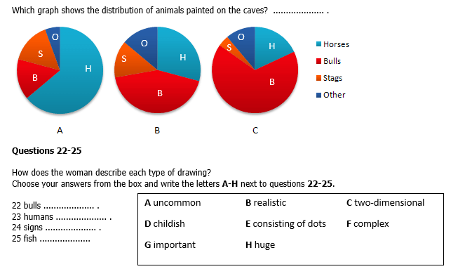
(22) _______ (23) _______
(24) _______ (25) _______
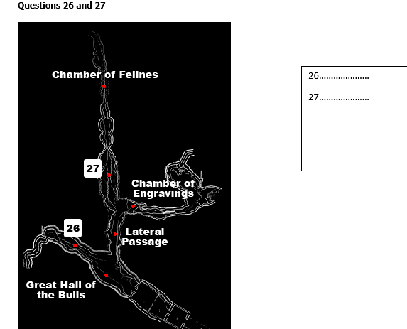
(26) _______
(27) _______
Questions 28-30
Choose the correct letter A, B or C.
28. The cave was closed in 1963 because.
[ ] A the tourists had drawn pictures on the walls
[ ] B the air was harming the rock art
[ ] C so few people were visiting the site
29. How does David feel about the closure of the cave?
[ ] A He agrees with the decision
[ ] B He thinks it was a bad idea
[ ] C He has no views on the matter
30. How can people enjoy the drawings today?
[ ] A The government has re-opened the cave
[ ] B The drawings have been photographed
[ ] C A replica of the cave has been built
Part 4: Questions 31 and 32.
Write NO MORE THAN THREE WORDS for each answer.
What is marketing?
(31) _______ and _______ represent only two aspects of marketing.
Marketing involves
• finding customers
• ensuring customer satisfaction
• (32) _______
Questions 33-34
Complete the chart below. Write NO MORE THAN TWO WORDS for each answer
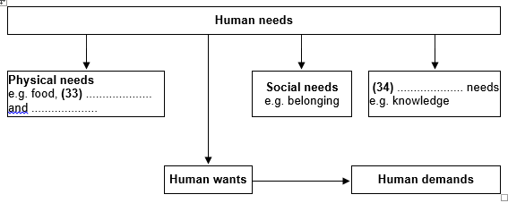
(33) _______
(34) _______
Questions 35-38
Which market research method is used by each of these businesses?
Write the correct letters A-C next to questions 35-38.
35. supermarkets _______
36. department stores _______
37. fast-food companies _______
38. theme parks _______
A customer observation
B free offers
C in-store surveys
Questions 39-40
Complete the notes below. Write NO MORE THAN THREE WORDS for each answer.
Product performance | Customers are
– poor – good – (40) …………… | – unhappy – (39) …………. – delighted
(39) _______
(40) _______

ANSWER KEY
1. D
2. E
3. H
4. 29 Loch Street
5. 558992
6. Saturday 1 May
7. 8 weeks
8. A
9. E
10. D
11. cities
12. palace
13. coat hanger
14. state/ government
15. 1924
16. 800 houses
17. 9.5 million
18. horse
19. 2.3 km
20. ship
21. A
22. H
23. D
24. E
25. A
26. painted gallery
27. main gallery
28. B
29. A
30. C
31. selling and advertising
32. making money
33. warmth and safety
34. individual
35. C
36. A
37. B
38. A
39. satisfies
40. better than expected

