IELTS Listening Practice - Test 60

Part 1: Questions 1-6
Complete the form below. Write NO MORE THAN TWO WORDS for each answer.
Requisition form
Item: (1) _______
Reasons (must give three)
Reason 1: unexpected demand
Reason 2: (4) _______
Reason 3: require (5) _______
Name: (6) _______
Questions 7-10
Complete the table below. Write NO MORE THAN TWO WORDS for each answer.
Equipment bought (previous year) | No. ordered
– (7) ………. | 2
– Computers | 17
– (8) ……… | 16
– Speakers | 15
– (9) ………… | 6
– Lamps | 27
– Fluorescent light | 34
– (10) ………. | 13
(7) _______ (8) _______
(9) _______ (10) _______
Part 2: Questions 11-15
Choose the correct letter A, B or C.
11. Arthur Island’s summer population is
[ ] A 7000
[ ] B 17000
[ ] C 22000
12. The new bridge was completed in
[ ] A 1971
[ ] B 1972
[ ] C 1974
13. The island is particularly well known for its
[ ] A motor racing
[ ] B seafood
[ ] C native wildlife
14. There will be a stop-off at a
[ ] A worm farm
[ ] B wildlife sanctuary
[ ] C scenic lookout
15. The tour price includes
[ ] A the wildlife park’s entrance fee
[ ] B a meal at Reggie’s restaurant
[ ] C tea and biscuits on the bus
Questions 16-20
Label the map below. Write the correct letter A-G next to questions 16-20.
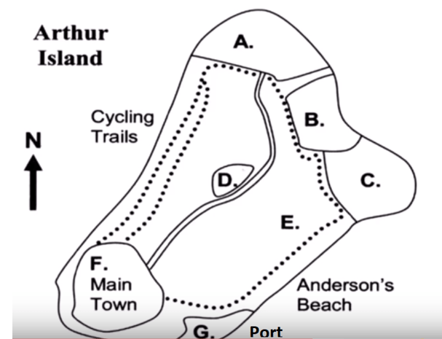
16. Wildlife park _______
17. Reggie’s restaurant _______
18. Nature reserve _______
19. Bicycle-hire shops _______
20. Main souvenir shops _______
Part 3: Questions 21-24
Complete the plan below. Write the correct letter from the list A-H next to questions 21-24.
 | 1st quarter | 2nd quarter | 3rd quarter | 4th quarter | 5th quarter
Sam | Interview people | (22) ……… | Draw conclusion and design essay structure | (23) …….. | (24) ………
Liz | (21) ………. | Gather facts | Begin writing essay | Proofread graphs and tables
(21) _______ (22) _______
(23) _______ (24) _______
A read other student’s writing
B proofread the essay
C write text summaries
D check the table of contents
E produce graphs and tables
F do theoretical research
G compile the bibliography
H analyse data
Questions 25-30
Complete the labels identifying the parts of the flyer. Write NO MORE THAN TWO WORDS for each answer.
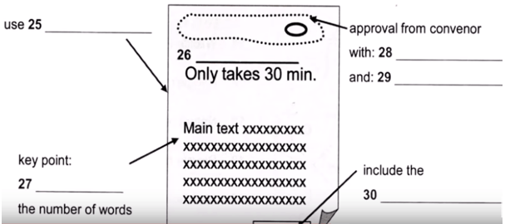
(25) _______ (26) _______
(27) _______ (28) _______
(29) _______ (30) _______
Part 4: Questions 31-34
Complete the sentences. Write NO MORE THAN TWO WORDS for each answer.
31. Movies are very influential because of their _______
32. In crime movies, the message given is that crime has _______
33. American movies are graded by a _______
34. Violence is allowed in war movies which are _______
Questions 35-40
Complete the notes below. Write NO MORE THAN TWO WORDS AND/ OR A NUMBER for each answer.
Movie-rating | Details
G | – for general audience – designed for the whole (35) ………..
PG | – movie contains some violence, suggestive humour or (36) …………
PG13 | – stronger than PG rating – allows movies to show real (37) ……. – can maximize (38) …………
R | – for a restricted audience – has stronger scenes
NC17 | – some scenes are especially (39) ……… – such movies made and shown by people (40) ……….
(35) _______ (36) _______
(37) _______ (38) _______
(39) _______ (40) _______

ANSWER KEY
1. (photo) copier
2. on going
3. immediately
4. original broken
5. more functions
6. Mike Greene
7. fax machines
8. headphones
9. mobile phones
10. (new) mouses
11. C
12. C
13. B
14. A
15. C
16. C
17. G
18. A
19. F
20. D
21. F
22. H
23. E
24. B
25. colored paper
26. easy money
27. limit
28. signature
29. department stamp
30. contact details
31. popularity
32. bad outcomes
33. trade association
34. realistic
35. community
36. scary scenes
37. society
38. viewership
39. graphic
40. independent

