IELTS Listening Practice - Test 62

Part 1: Questions 1-5
Complete the form below. Write NO MORE THAN THREE WORDS AND/ OR A NUMBER for each answer.
Survey form
Dealing with: exercise
Time contacted: (1) _______
Questions 6-10
Complete the summary. Write ONE WORD only for each answer.
The subject undertakes exercise by regularly (6) _______ She does yoga in order to relax and (7) _______ her muscles. When she was younger she would (8) _______ , and in the future, she may (9) _______ , although that will depend on whether she has enough (10) _______
Part 2: Questions 11-16
Label the floor plan. Write correct letter A-F for each answer.
11. Quiet reading _______
12. Computers _______
13. Newspapers and magazines _______
14. Reference books _______
15. Audio section _______
16. Main library _______
Questions 17-20
Complete the timetable. Write the correct letter A-J for each answer.
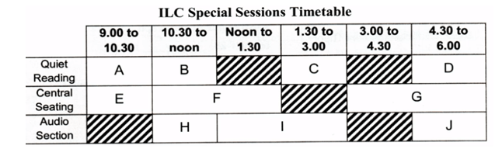
17. Teacher-led discussion _______
18. Writing skills _______
19. On-call teacher _______
20. Language exchange _______
Part 3: Questions 21-24
Complete the summary below. Write ONE WORD only for each answer.
One of the basic strategies when listening to lectures is to use (21) _______ This saves time, but it is only effective if they can be (22) _______ later. More generally, it is necessary to (23) _______ the page in anticipation of the nature of the lecture. As an example, one can draw (24) _______ , tables and flowcharts, consistent with the way the subject matter is presented.
Questions 25-30
Complete the table below. Write ONE WORD only for each answer.
Subject | Recommended page design
(25) ……… studies | Flowchart showing courtroom processes and (26) ……..
Culture studies | Table or spider-graph, linking (27) ……….. thoughts etc.
Management theory | Network (like spider-graph but has (28) ………… )
Political science | Linear (29) ………..
Mass media | Just use (30) ………….
(25) _______ (26) _______
(27) _______ (28) _______
(29) _______ (30) _______
Part 4: Questions 31-35
Complete the notes. Write NO MORE THAN TWO WORDS for each answer.
(31) _______ (32) _______
(33) _______ (34) _______
(35) _______
Questions 36-40
Complete the diagram. Write NO MORE THAN TWO WORDS AND/ OR A NUMBER for each answer.
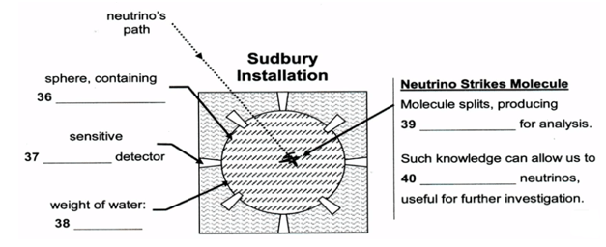
(36) _______ (37) _______
(38) _______ (39) _______
(40) _______

ANSWER KEY
1. 10.25 am
2. box hill
3. 30-39
4. domestic duties
5. married, no children
6. walking
7. tighten
8. hike
9. swim
10. energy
11. A
12. E
13. D
14. F
15. C
16. B
17. E
18. C
19. I
20. F
21. symbols
22. interpreted
23. format
24. headings
25. legal
26. procedures
27. associated
28. directions
29. notes
30. headings
31. billion
32. cleanroom
33. radiation
34. underground
35. complex
36. heavy water
37. electronic
38. 1000 tons
39. electric current
40. control

