IELTS Listening Practice - Test 63

Part 1: Questions 1-10
Complete the information below. Write NO MORE THAN TWO WORDS AND/ OR A NUMBER.
House Rental
Name: Mary Collins
Facility available: (1) _______
Part 2: Questions 11-15
Choose the correct letter A, B or C.
11. What’s the new improvement about the zoo this time?
[ ] A The zoo has built a new dog-walking area.
[ ] B The zoo has brought a new batch of animals
[ ] C The zoo has expanded its exhibition area.
12. What is the change for the new regulation enacted in June?
[ ] A The zoo is not open during the weekdays.
[ ] B Visitors are allowed to feed the animals at night
[ ] C Visitors are allowed to see the animals until the late night.
13. While visiting the kangaroo, which behaviour is forbidden?
[ ] A Photo-taking
[ ] B Shouting
[ ] C Feeding
14. Why is the pye-dog zone temporarily closed?
[ ] A Because the fence is broken.
[ ] B Because the pye-dogs are in hibernation
[ ] C Because the pye-dog zone is under construction.
15. Where can the visitors buy the discounted ticket?
[ ] A Gift shop
[ ] B Photo shop
[ ] C Reception desk
Questions 16-20
Label the map below. Write the correct letter A-H next to questions 16-20.
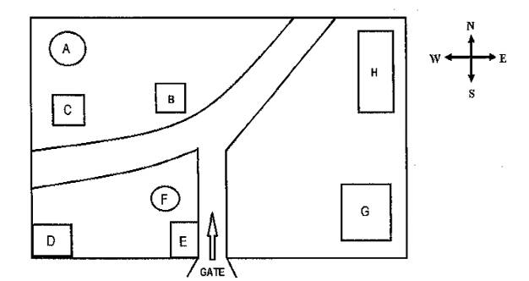
16. Bird hide _______
17. Pye-dog zone _______
18. Rest area _______
19. Kangaroo visiting site _______
20. Photo shop _______
Part 3: Questions 21-24
Choose the correct letter A, B or C.
21. The course has improved the environment since
[ ] A it was regulated by law.
[ ] B more students were involved.
[ ] C more species were brought from other places.
22. What is the biggest reason why the organisation improved greatly?
[ ] A It was funded by a private investor
[ ] B It sold out its shares.
[ ] C It got the governmental fund in the first year.
23. What is suggested from the reports?
[ ] A Resources still need management.
[ ] B Teachers and the students have benefitted from the field trips.
[ ] C The environment has been terribly damaged.
24. Who did obtain the special experience from the field trip carried out by the organisation?
[ ] A students
[ ] B teachers
[ ] C researchers
Questions 25 and 26
Choose TWO letters A-E.
What TWO problems does the report focus on?
[ ] A air pollution
[ ] B soil erosion
[ ] C overgrazing
[ ] D forest exploitation
[ ] E water pollution
Questions 27 and 28
Choose TWO letters A-E.
Which TWO benefits of this activity to the students are mentioned by the professor?
[ ] A they become more punctual
[ ] B they feel more confident
[ ] C they get practical experience
[ ] D they learn how to collect data
[ ] E they know the importance of environment protection
Questions 29 and 30
Choose TWO letters A-E.
What TWO things will the woman do in the rest of the time when no activities are going on?
[ ] A read more reference books
[ ] B study in library
[ ] C interview some teachers
[ ] D participate in one of fun hobbies
[ ] E join in some tutorials
Part 4: Questions 31-40
Complete the notes below. Write NO MORE THAN TWO WORDS for each answer.
ROBERTS COMPANY
Founding
• The most important principal of the company is to improve the (31) _______ development of camera technology.
Aim
• It was founded by Dwayne Roberts in 1957 and mainly explore (32) _______
Potential applications
• recording high-definition video
• discovering (33) _______
• searching plants in the rainforest to experiment (34) _______
• distributing more across the road network to control (35) _______
At present
• (36) _______ are the best sellers in the company.
• They are designed to look like (37) _______
• The company is working on a tiny (38) _______ to change the way people see photography.
Other applications
• Surgeries could be faster and more (39) _______
Internship opportunity
• To get it, the students can participate in the (40) _______ organised by the company every year.

ANSWER KEY
1. swimming pool
2. dining room
3. garage
4. local supermarket
5. park
6. primary school
7. garden
8. 23 April
9. 10.15
10. spring street
11. B
12. C
13. C
14. A
15. B
16. G
17. B
18. A
19. F
20. D
21. A
22. C
23. B
24. A
25. B
26. D
27. A
28. B
29. C
30. D
31. present
32. new facts
33. other planets
34. future medicine
35. traffic
36. toys
37. animals
38. camera
39. efficient
40. competitions

