IELTS Listening Practice - Test 64

Part 1: Questions 1-4
Complete the notes below. Write ONE WORD ONLY for each answer.
Name: | Barbara Hill
Location: | (1)……………………..London
Postcode: | SW105
Rooms: | Two (2)………………….bedrooms
The other room used as: | An (3)…………………….
Downstairs: | Kitchen-diner, conservatory and (4)……………….
Pets: | 2 dogs and 3 cats
(1) _______
Questions 5-7
Choose the correct letter, A, B, or C.
5. Which of these extra services does the customer agree to do?
[ ] A Change the bed linen
[ ] B Do some gardening work
[ ] C Clean the glass
6. What does the customer want cleaned every three months?
[ ] A Curtains
[ ] B Carpets
[ ] C Mats
7. What does the customer want done with clothes?
[ ] A Wash and iron the clothes
[ ] B Iron the clothes
[ ] C Clean and dry the clothes
Questions 8-10
Complete the sentences below. Write ONE WORD AND/OR A NUMBER for each answer.
The agent’s address is 12 (8) _______ Road.
Her house will get cleaned next (9) _______
The maximum time of cleaning service is (10) _______ hours
Part 2: Questions 11-17
Choose the correct letter, A, B, or C.
11. The main purpose of the service is to
[ ] A educate people.
[ ] B persuade people to fly.
[ ] C provide people with comfort.
12. The number of people working at Sydney Airport is
[ ] A 200
[ ] B 360
[ ] C 440
13. Dogs are chosen according to
[ ] A their ability to stay calm.
[ ] B their friendliness.
[ ] C their skill at locating narcotics.
14. The number of postal items processed last year amounted to
[ ] A 4,400.
[ ] B 52,000.
[ ] C 72,000.
15. People carrying items that are not allowed
[ ] A will get arrested.
[ ] B will be refused on board.
[ ] C will be given a warning.
16. Which of the following is NOT allowed to be taken on the flight?
[ ] A Carry-on items
[ ] B Plant seeds
[ ] C Parcels
17. What is the proper security protocol for a pocket knife found in a carry-on suitcase?
[ ] A It is returned to the passenger after examination.
[ ] B It is thrown away in a safe receptacle.
[ ] C It is passed on to higher-level authorities.
Questions 18-20
Complete the sentences below. Write NO MORE THAN THREE WORDS for each answer.
The acceptable material for packing goods in Australia is (18) _______
The belongings most of time are refused due to problems with the (19) _______
The customs must be given notice of the goods from (20) _______ days before it arrives in Australia.
Part 3: Questions 21-26
Write the correct letter, A-F, next to questions 21-26.
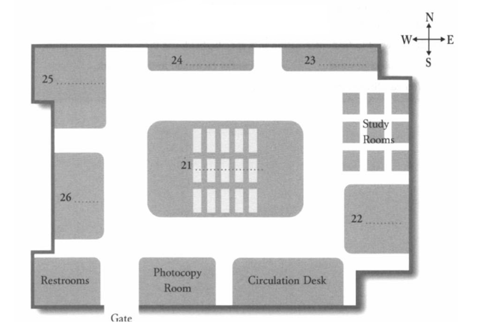
(21) _______ (22) _______
(23) _______ (24) _______
(25) _______ (26) _______
A Video resource centre
B Reading room
C Food service centre
D Periodicals section
E Enquiry desk
F Satellite TV station
Questions 27-30
Complete the sentences below. Write NO MORE THAN THREE WORDS for each answer.
If you need to find information on a certain book, you can use (27) _______ check-out cards.
If you want to find information in a specific field, use the (28) _______ guides.
Computers in some (29) _______ cannot be linked to the network.
You can find more information in a (30) _______ on my desk.
Part 4: Questions 31-35
Choose the correct letter, A, B, or C.
31. The student thought there were no crocodiles in Northern Africa because
[ ] A North Africa contains very little wildlife for the crocodile to prey on.
[ ] B she found no mention in the literature of their existence there.
[ ] C there is very little water in North Africa.
32. Generally, crocodiles live in groups of about
[ ] A 20
[ ] B 38
[ ] C 46
33. African crocodiles usually live in areas with
[ ] A hot, dry climates.
[ ] B hot, wet rainforests.
[ ] C warm, wet climates.
34. Crocodiles in dry areas live in caves located
[ ] A underground.
[ ] B in mountainsides.
[ ] C underwater.
35. What change caused changes in crocodile populations in North Africa?
[ ] A They were driven away by a fierce predator.
[ ] B Crocodiles evolved from desert creatures to wetland creatures.
[ ] C North Africa used to be wetland but slowly turned to desert over time.
Questions 36-40
Complete the sentences below. Write NO MORE THAN TWO WORDS AND/OR A NUMBER for each answer.
Desert crocodiles sometimes live in places with dry periods that last up to (36) _______ months.
A hole dug by a female crocodile in which to lay eggs can have a (37) _______ of up to 60 cm.
Local people are not (38) _______ crocodiles.
Crocodiles (39) _______ out of fear when humans populate their habitat.
Researchers want to study more about population size, (40) _______ , and relations to other populations of crocodiles.

ANSWER KEY
1. southwest
2. double
3. office
4. lounge
5. A
6. B
7. B
8. amyes
9. thursday
10. 3
11. A
12. C
13. A
14. B
15. C
16. B
17. B
18. paper
19. package labels
20. 2 to 10
21. B
22. D
23. C
24. A
25. F
26. E
27. pink and yellow
28. subjects
29. universities
30. blue folder
31. B
32. A
33. C
34. A
35. C
36. 8
37. depth
38. afraid of
39. attack
40. migration patterns

