IELTS Listening Practice - Test 67

Part 1: Questions 1-5
Complete the notes below. Write NO MORE THAN ONE WORDS AND/OR A NUMBER for each answer.
Hotel Armitage Booking Form
Name: Kelvin Jones
Booking number: (1) _______
Questions 6-10
Complete the map below. Write NO MORE THAN ONE WORD for each answer.
(6) _______ (7) _______
(8) _______ (9) _______
(10) _______
Part 2: Questions 11-13
Choose the correct letter A, B or C.
11. The SIS is
[ ] A a non-profit making organization
[ ] B owned by an international corporation
[ ] C a collective owned by ordinary people
12. The SIS
[ ] A has no fees
[ ] B has low fees
[ ] C avoids paying fees
13. SIS accounts with the same customer number
[ ] A will be charged for setting up automatic payments
[ ] B attract no service charges
[ ] C must have a minimum balance
Questions 14-20
Complete the table below. Write NO MORE THAN TWO WORDS AND/ OR A NUMBER for each answer.
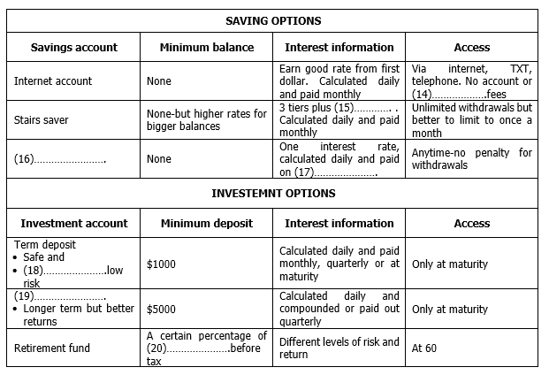
(14) _______ (15) _______
(16) _______ (17) _______
(18) _______ (19) _______
(20) _______
Part 3: Questions 21-23
Answer the questions below. Write NO MORE THAN TWO WORDS AND/ OR A NUMBER for each answer.
21. What period of English Literature will the conference cover? _______
22. How many panel discussions have been arranged? _______
23. What is the aim of a panel discussion? To present _______
Questions 24-30
Complete the notes below. Write ONE WORD ONLY.
Procedure (dealt with by prof.)
• Identify topic of interest involving some (24) _______
• Invite penalties
• Select a (25) _______
• Decide on (26) _______
Guidelines
• Introduction of topic and speakers-get (27) _______ information form prof.
• Each panelist speaks for 2 mins-make a hand (28) _______ to show time is up
• Primary function = panel discussion (about 40 mins)
• Close discussion and give (29) _______
• Secondary function = question time (about 15-20 mins)
• At end of question time panel is thanked and audience shows appreciation by (30) _______
Part 4: Questions 31-35
Complete the notes below. Write ONE WORD ONLY for each answer.
Hydropower
• Renewable-constant source of (31) _______ from natural hydrologic cycle
• (32) _______ -90% of hydro energy-electric
• Clean-no air or (33) _______ pollution
• (34) _______ and durable-simple to operate
• Flexible-can start and adapt quickly to meet demand-leads to (35) _______ of power supply
Questions 36-38
Label the diagram below. Write NO MORE THAN TWO WORDS for each answer.
(36) _______
(37) _______
(38) _______
Questions 39-40
Complete the sentences below. Write NO MORE THAN TWO WORDS for each answer.
39. To be effective, hydroelectric dams should be built across rivers with both sufficient head and _______
40. There needs to be a balance between the needs of _______ living in developed environments and the preservation of natural habitat.

ANSWER KEY
1. OOL2381420
2. HUV 3331
3. deluxe
4. (2) pillows
5. three nights
6. mexican cafe
7. mill
8. bookshop
9. kitched
10. king
11. C
12. B
13. A
14. transaction
15. bonus (interest)
16. simple saver
17. June 30
18. secure
19. bonds
20. income
21. 17 century
22. 5
23. views/ opinions
24. conflict
25. moderator/ leader
26. format
27. biographical
28. gesture
29. summary
30. applause
31. water
32. efficient
33. noise
34. reliable
35. stability
36. intake (gate)
37. generator
38. power lines
39. stream flow
40. consumers/ people

