IELTS Listening Practice - Test 69

Part 1: Questions 1-5
Complete the notes below. Write ONE WORD AND OR A NUMBER for each answer.
Celebrating 20 years
Budget for meal: (1) $ _______
Meal C: cost – $50 per head
Consists of prawns, and seafood platter with (2) _______ and oysters
Meal D: cost – (3) $ _______
Consists of (4) _______ with (5) _______ soup, dessert and coffee
Questions 6-10
Choose the correct letter A, B or C.
6. The function will take place on the
[ ] A 14th
[ ] B 18th
[ ] C 20th
7. It will start at
[ ] A 7 pm
[ ] B 7.30 pm
[ ] C 8 pm
8. The dress code will be
[ ] A smart casual
[ ] B formal
[ ] C casual
9. Guests can
[ ] A smoke freely
[ ] B not smoke
[ ] C smoke in special places
10. Guests should bring a
[ ] A card
[ ] B gift
[ ] C large box
Part 2: Questions 11-15
Fill in the timeline.
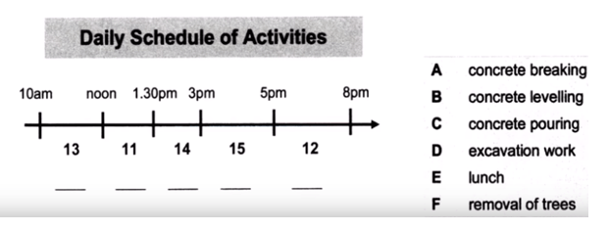
Choose FIVE answers from the list and write the correct letter A-F next to questions 11-15.
(11) _______ (12) _______
(13) _______ (14) _______
(15) _______
Questions 16-20
Complete the sentences. Write NO MORE THAN TWO WORDS for each answer.
Changes to University Plaza
16. Instead of concrete, the paths will be _______
17. The rear corner will have _______
18. The left hand strip will have a _______
19. In the middle, there will be _______
20. The walls will have _______
Part 3: Questions 21-26
Complete the table below. Write NO MORE THAN TWO WORDS for each answer.
Physicist | Name of significant work | Reason for significance
Galileo | (21)……………….. | It (22)…………………..
Newton | (23)………………….. | It (24)…………………..
Einstein | (25)………………….. | It (26)…………………..
(21) _______ (22) _______
(23) _______ (24) _______
(25) _______ (26) _______
Questions 27-30
Choose the correct letter G, N or E. NB you may use a letter more than once.
Which scientist does each person think was the greatest?
27. Steve _______
28. David _______
29. Susan _______
30. Peter _______
G Galileo
N Newton
E Einstein
Part 4: Questions 31 and 32
Choose the correct letter A, B or C.
31. ‘Echo’ is an example of a
[ ] A brand name
[ ] B model name
[ ] C symbol
32. Calvin Klein and Sara Lee
[ ] A are very popular
[ ] B are nice sounding names
[ ] C have many products
Questions 33-35
Choose THREE answers from the list and write the correct letter A-F next to questions 33-35.
What type of name does each company use?
33. Amazon _______
34. Safe and Sleek _______
35. Kodak _______
Type of name
A Acronym
B Descriptive
C Evocative
D Founders’ names
E Neologism
F Rhyming
Questions 36-40
Complete the table below. Write NO MORE THAN TWO WORDS for each answer.
Product | Logo/ symbol | Image
Marlboro | a cowboy | sponsorship of (36)………………..
Nike (37)……………. | a single tick | power, speed, (38)………………….
Rolex watches | a (39)…………………. | solid, smart, reliable
Calvin Klein jean | the name | put forward by a series of (40)……………advertisements
(36) _______ (37) _______
(38) _______ (39) _______
(40) _______

ANSWER KEY
1. 3,000
2. crabs
3. 45
4. lamb
5. chicken
6. B
7. B
8. A
9. C
10. B
11. A
12. D
13. C
14. E
15. B
16. polished stone
17. shops
18. garden
19. seating
20. plants
21. two systems
22. challenged authority
23. principia
24. created order
25. relativity
26. explained gravity
27. E
28. N
29. G
30. N
31. B
32. B
33. C
34. B
35. E
36. car racing
37. jogging shoes
38. freedom
39. crown
40. controversial

