IELTS Listening Practice - Test 70

Part 1: Questions 1-6
Complete the notes below. Write NO MORE THAN ONE WORD AND/ OR A NUMBER for each answer.
Small claims tribunal – Claim form
Claimant’s name: Emily-Jane Appleby
Address: 1 Yeronga Street, (1) _______
Questions 7-10
Complete the notes below. Write NO MORE THAN TWO WORDS AND/ OR A NUMBER for each answer.
Full particulars of claim
Good: (7) _______ – (‘Mallard’ brand, ‘Whisper’ model, serial no. XY303)
Agreed to pay: (8) £ _______
Good delivered on 5/3/2011
ABC appliances picked up the trade in on the same date.
Salesman said: Mallard Whisper model
• Uses less energy because it has shorter cycle
• Reduces the amount of (9) _______ used
• Whisper quiet
Complaint: the cycle is longer and the appliance is very (10) _______
Part 2: Questions 11-14
Complete the sentences below. Write NO MORE THAN TWO WORDS for each answer.
11. The coach is comfortable because it is _______
12. After all passengers are aboard, the coach will make its first stop at _______ Island
13. The ‘Tree top walk’ is above a _______
14. Passengers will have a _______ with the alpacas before boarding the bus for home.
Questions 15-20
Complete the table below. Write NO MORE THAN TWO WORDS AND/ OR A NUMBER for each answer.
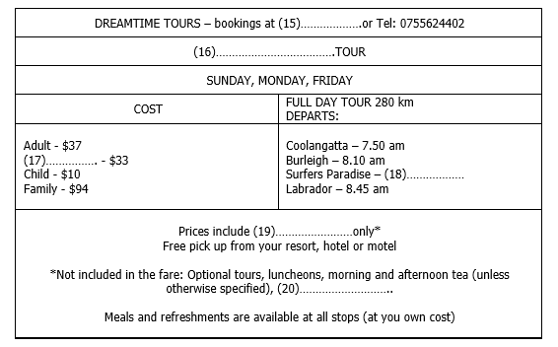
(15) _______ (16) _______
(17) _______ (18) _______
(19) _______ (20) _______
Part 3: Questions 21-25
Answer the questions below. Write NO MORE THAN TWO WORDS for each answer.
21. According to the liaison officer, what do volunteers help provide? _______
22. What can volunteers help students check and correct? _______
23. What aspects of students’ self-management can volunteers assist greatly with improving? _______
24. What will volunteers try to develop in the students so that they exert themselves more? _______
25. What is it that teachers have that allows them to respond to individual student requirements?
Many different _______
Questions 26-30
Complete the summary below using the phrases from the box.
Sharon and Lester have different (26) _______ Sharon studied business while Lester studied science. They are volunteering to help out at a school which is increasing its students’ (27) _______ in a number of subject areas. The (28) _______ programme is well underway. It’s a well equipped school and the liaison officer is particularly impressed by the (29) _______ The school offers many things to do outside the curriculum and students are encouraged to take part in (30) _______
A vocational learning experiences
B practical components
C self learning software
D academic backgrounds
E marine studies
F interesting developments
G scholastic competitions
H building and construction
Part 4: Questions 31-33
Complete the sentences below. Write NO MORE THAN TWO WORDS for each answer.
31. Someone in an anxiety state has worse _______ than normal.
32. A phobia may stem from heredity or _______
33. The reason for the final breakdown is generally linked with _______ like the loss of a loved one or a health crisis.
Questions 34-40
Match the phobic state in the box to the symptoms below.
Choose your answers from the box and write the letters A-D next to questions 34-40.
Phobic States
A Single Phobia
B Agoraphobia
C Claustrophobia
D Social phobia
The sufferer:
34. Feels extremely shy in company _______
35. Likes to sleep with the lights on _______
36. Fears leaving the house _______
37. Gets sweaty hands _______
38. Fears a particular creature _______
39. Fears small spaces _______
40. Has difficulty speaking in front of other people _______

ANSWER KEY
1. Durham
2. 7848762
3. trader
4. 17 brown
5. 4065
6. 6 months
7. washing machine
8. 750
9. water
10. noisy
11. air-conditioned
12. hope
13. rain forest
14. photo opportunity
15. reception desk
16. green mountain
17. senior citizen
18. 8.30 am
19. coach travel
20. entrance fees
21. quality education
22. written responses
23. organisational skill
24. work ethic
25. teaching styles
26. D
27. A
28. E
29. C
30. G
31. anxiety reactions
32. environmental issues
33. personal events
34. D
35. A
36. B
37. D
38. A
39. C
40. D

