IELTS Listening Practice - Test 72

Part 1: Questions 1-6
Complete the notes below. Write NO MORE THAN TWO WORDS.
Robert Goddard
Destination: Melbourne
Total number of visits: (1) _______
Part 2: Questions 11-15
Complete the map below. Write the correct letter A-E next to questions 11-15.
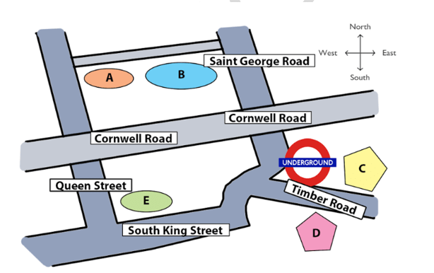
11. Science Museum _______
12. National History Museum _______
13. Car Park _______
14. Shopping Mall _______
15. Primary School _______
Questions 16-20
What is the improvement of each main point of interest in the area?
Choose FIVE answers from the box and write the correct letter, A-G, next to questions 16-20.
A New entrance
B Free lunch provided
C Free information provided
D Increase in size
E Additional signs
F New exhibitions
G New structure
16. Car Park _______
17. Primary School _______
18. Science Museum _______
19. National History Museum _______
20. Shopping Mall _______
Part 3: Questions 21-23
Choose correct letter A, B or C.
21. The proposal will
[ ] A be reviewed by two examiners.
[ ] B be added to the final grade.
[ ] C be returned with feedback.
22. The proposal will consist mostly of
[ ] A topics.
[ ] B methods.
[ ] C results.
22. For the practice paper, the tutor has directed the students to make sure to
[ ] A pay attention to time limits.
[ ] B write at least 6,000 words.
[ ] C keep on topic.
Questions 24-30
Complete the sentences below. Write ONE WORD AND/OR A NUMBER for each answer.
24. There is no need to _______ lots of people.
25. Pay attention to the _______ of the final report.
26. Prepare _______ , one for the teaches, another for the students themselves.
27. The deadline of the final paper is _______
28. The students can _______ their topics before the beginning of April.
29. Students deciding to change topics must deliver a _______ to the research in advance.
30. At the beginning of the report, the hypothesis and an outline of the _______ are needed.
Part 4: Questions 31-40
Complete the notes below. Write NO MORE THAN TWO WORDS for each answer.
The advertising effect
The important factor to consider
• The (31) _______ customers must travel affects the probability that they will buy the product.
Methods of communication
• Advertising slogans are easier to remember if there is a (32) _______ played with them.
• Mandy’s Candy Store appeals to people’s sense of (33) _______ to draw in customers.
• To an ad campaign for digital products, it is (34) _______ that is extremely important.
Effect on your product sales
• The customer’s (35) _______ after he or she experiences the ad is most important.
Marketing strategies
• On international flights, it is wise for the advertisement to be displayed in the common (36) _______ of most passengers.
• Very few young people buy (37) _______
• The UNESCO website would be a good place to advertise for companies aiming to improve the (38) _______
• One good location to place ads for sunscreen is the (39) _______
• A good scene for a water purification commercial would be (40) _______

ANSWER KEY
1. 3
2. amazing weather
3. town hall
4. variety
5. plane
6. over 40
7. mid-range
8. tourism
9. computer programmer
10. good value
11. B
12. A
13. E
14. C
15. D
16. E
17. G
18. C
19. D
20. A
21. C
22. B
23. A
24. interview
25. format
26. 2 copies
27. May 11
28. change
29. note
30. procedure
31. distance
32. sound
33. smell
34. flexibility
35. reaction
36. languages
37. newspaper
38. environment
39. swimming pool
40. national park

