IELTS Listening Practice - Test 75

Part 1: Questions 1-10
Complete the notes below. Write NO MORE THAN TWO WORDS AND/OR A NUMBER for each answer.
BIRMINGHAM EXHIBITION
Open in: (1) _______
Part 2: Questions 11-15
Choose the correct letter, A, B, or C.
11. How many patients does the hospital consult every year?
[ ] A 3,000.
[ ] B 5,000.
[ ] C 11,000.
12. When can patients meet the female doctor?
[ ] A On weekday mornings.
[ ] B Three days a week.
[ ] C Only on Mondays and Fridays.
13. Who is the expert on treating hearing loss?
[ ] A Mr. Roberts.
[ ] B Mr Green.
[ ] C Mr. Edwards.
14. Where are patients recommended to buy their medicine?
[ ] A The supermarket in the town.
[ ] B Pharmacies nearby the city centre.
[ ] C The health care’s pharmacy.
15. What will the patients be asked about whether they are willing to do?
[ ] A Letting one student attend the consultation.
[ ] B Asking postgraduate students to do treatment.
[ ] C Meeting students in group discussion.
Questions 16-20
Label the map below. Write the correct letter, A-H, next to questions 16-20.
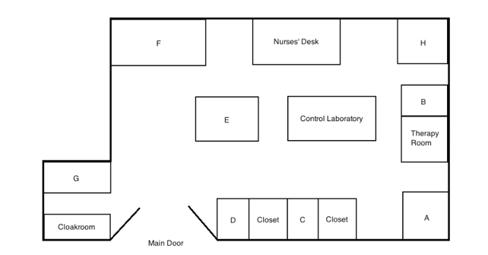
16. Reception _______
17. Mr. Green’s room _______
18. Medical Records Office _______
19. Surgery Room _______
20. Manager’s Office _______
Part 3: Questions 21-25
What is the main opinion of each of the following people?
Choose FIVE answers from the box and write the correct letter, A-G, next to questions 21-25.
Opinions
A lightning restrictions
B alternative lighting
C reduce the number of insects
D decline in the number of species
E climate changes
F impacts on the growth of animals
G impacts on water quality
21. Ken Simpson _______
22. Dave Kepler _______
23. Sharon Grey _______
24. Maria Jackson _______
25. Barbara Swallow _______
Questions 26 and 27
Choose the correct letter, A, B or C.
26. What does Jim think about the difference among species in natural and artificial light?
[ ] A It makes no difference.
[ ] B Species will die out in natural light.
[ ] C Species will die out in artificial light.
27. One reason why Jim and Jane felt unsatisfied about the theories discussed in the lecture was that
[ ] A governments didn’t increase any spending on them.
[ ] B most theories had nothing to do with the exam.
[ ] C many theories lack solid proof in the field.
Questions 28-30
Choose THREE letters, A-G.
Which THREE topics are they interested in studying in the future?
[ ] A quality of life tourism
[ ] В wildlife park animals
[ ] С migration birds
[ ] D animals living in rural areas
[ ] E animals living in tropical climate
[ ] F the impact of different environment on animals
[ ] G pandas in the zoo
Part 4: Questions 31 and 32
Choose TWO letters, A-E
Which TWO aspects did the new rules at the end of the 19th century focus on?
[ ] A cooperation
[ ] В competition
[ ] С moral values
[ ] D player’s physical protection
[ ] E business model
Questions 33-40
Complete the sentences below. Write ONLY ONE WORD for each answer.
Football in the UK
• At present the main reason why UK schools push football education is the pressure from (33) _______
• Prior to the 19th, football players used different (34) _______ of rules.
• People attempted to standardise the rules from the whole (35) _______ , known as the ‘Cambridge Rules’ in 1848.
• Attendences were increasing due to the improvement of infrastructure and the (36) _______ system.
• Football became popular and it is regarded as a (37) _______ event.
• The football clubs were responsible for most of the (38) _______ and development for the football association.
• (39) _______ against other teams were also organised by the football clubs.
• In 1910s, (40) _______ football players were approved of in the game.

ANSWER KEY
1. July
2. 3 days
3. test driving
4. camera
5. 110
6. edgeworth
7. summer
8. city centre
9. directions
10. enquiring online
11. C
12. A
13. B
14. C
15. A
16. F
17. H
18. B
19. D
20. C
21. A
22. B
23. F
24. G
25. D
26. A
27. C
28. B
29. E
30. F
31. C
32. D
33. parents
34. versions
35. country
36. transport
37. social
38. funding
39. competitions
40. professional

