IELTS Listening Practice - Test 77

Part 1: Questions 1-7
Complete the table below. Write ONE WORD AND/OR A NUMBER.
Event | Cost | Venue | Notes
Jazz band | tickets available for £ 15 | the (1)…………….school | also appearing: Carolyn Hart (plays the (2)……………..)
Duck races | £ 1 per duck | start behind the (3)……………… | – prize: tickets for (4)……………..held at the end of the festival  – ducks can be bought in (5)……………..
Flower show | free | (6)……………….Hall | prizes presented at 5 pm by a well known (7)……………….
(1) _______
Questions 8-10
Who is each play suitable for?
Write the correct letter A, B or C.
A mainly for children
B mainly for adults
C suitable for people of all ages
Plays
8. The Mystery of Muldoon _______
9. Fire and Flood _______
10. Silly Sailor _______
Part 2: Questions 11-16
What does the speaker say about each of the following collections?
Choose SIX answers from the box and write the correct letter A-G.
Comments
A was given by one person
B was recently publicized in the media
C includes some items given by members of the public
D includes some items given by the artists
E includes the most popular exhibits in the museum
F is the largest of its kind in the country
G has had some of its contents relocated
Collections
11. 20th-and 21st-century paintings _______
12. 19th-century paintings _______
13. Sculptures _______
14. ‘Around the world’ exhibition _______
15. Coins _______
16. Porcelain and glass _______
Questions 17-20
Label the plan below. Write the correct letter A-H, next to questions 17-20.
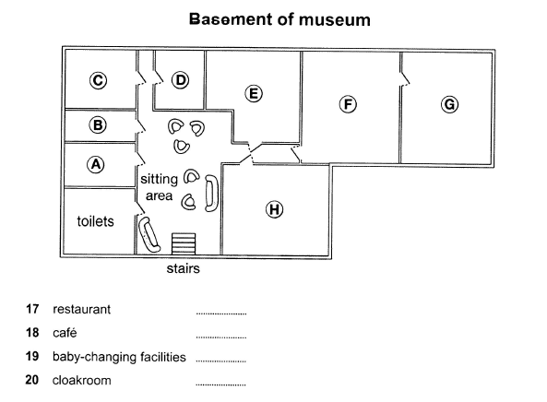
(17) _______ (18) _______
(19) _______ (20) _______
Part 3: Questions 21 and 22
Choose TWO letters A-E.
Which TWO characteristics were shared by the subjects of Joanna’s psychology study?
[ ] A They had all won prizes for their music
[ ] B They had all made music recordings
[ ] C They were all under 27 years old
[ ] D They had all toured internationally
[ ] E They all played a string instrument
Questions 23 and 24
Choose TWO letters, A-E.
Which TWO points does Joanna make about her use of telephone interviews?
[ ] A It meant rich data could be collected
[ ] B It allowed the involvement of top performers
[ ] C It led to a stressful atmosphere at times
[ ] D It meant interview times had to be limited
[ ] E It caused some technical problems
Questions 25 and 26
Choose TWO letters, A-E.
Which TWO topics did Joanna originally intend to investigate in her research?
[ ] A regulations concerning concert dress
[ ] B audience reactions to the dress of performers
[ ] C changes in performer attitudes to concert dress
[ ] D how choice of dress relates to performer roles
[ ] E links between musical instrument and dress choice
Questions 27-30
Choose the correct letter A, B or C.
27. Joanna concentrated on women performers because
[ ] A women are more influenced by fashion
[ ] B women’s dress has led to more controversy
[ ] C women’s code of dress is less strict than men’s
28. Mike Frost’s article suggests that in popular music, women’s dress is affected by
[ ] A their wish to be taken seriously
[ ] B their tendency to copy each other
[ ] C their reaction to the masculine nature of the music
29. What did Joanna’s subjects say about the audience at a performance?
[ ] A The musicians’ choice of clothing is linked to respect for the audience
[ ] B The clothing should not distract the audience from the music
[ ] C The audience should make the effort to dress appropriately
30. According to the speakers, musicians could learn from sports scientists about
[ ] A the importance of clothing for physical freedom
[ ] B the part played by clothing in improving performance
[ ] C the way clothing may protect against physical injury
Part 4: Questions 31-40
Complete the notes below. Write ONE WORD ONLY.
The use of soil to reduce carbon dioxide (CO2) in the atmosphere
Rattan Lal:
• Claims that 13% of CO2 in the atmosphere could be absorbed by agricultural soils
• Erosion is more likely in soil that is (31) _______
• Lai found soil in Africa that was very (32) _______
• It was suggested that carbon from soil was entering the atmosphere
Soil and Carbon:
• Plants turn CO2 from the air into carbon based substance such as (33) _______
• Some CO2 moves from the (34) _______ of plants to microbes in soil
• Carbon was lost from the soil when agriculture was invented
Regenerative agriculture:
• uses established practices to make sure soil remains fertile and (35) _______
• e.g. through year-round planting and increasing the (36) _______ of plants that are grown
California study:
• taking place on a big (37) _______ farm
• uses compost made from waste from agriculture and (38) _______
Australia study:
• aims to increase soil carbon by using (39) _______ that are always green
Future developments may include:
• reducing the amount of fertilizer used in farming
• giving farmers (40) _______ for carbon storage, as well as their produce

ANSWER KEY
1. secondary
2. flute
3. cinema
4. concert
5. market
6. Bythwaite
7. actor
8. A
9. B
10. C
11. E
12. D
13. G
14. B
15. C
16. A
17. F
18. H
19. C
20. B
21. B
22. D
23. A
24. B
25. B
26. E
27. C
28. A
29. A
30. C
31. dry
32. hard
33. sugars
34. roots
35. moist/ wet/ damp
36. variety
37. cattle
38. gardens
39. grasses
40. payment/ money

