IELTS Listening Practice - Test 78

Part 1: Questions 1-10
Complete the notes below. Write ONE WORD AND/OR A NUMBER.
HIRING A PUBLIC ROOM
• The main hall seats 200
Room and cost
• The (1) _______
Before the event
• Will need a (5) _______ licence
• Need to contact caretaker (Mr Evans) in advance to arrange (6) _______
During the event
• The building is no smoking
• The band should use the (7) _______ door at the back
• Don’t touch the system that controls the volume
• For microphones, contact the caretaker
After the event
• Need to know the (8) _______ for the cleaning cupboard
• The (9) _______ must be washed and rubbish placed in black bags
• All (10) _______ must be taken down
• Chairs and tables must be piled up
Part 2: Questions 11-14
Complete the notes below. Write ONE WORD for each answer.
Fiddy Working Heritage Farm
Advice about visiting the farm
Visitors should
• Take care not to harm any (11) _______
• Not touch any (12) _______
• Wear (13) _______
• Not bring (14) _______ into the farm, with certain exceptions
Questions 15-20
Label the map below. Write the correct letter A-I, next to questions 15-20.
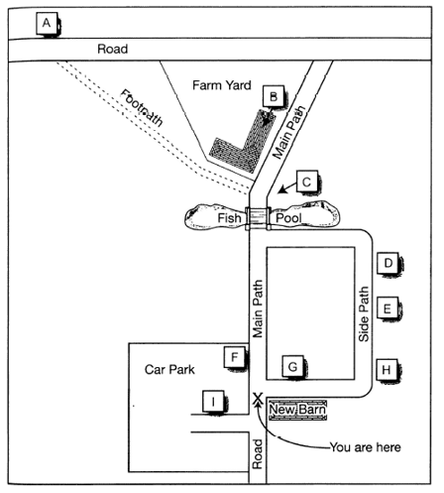
15. Scarecrow _______
16. Maze _______
17. Café _______
18. Black Barn _______
19. Covered picnic area _______
20. Fiddy house _______
Part 3: Questions 21-30
Choose the correct letter A, B or C.
Study on Gender in Physics
21. The students in Akira Miyake’s study were all majoring in
[ ] A physics
[ ] B psychology or physics
[ ] C science, technology, engineering or mathematics
22. The aim of Miyake’s study was to investigate
[ ] A what kind of women choose to study physics
[ ] B a way of improving women’s performance in physics
[ ] C whether fewer women than men study physics at college
23. The female physics students were wrong to believe that
[ ] A the teachers marked them in an unfair way
[ ] B the male students expected them to do badly
[ ] C their test results were lower than the male students’
24. Miyake’s team asked the students to write about
[ ] A what they enjoyed about studying physics
[ ] B the successful experiences of other people
[ ] C something that was important to them personally
25. What was the aim of the writing exercise done by the subjects?
[ ] A to reduce stress
[ ] B to strengthen verbal ability
[ ] C to encourage logical thinking
26. What surprised the researchers about the study?
[ ] A how few students managed to get A grades
[ ] B the positive impact it had on physics results for women
[ ] C the difference between male and female performance
27. Greg and Lisa think Miyake’s results could have been affected by
[ ] A the length of the writing task
[ ] B the number of students who took part
[ ] C the information the students were given
28. Greg and Lisa decide that in their own project, they will compare the effects of
[ ] A two different writing tasks
[ ] B a writing task with an oral task
[ ] C two different oral tasks
29. The main finding of Smolinsky’s research was that class teamwork activities
[ ] A were most effective when done by all-women groups
[ ] B had no effect on the performance of men or women
[ ] C improved the results of men more than of women
30. What will Lisa and Greg do next?
[ ] A talk to a professor
[ ] B observe a science class
[ ] C look at the science timetable
Part 4: Questions 31-40
Complete the notes below. Write ONE WORD ONLY.
Ocean Biodiversity
Biodiversity hotspots
• areas containing many different species
• important for locating targets for (31) _______
• at first only identified on land
Boris Worm, 2005
• identified hotspots for large ocean predators, e.g. sharks
• found that ocean hotspots:
– were not always rich in (32) _______
– had higher temperatures at the (33) _______
– had sufficient (34) _______ in the water
Lisa Ballance, 2007
• looked for hotspots for marine (35) _______
• found these were all located where ocean currents meet
Census of Marine Life
• found new ocean species living:
– under the (36) _______
– near volcanoes on the ocean floor
Global Marine Species Assessment
• want to list endangered ocean species, considering:
– population size
– geographical distribution
– rate of (37) _______
• Aim: to assess 20,000 species and make a distribution (38) _______ for each one
Recommendations to retain ocean biodiversity
• increase the number of ocean reserves
• establish (39) _______ corridors (e.g. for turtles)
• reduce fishing quotas
• catch fish only for the purpose of (40) _______

ANSWER KEY
1. Charlton
2. £115
3. cash
4. parking
5. music
6. entry
7. stage
8. code
9. floors
10. decorations
11. animals
12. tools
13. shoes
14. dogs
15. F
16. G
17. D
18. H
19. C
20. A
21. C
22. B
23. B
24. C
25. A
26. B
27. C
28. A
29. B
30. A
31. conservation
32. foods
33. surface
34. oxygen
35. mammals
36. ice
37. decline
38. map
39. migration
40. consumption

