IELTS Listening Practice - Test 79

Part 1: Questions 1-10
Complete the notes below. Write ONE WORD AND/OR A NUMBER.
Enquiry about joining Youth Council
Name: Roger Brown
Age: 18
Currently staying in a (1) _______
Part 2: Questions 11-20
New staff at theatre
Questions 11 and 12
Choose TWO letters A-E.
Which TWO changes have been made so far during the refurbishment of the theatre?
[ ] A Some rooms now have a different use.
[ ] B A different type of seating has been installed.
[ ] C An elevator has been installed.
[ ] D The outside of the building has been repaired.
[ ] E Extra seats have been added.
Questions 13 and 14
Choose TWO letters, A-E.
Which TWO facilities does the theatre currently offer to the public?
[ ] A rooms for hire
[ ] B backstage tours
[ ] C hire of costumes
[ ] D a bookshop
[ ] E a cafe
Questions 15 and 16
Choose TWO letters, A-E.
Which TWO workshops does the theatre currently offer?
[ ] A sound
[ ] B acting
[ ] C making puppets
[ ] D make-up
[ ] E lighting
Questions 17-20
Label the plan below. Write the correct letter A-G, next to questions 17-20.
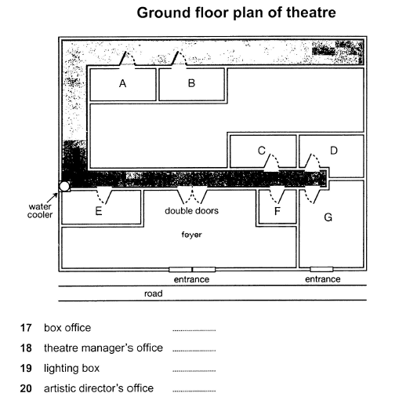
(17) _______ (18) _______
(19) _______ (20) _______
Part 3: Questions 21-26
Choose the correct letter A, B or C.
Rocky Bay field trip
21. What do the students agree should be included in their aims?
[ ] A factors affecting where organisms live
[ ] B the need to preserve endangered species
[ ] C techniques for classifying different organisms
22. What equipment did they forget to take on the Field Trip?
[ ] A string
[ ] B a compass
[ ] C a ruler
23. In Helen’s procedure section, Colin suggests a change in
[ ] A the order in which information is given
[ ] B the way the information is divided up
[ ] C the amount of information provided
24. What do they say about the method they used to measure wave speed?
[ ] A It provided accurate results
[ ] B It was simple to carry out
[ ] C It required special equipment
25. What mistake did Helen make when first drawing the map?
[ ] A She chose the wrong scale
[ ] B She stood in the wrong place
[ ] C She did it at the wrong time
26. What do they decide to do next with their map?
[ ] A scan it onto a computer
[ ] B check it using photographs
[ ] C add information from the internet
Questions 27 and 28
Choose TWO letters A-E.
Which TWO problems affecting organisms in the splash zone are mentioned?
[ ] A lack of water
[ ] B strong winds
[ ] C lack of food
[ ] D high temperatures
[ ] E large waves
Questions 29 and 30
Choose TWO letters, A-E.
Which TWO reasons for possible error will they include in their report?
[ ] A inaccurate records of the habitat of organisms
[ ] B influence on behaviour of organisms by observer
[ ] C incorrect identification of some organisms
[ ] D making generalisations from a small sample
[ ] E missing some organisms when counting
Part 4: Questions 31-40
Complete the notes below. Write ONE WORD ONLY.
DESIGNING A PUBLIC BUILDING:
THE TAYLOR CONCERT HALL
Introduction
The designer of a public building may need to consider the building’s
• Function
• Physical and (31) _______ context
• Symbolic meaning
Location and concept of the Concert Hall
• On the site of a discussed (32) _______
• Beside a (33) _______
• The design is based on the concept of a mystery
Building design
It’s approached by a (34) _______ for pedestrians
The building is the shape of a (35) _______
One exterior wall acts as a large (36) _______
In the auditorium:
• The floor is built on huge pads made of (37) _______
• The walls are made of local wood and are (38) _______ in shape
• Ceiling panels and (39) _______ on walls allow adjustment of acoustics
Evaluation
Some critics say the (40) _______ style of building is inappropriate

ANSWER KEY
1. hostel
2. Buckleigh
3. PE9 7QT
4. waiter
5. politics
6. cycling
7. cinema
8. disabled
9. 4.30 pm
10. 07788136711
11. A
12. B
13. B
14. D
15. C
16. E
17. G
18. D
19. B
20. F
21. A
22. A
23. C
24. B
25. B
26. B
27. A
28. D
29. C
30. E
31. social
32. factory
33. canal
34. bridge
35. box
36. screen
37. rubber
38. curved
39. curtains
40. international

