IELTS Listening Practice - Test 8

Part 1: Questions 1-6
Complete the form below. Write NO MORE THAN THREE WORDS OR A NUMBER.
HOMESTAY APPLICATION
Surname: Yuichini
First name: (1) _______
Sex: female Nationality: Japanese
Passport number: (2) _______
Questions 7-10
Answer the questions below. Write NO MORE THAN TWO WORDS.
7. What does the student particularly like to eat? _______
8. What sport does the student play? _______
9. What mode of transport does the student prefer? _______
10. When will the student find out her homestay address? _______
Part 2: Questions 11-14
Choose the correct letter A, B or C.
11. What kind of tour is Sally leading?
[ ] A a bus tour
[ ] B a train tour
[ ] C a walking tour
12. The original buildings on the site were
[ ] A houses
[ ] B industrial buildings
[ ] C shops
13. The local residents wanted to use the site for
[ ] A leisure
[ ] B apartment blocks
[ ] C a sports centre
14. The Tower is at the centre of the
[ ] A nature reserve
[ ] B formal gardens
[ ] C Bicentennial Park
Questions 15-17
Label the plan below. Write NO MORE THAN TWO WORDS.
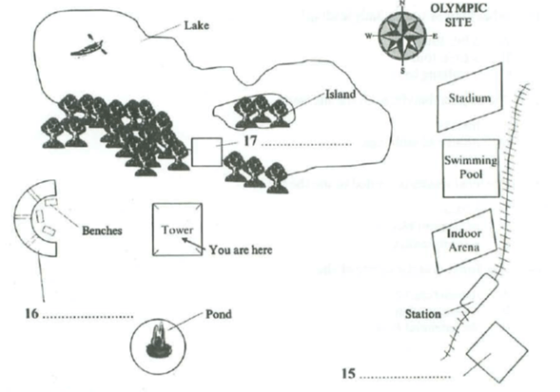
(15) _______
(16) _______
(17) _______
Questions 18-20
Complete the table below. Write NO MORE THAN TWO WORDS.
Area | Facility | Activity
The Mangroves | Boardwalk | (18)…………………..
Frog Pond | Outdoor classroom | (19)………………………
The Waterbird Refuge | (20)……………………… | Bird watching
(18) _______
(19) _______
(20) _______
Part 3: Questions 21 and 22
Complete the sentences below. Write NO MORE THAN ONE WORD AND/OR A NUMBER for each answer.
The presentation will last 15 minutes.
There will be (21) _______ minutes for questions.
The presentation will not be (22) _______
Questions 23-26
What do the students decide about each topic for the geography presentation?
A They will definitely include this topic.
B They might include this topic.
C They will not include this topic.
Write the correct letter, A, B or C, next to questions 23-26.
23. Geographical Location _______
24. Economy _______
25. Overview of Education System _______
26. Role of English Language _______
Questions 27-30
Complete the table below. Write NO MORE THAN TWO WORDS.
Information/ visual aid | Where from?
Overhead projector | The (27)………………
Map of West Africa | The (28)……………….
Map of the islands | A tourist brochure
Literacy figures | The (29)………………….
(30)…………………….on school places | As above
(27) _______ (28) _______
(29) _______ (30) _______
Part 4: Questions 31-33
Choose the correct letter A, B or C.
Monosodium Glutamate (MSG)
31. The speaker says the main topic of the lecture is
[ ] A the history of monosodium glutamate
[ ] B the way monosodium glutamate works
[ ] C where monosodium glutamate is used
32. In 1908, scientists in Japan
[ ] A made monosodium glutamate
[ ] B began using kombu
[ ] C identified glutamate
33. What change occurred in the manufacture of glutamate in 1956?
[ ] A It began to be manufactured on a large scale
[ ] B The Japanese began extracting it from natural sources
[ ] C It became much more expensive to produce
Questions 34-40
Complete the notes below. Write NO MORE THAN TWO WORDS.
Monosodium Glutamate (MSG)
• MSG contains
o Glutamate (78.2%)
o Sodium (12.2%)
o (34) _______ (9.6%)
• Glutamate is found in foods that contain protein such as (35) _______ and
(36) _______
• MSG is used in foods in many different parts of the world.
• In 1908 Kikunae Ikeda discovered a (37) _______
• Our ability to detect glutamate makes sense because it is so (38) _______ naturally.
• John Prescott suggests that:
o Sweetness tells us that a food contains carbohydrates.
o (39) _______ tells us that a food contains toxins.
o Saltiness tells us that a food contains (40) _______

ANSWER KEY
1. Keiko
2. JO6337
3. 4 months
4. English (studies)
5. (young) children
6. pets
7. seafood
8. tennis
9. trains
10. that afternoon
11. C
12. B
13. A
14. B
15. car park
16. rose garden
17. cafe
18. cycling
19. biology lesson
20. viewing shelter
21. 5
22. assessed
23. A
24. B
25. A
26. C
27. media room
28. resources room
29. embassy
30. statistics/ stat
31. B
32. C
33. A
34. water
35. meat
36. cheese
37. fifth taste
38. common
39. bitterness
40. minerals

