IELTS Listening Practice - Test 80

Part 1: Questions 1-10
Complete the notes below. Write NO MORE THAN TWO WORDS AND/ OR A NUMBER for each answer.
Costwise Car Hire
Number of offices in Sydney – 3
• Booking reference number – (1) _______
Part 2: Questions 11-15
The following are essential requirements for which job?
Write the correct letter A, B or C next to questions 11-15.
Essential requirements
A foreign languages
B willingness to travel abroad
C professional qualification
11. conference organizer _______
12. catering manager _______
13. housekeeper _______
14. fitness centre staff _______
15. reservations assistant _______
Questions 16-20
Choose FIVE answers from the list and write the correct letter A-G next to questions 16-20.
International finest group – Recruitment procedures
• Register interest in working for International Finest Group
• Receive personal code and check (16) _______
• Download application form
• Send in form and attach (17) _______
• Receive reply and confirm (18) _______
• Send in (19) _______
• Attend (20) _______
A CV
B names of referees
C work permit
D recruitment seminar
E evidence of qualifications
F conditions of employment
G initial interview
Part 3: Questions 21 and 22
Choose TWO letters A-E.
Which TWO possible objections to a roof garden are discussed?
[ ] A problems of access
[ ] B the cost of construction
[ ] C the time needed to install it
[ ] D who will look after it
[ ] E how to support the weight of it
Questions 23 and 24
Choose TWO letters A-E.
Which TWO recent developments in roof garden building are mentioned?
[ ] A waterproof barrier materials
[ ] B drainage systems
[ ] C tank designs
[ ] D lightweight construction materials
[ ] E watering systems
Questions 25-30
Label the diagram below. Write the correct letter A-H next to questions 25-30
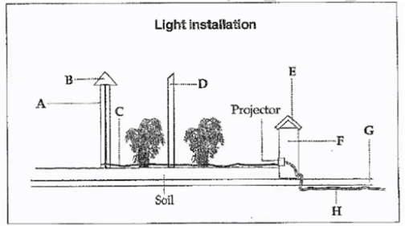
25. wall _______
26. electric wire _______
27. fibre optic cable _______
28. wooden post _______
29. glass cap _______
30. acrylic rod _______
Part 4: Questions 31-36
Complete the notes below. Write NO MORE THAN TWO WORDS for each answer.
The Argus System
Developed by Rob Holman in North Carolina with other researchers. Research is vital for understanding (31) _______ Matches information from under the water with information from a (32) _______ According to S. Jeffress Williams, useful because can make observations during (33) _______
Dr Holman’s sand collection
• Dr. H. has samples from every (34) _______
• Used in teaching students of (35) _______
• E.g. US East Coast display – grairs from south are small, light colored and (36) _______ in shape
Questions 37-40
Complete the flow chart below. Write NO MORE THAN THREE WORDS for each answer.
(37) _______ (38) _______
(39) _______ (40) _______

ANSWER KEY
1. 743002
2. international
3. 6.15 pm
4. 30
5. echo
6. credit card
7. 7
8. 1000
9. luggage
10. pavement
11. A
12. C
13. B
14. C
15. A
16. F
17. A
18. G
19. E
20. D
21. B
22. D
23. A
24. E
25. F
26. H
27. C
28. D
29. B
30. A
31. beach erosion
32. (fixed) camera
33. storm
34. continent
35. geology
36. round
37. spoon
38. permanent marker
39. newspaper
40. (identification) label

